- Warm Up:
10 Jumping Jacks 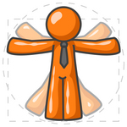
10 Arm Circles (both ways) 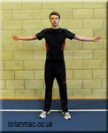
10 Leg Swings (on each leg) 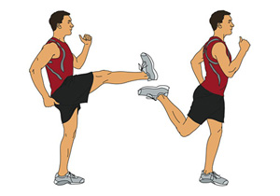

- Four Machines:
Machine: _________________________________
How Many Reps/How Much Time?: __________________
Was it easy, medium or hard? (Circle One)
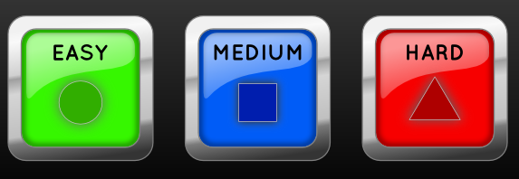

Machine: _________________________________
How Many Reps/How Much Time?: __________________
Was it easy, medium or hard? (Circle One)

Machine: _________________________________
How Many Reps/How Much Time?: __________________
Was it easy, medium or hard? (Circle One)

Machine: _________________________________
How Many Reps/How Much Time?: __________________
Was it easy, medium or hard? (Circle One)
- Cardio:

Choose 1 for 10 Minutes:

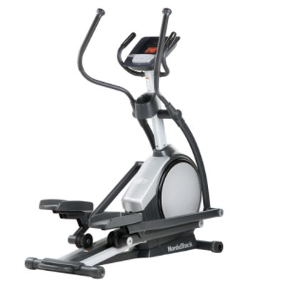
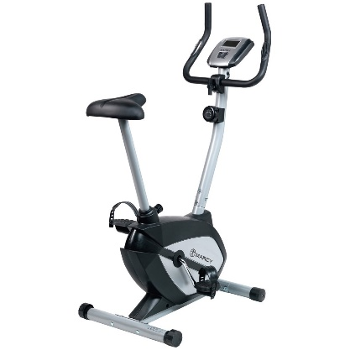
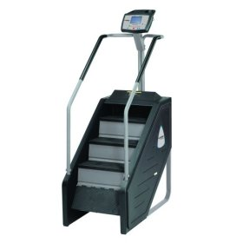
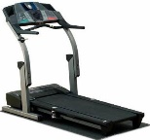

Was it easy, medium, or hard?

- Four Machines:
Machine: _________________________________
How Many Reps/How Much Time?: __________________
Was it easy, medium or hard? (Circle One)

Machine: _________________________________
How Many Reps/How Much Time?: __________________
Was it easy, medium or hard? (Circle One)

Machine: _________________________________
How Many Reps/How Much Time?: __________________
Was it easy, medium or hard? (Circle One)

Machine: _________________________________
How Many Reps/How Much Time?: __________________
Was it easy, medium or hard? (Circle One)
- Stretch:
Choose 4 Stretches. Hold each for 30 Seconds.:
2 leg stretches
Examples:
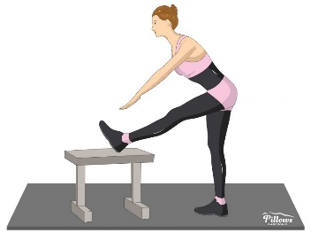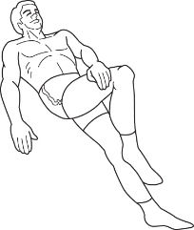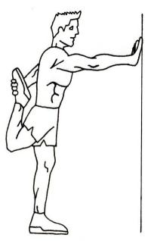
1 arm stretch
Examples:
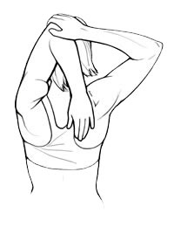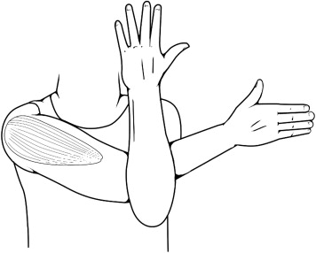
1 back stretch
Example:
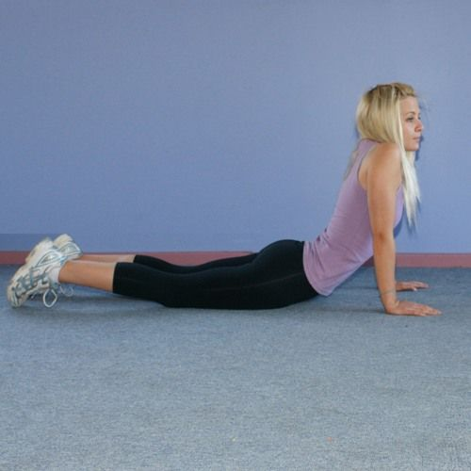

Challenge:

Use the foam roller to stretch out your quads
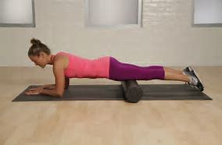

After the workout:

- How do you feel?

- Did you sweat?
- Yes, a little
- Yes, a lot
- No

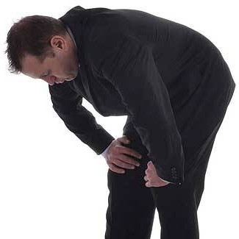
- Did you run out of breath?
- Yes
- No

- Was this workout easy, medium, or hard?

- Did you like this workout?

