S.N.A.P: Supplemental Nutrition Assistance Program
https://www.youtube.com/watch?v=4b_-rIXQU_0

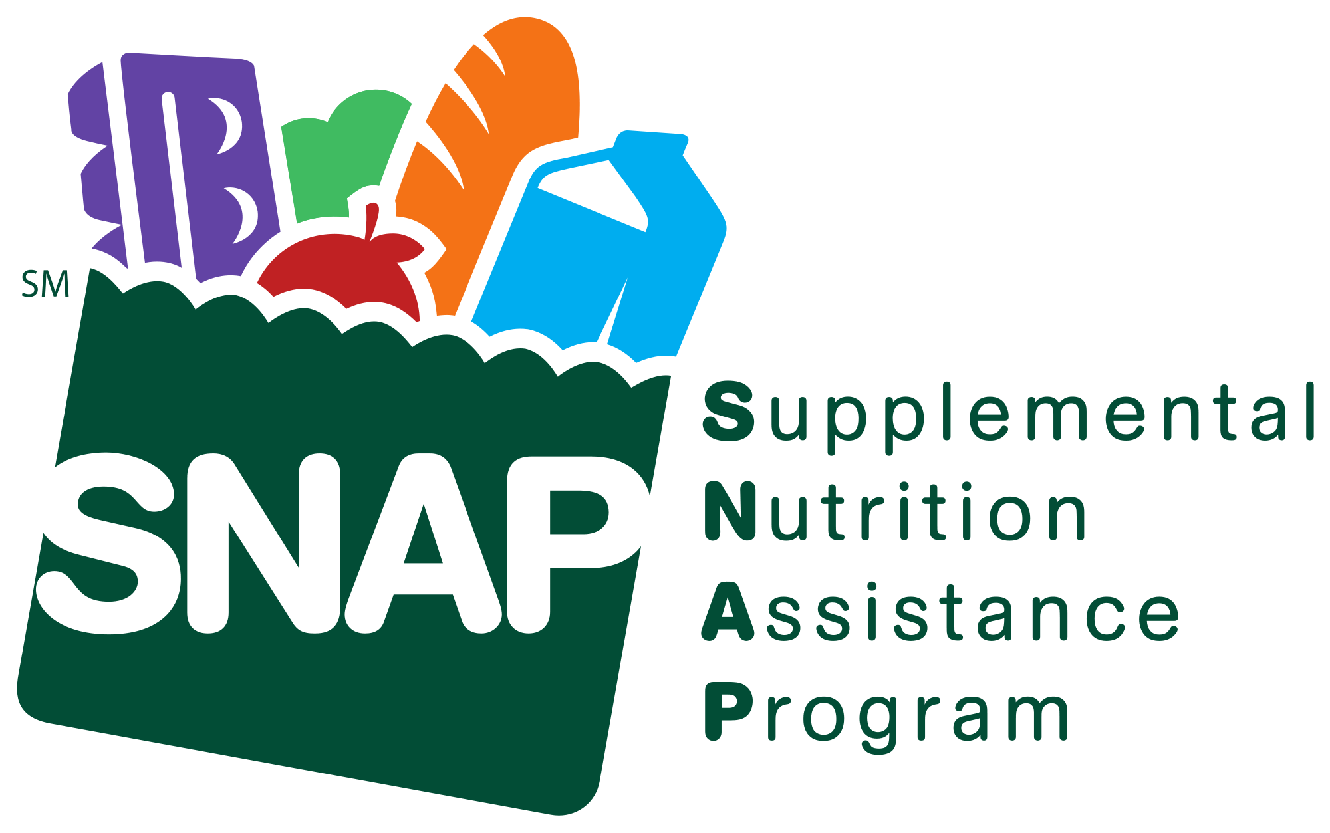
In 1939 the U.S. Government began the first program to help people who don’t have enough money to buy the food they need to be healthy. This program used to be called “Food Stamps” and is now called S.N.A.P, the Supplemental Nutrition Assistance Program. Today, over 45 million Americans and 1 out of every 5 children use S.N.A.P. to help buy groceries every month. Without S.N.A.P., many Americans would go hungry and become sick.

S.N.A.P. stands for: __________________________________

__________________________________________________.

https://www.snaptohealth.org/snap/snap-frequently-asked-questions/
E.B.T.: Electronic Balance Transfer

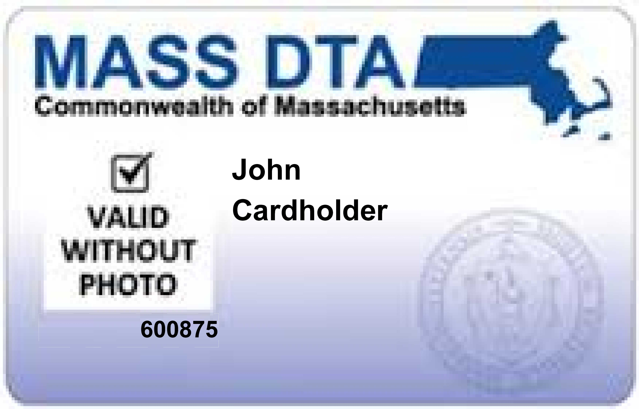
https://www.masslegalservices.org/content/snap-and-photo-ebt-cards-information-and-resources

E.B.T. stands for Electronic Balance Transfer. The government agency that manages this program in Massachusetts is called D.T.A., the Department of Transitional Assistance. D.T.A. helps support one out of every eight Massachusetts residents with direct economic assistance (cash benefits) and food assistance (SNAP benefits).
In Massachusetts, people who qualify can use E.B.T. cards similar to ATM cards to spend S.N.A.P. money on groceries. E.B.T. cards can also be used in Massachusetts’ “Card to Culture Program” to get discounts at local museums, plays, concerts, and zoos.
Citizens of Massachusetts who are poor or who have disabilities may be able to get an E.B.T. card if they have no job or don’t earn enough money in their paycheck from working.

E.B.T. stands for: _____________________________________

D.T.A. stands for: _____________________________________
https://www.mass.gov/orgs/department-of-transitional-assistance



If you qualify for S.N.A.P. in Massachusetts, you get an E.B.T. card that has a secret code you can use when you are checking out at the grocery store. On the same day every month Massachusetts D.T.A. puts money for groceries onto your card. The average monthly amount in the U.S. is about $125.
https://en.wikipedia.org/wiki/Electronic_benefit_transfer

This is what the Mass D.T.A. website says about EBT cards:
“The Electronic Benefits Transfer (EBT) card is how DTA delivers its core services: food and economic assistance. Once you qualify for food benefits through the Supplemental Nutrition Assistance Program (SNAP), and/or economic assistance through Transitional Aid to Families with Dependent Children (TAFDC) or Emergency Aid to the Elderly, Disabled, and Children (EAEDC), you can access them using an EBT card. It looks and works like a debit card. We keep your benefits in a special account for you until you want to use them. Your EBT card "talks" to the account to let you get and spend your benefit dollars in an easy, secure way.”
https://www.mass.gov/guides/using-your-ebt-card

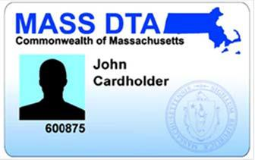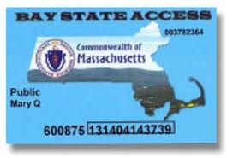https://www.masslegalservices.org/content/snap-and-photo-ebt-cards-information-and-resources

I am already enrolled in SNAP and have an EBT Card.

Yes No I’m not sure

I am interested in applying for or keeping my EBT card.

Yes No I’m not sure

I have a disability.

Yes No I’m not sure

I am a resident of Massachusetts.

Yes No I’m not sure

I am glad that Massachusetts provides EBT cards to people who have disabilities and/or low income.

Yes No I’m not sure

SNAP and EBT Word Search
C E K T V T T W H G E N S S Q
O A C H R I R F E L I T Y N F
N X I N S A Z A E P T J O G P
T M B O A M N C N E R I U R K
R B U K Z T T S S S T Z O T E
O A J D U R S U I I F G Z N G
V L O K O T H I R T R E M E Q
E A E N Y C B T S A I W R M D
R N I B A P U S M S A O F T T
S C O S T N L X P M A K N R A
Y E S S U P P L E M E N T A L
G A E R U T L U C D A V D P L
M T N E M N R E V O G T A E L
C A R D K S L R O O C N S D A
P O L I T I C A L F S A K C L

ASSISTANCE BALANCE
CARD CONTROVERSY
CULTURE DEPARTMENT
DTA EBT
ELECTRONIC FOOD
GOVERNMENT MASSACHUSETTS
NUTRITION POLITICAL
PROGRAM SNAP
STAMPS SUPPLEMENTAL
TRANSFER TRANSITION

