Neurodiversity in the Workplace
By Katie Johnston
November 28, 2018
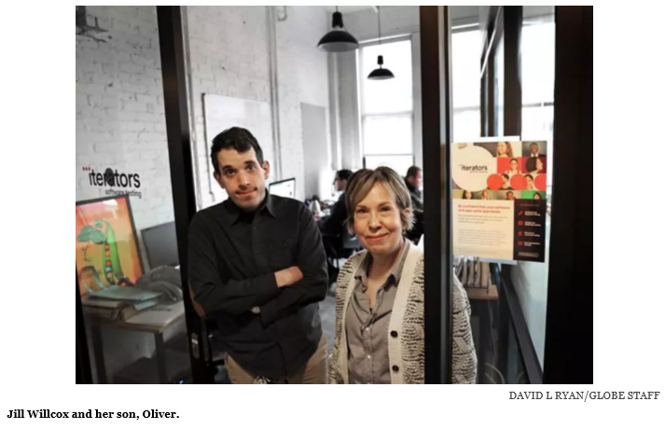
Text and photos adapted from: Companies tap into an underused but highly capable workforce, Boston Globe; November 28, 2018

Oliver Willcox was always an excellent student. But when he started applying for jobs, Willcox, who has ADHD and a speech and language disorder, got nowhere. In interviews, he could be socially awkward, fidgeting nervously and not looking people in the eye.

Such people as Willcox, 28, often have a hard time finding work. But a movement has emerged in recent years to promote awareness of “neurodiverse” people who can be highly intelligent but are wired differently.

Neurodiverse people are estimated to make up 8-10% of the population, and some of them, such as those with autism, have unique abilities to see patterns, think creatively, and focus on repetitive tasks.

A number of small companies have made it their mission to hire from this population. And after Jill Willcox saw her bright, funny son, Oliver, struggle to find work, that’s exactly what she did.

In June of 2017, she launched Iterators, a software-testing firm.

“There are lots of people who are overlooked, and we just think that that doesn’t make sense,” she said. “The way you can become diverse in this world is to really be accepting of people in all their strengths.”

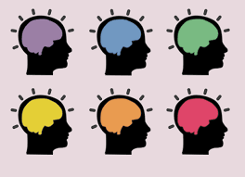
Image: https://www.madinamerica.com/2018/04/neurodiversity-dead-now-what/

Advocates see the neurodiversity movement as a civil rights issue, similar to promoting equality in the LGBTQ community. These aren’t disorders, they argue, but a natural part of human diversity. Some have started referring to them not as disabilities but “coolabilities” — conditions that come with valuable assets.

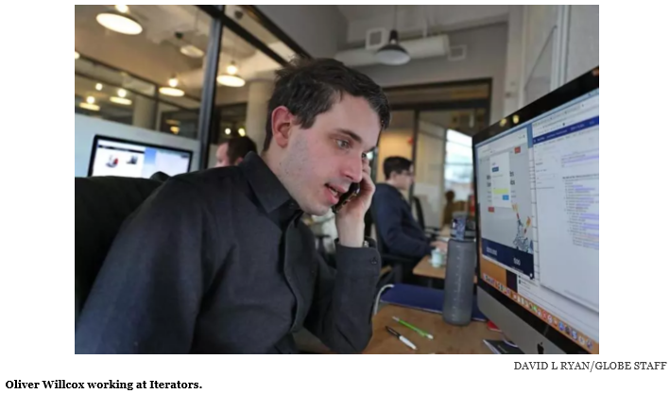

Neurodiverse employees are 30-40% more productive than “neurotypical” workers when performing tasks such as data analysis, software testing, and compliance, provided they are supported properly.
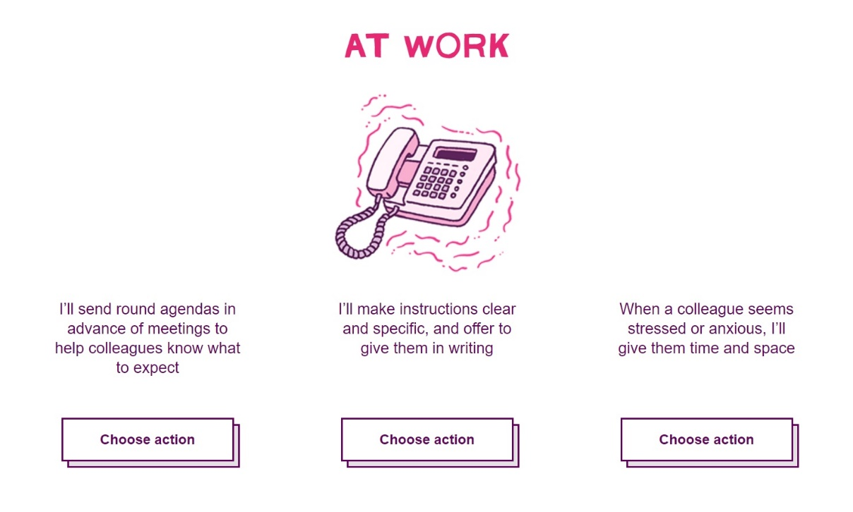
Image: http://yonah.org/channel/neurodiversity-workplace

“Neurodiverse people see the world differently, which can give them a competitive advantage in certain fields”, said John Elder Robison, an Amherst-based advocate and author. “A dyslexic person who sees letters and words differently, for example, might be able to crack codes for the CIA”, Robison said.
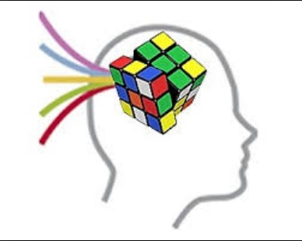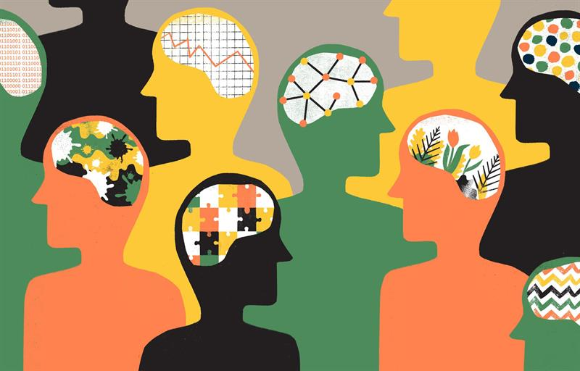
Image: http://yonah.org/channel/neurodiversity-workplace
Image: https://www.indiamart.com/proddetail/visual-spatial-intelligence-8848363762.html

At Aspiritech in Chicago, a software-testing service with 100 neurodiverse employees, business is booming, said founder Brenda Weitzberg.

“First impressions can be deceiving”, she said. One of her employees spends part of his day hugging a teddy bear and takes daily naps in a break room, but he is the highest performer on his four-person team.
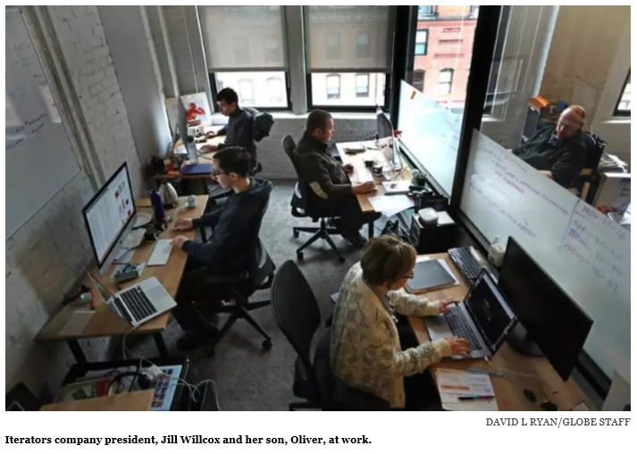
“He’s not wasting any time around the water cooler,” said Weitzberg... “If you really want innovation, people who think outside the box are perfect.”

