Lesson 1: Expressing Memories

Think of a memory that you remember very clearly. It should be a memory that comes easily to you.

“My memory is the time when… _________________________________________________________________________________________________________________________________________________________________________________________________________________”

Why do you think you remember this so well? Try connecting one or more emotions to this

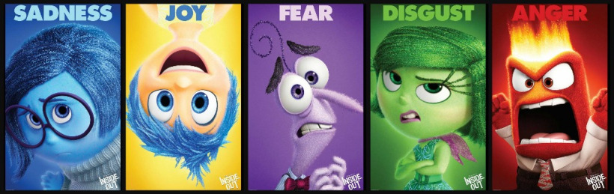
Picture taken from https://movies.stackexchange.com/questions/37345/why-are-two-of-rileys-five-emotions-in-inside-out-male/37346

“My memory makes me feel these emotions…..
______________________________________________________________”

Now try and express your memory and emotion in some way. The goal is to get it out of your head. Now, tell your memory to someone who will help you write it down in less than a page.

Do the emotions come out in your words?

“I remember the time when… ______________________________________________________________________________________________________________________________________________________________________________________________________________________________________________________________________________________________________________________________________________________________________________________________________________________________________________________________________________________________________________________________________________________________________”
Express your memory using only lines and shapes. Do the emotions come out in your drawings?

Lesson 2: Your three favorite films
Identify the three films that you would take to a deserted island....

- _____________
- _____________
- _____________

Why do you think you connected with these stories? Come up with at least one reason for each.
_____________________ _________________________________________________________________________________________________________
What, if anything, do these three films have in common? How are they different?
_____________________ _________________________________________________________________________________________________________

