1. Choose One: Brushing Brain Gym
2. Bounce! 2 Songs

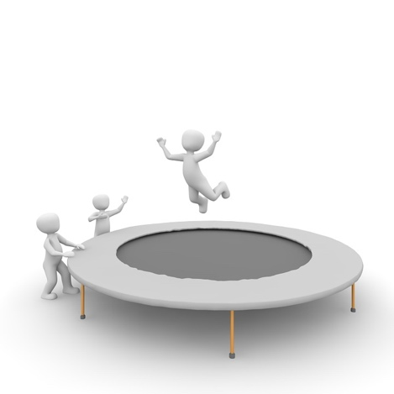 

1. Walk or Jog Watch 1 Show

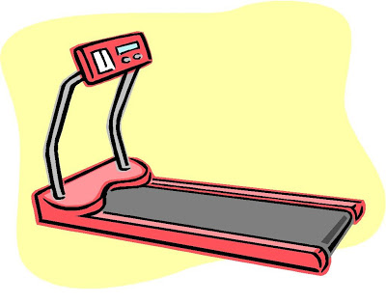 

1. Stretch

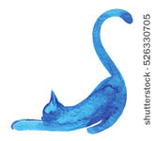

What Are 2 Songs you want to listen to while bouncing?

1.__________________________________________

2.__________________________________________

What is 1 show you want to watch while walking?

1. ________________________________________