COMPASS

North

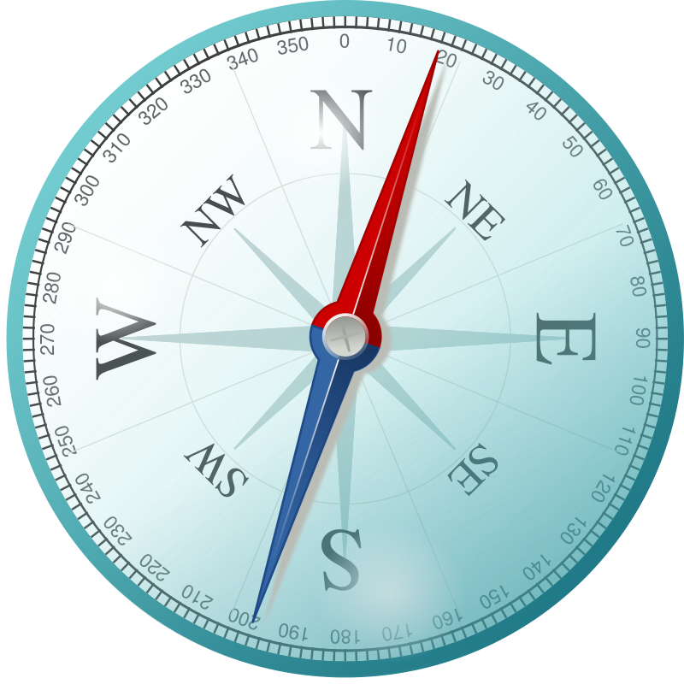

West

East

South

Fill out the worksheet below. You can use the compass as a guide!

This is a map of:

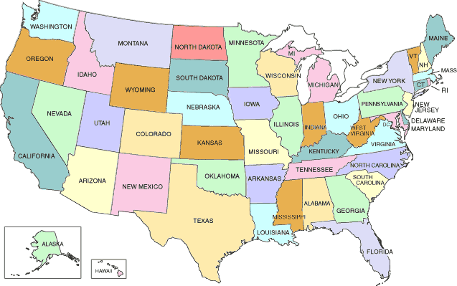

**Checklist:**

* Circle **the state you are in** on the map
* If you could visit anywhere in America, where would you go?
* Circle it on the map.
* Circle one: Is your state closer to the **north** or **south**?
* Circle one: Is your state closer to the **east** or **west**?

Now,

Let’s look up your state on google maps.

How many miles away is your state?

How long would it take you to walk to your state?

How long would it take you to drive to your state?