What Do I Need to Buy at the Grocery Store?

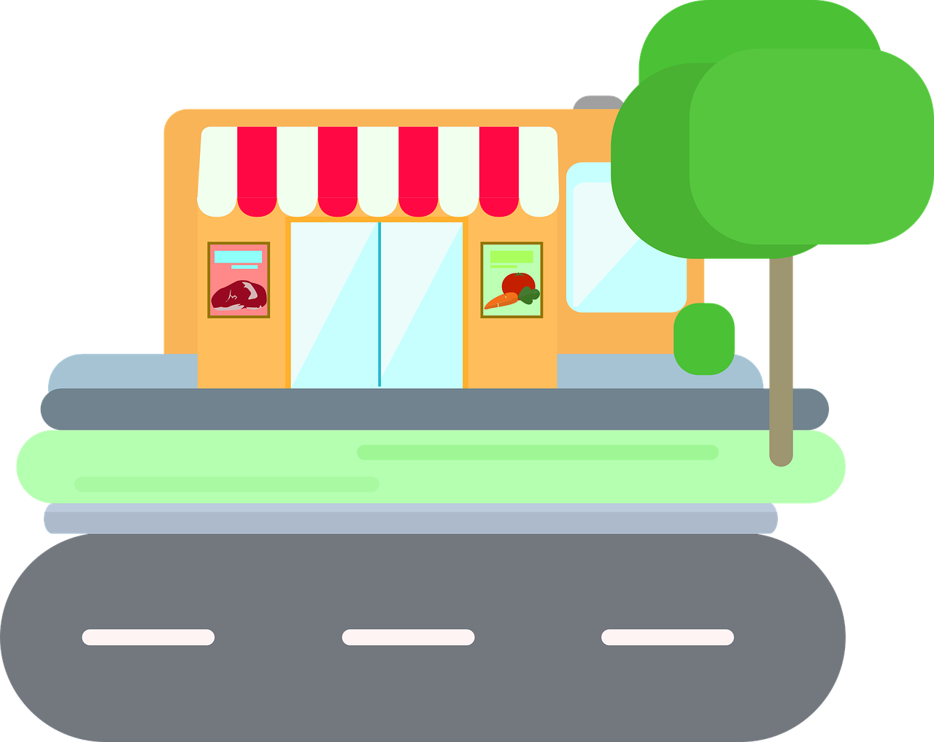

1. Look at “My Weekly Menu”
2. Make a list of foods you will eat this week. Put 1 food on each line.

Yes No

Yes No

Yes No

Yes No

Yes No

Yes No

1. Check in the kitchen: do I have these foods? Circle **Yes** or **No**.
2. Look at your list. If you circled **No**, write that food here: