Rudyard Kipling’s “Jungle Book”

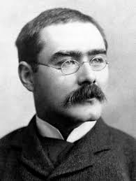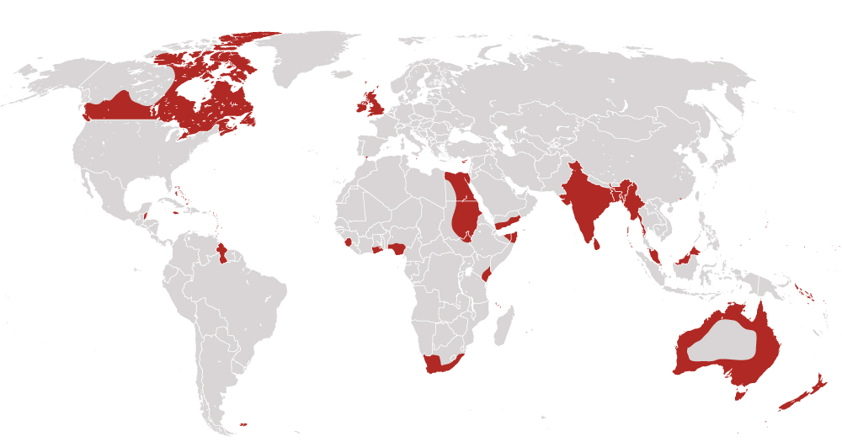

**Rudyard Kipling** was born in 1865 to English parents in Bombay, **India**. At that time, **England** was the most powerful country in the world. All of the red areas on the map, including India, were **colonies** ruled by England as part of the **British Empire**.

At a time before television, the little British boy from India grew up to become one of the greatest writers in the English language. By the time he wrote the **Jungle Book** in 1894, Rudyard Kipling was one of the most famous celebrities in the entire world.

***Colonies like India that were ruled by England were part of the: ________________ ________________***

**Rudyard Kipling’s Childhood in India**

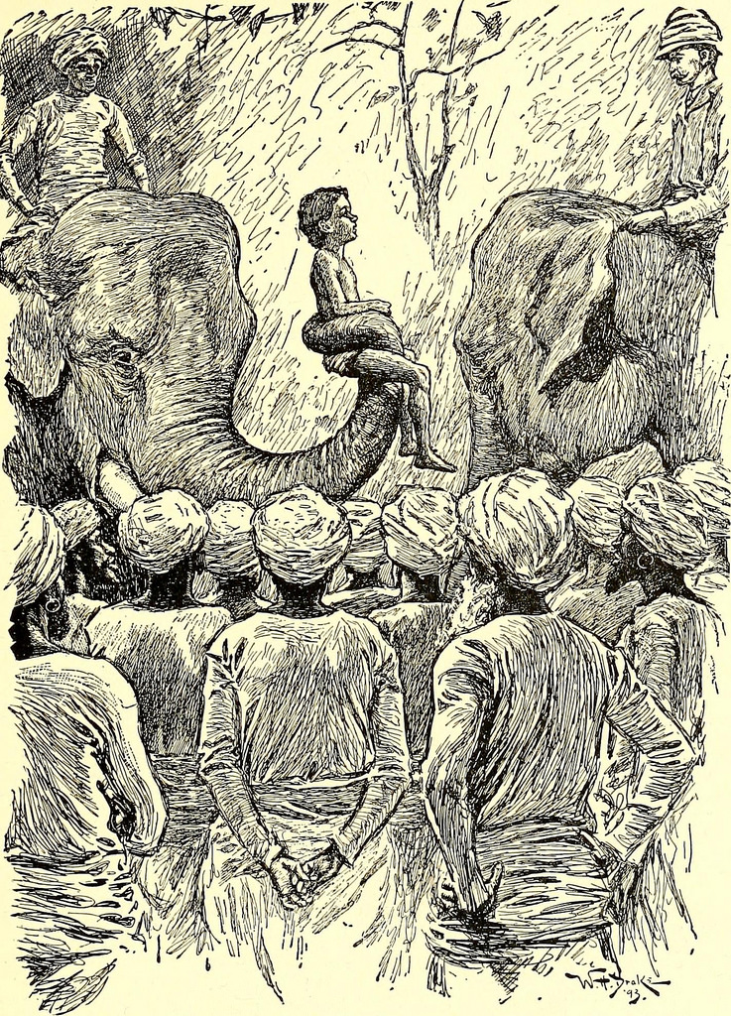

The first six years of Rudyard’s life in India were filled with unconditional love, magic and wonder. His parents were often busy working for England but Rudyard was always surrounded by kind Indian nannies and caregivers that showed him unconditional love and patience. They would bring him to beautiful and exciting places filled with animals, bright colors, and endless new smells and tastes. For the rest of his life, his early childhood in India was sacred and special in his heart. His time their inspired him most famous book, “The Jungle Book.”

***The country that inspired Rudyard Kipling’s Jungle Book is called __________________________***

**Rudyard Kipling’s Childhood in England**

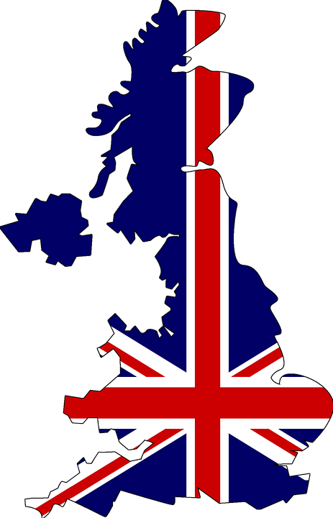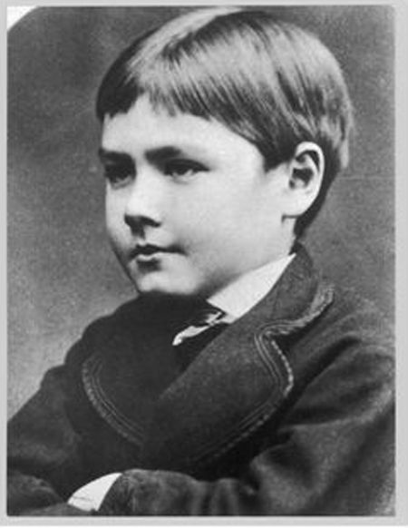

When Rudyard was six years old, his mother brought him from India to England and left him with a family he had never met before. The mother of the family and her 13 year-old son were abusive bullies. Rudyard was beaten and treated terribly by them. His life was so sad and hard in England that he only survived because of his amazing imagination and his love of reading books.

When Rudyard’s mother discovered the abuse, she rescued him and he was sent to a boarding school where he did very well. At 16 he graduated and moved back to India to live with his family. Coming home to India was one of the best feelings Rudyard ever had in his life.

***A way to describe Rudyard’s childhood in England is:***

**The Jungle Book**

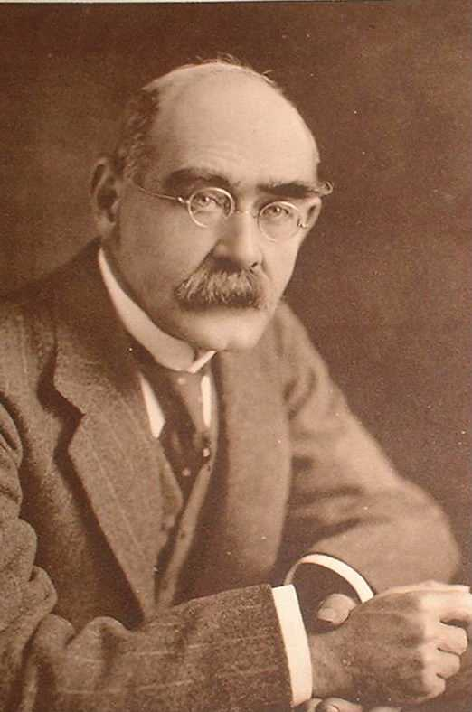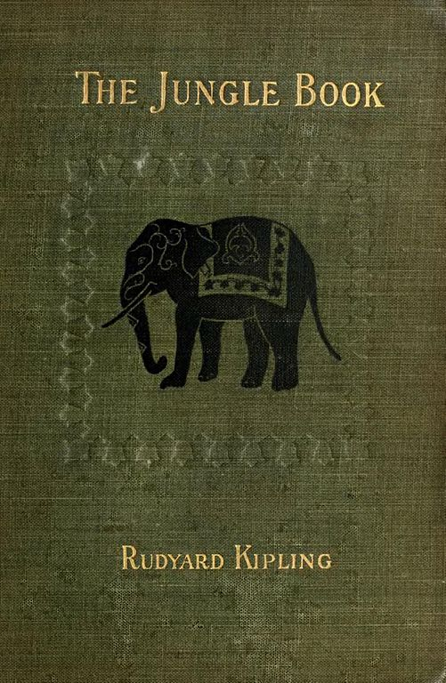

In 1892 Rudyard married an American woman named Carrie with whom he had three children. After their honeymoon in Japan, California, and Canada they moved together to Carrie’s birthplace, Brattleboro, Vermont in the United States. It was here, in 1894, that Rudyard transformed his childhood experiences In India into “The Jungle Book.”

The Jungle Book was a huge success around the world and it helped make Rudyard Kipling one of the most famous people who ever lived.

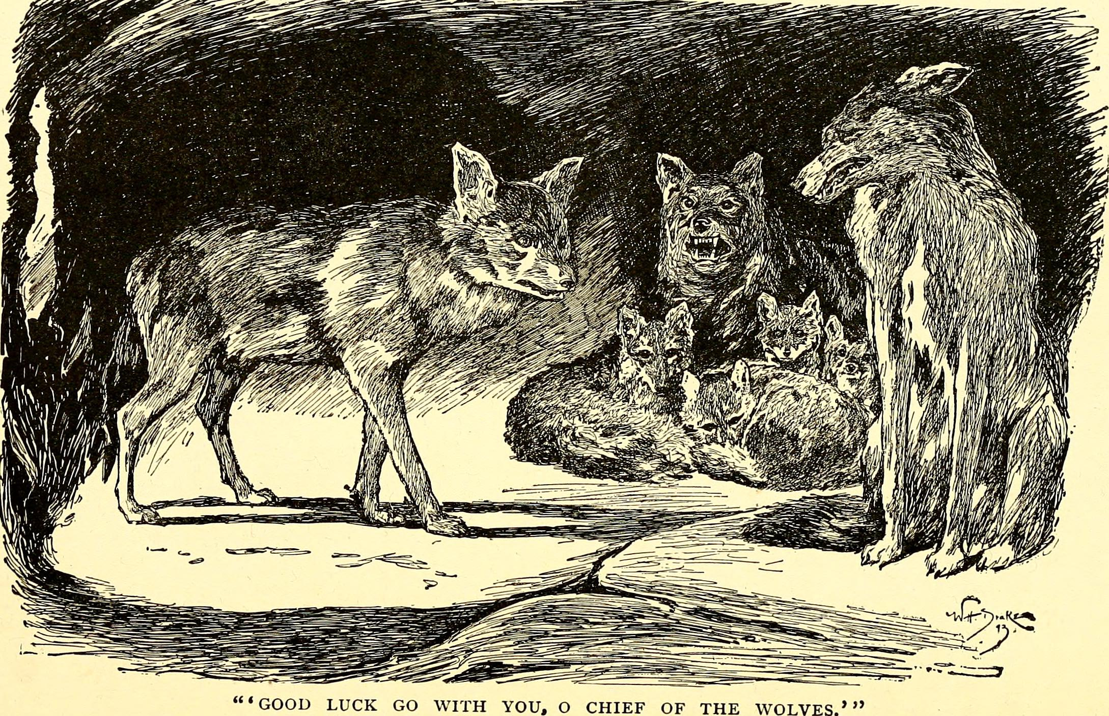

**Walt Disney’s Jungle Book**

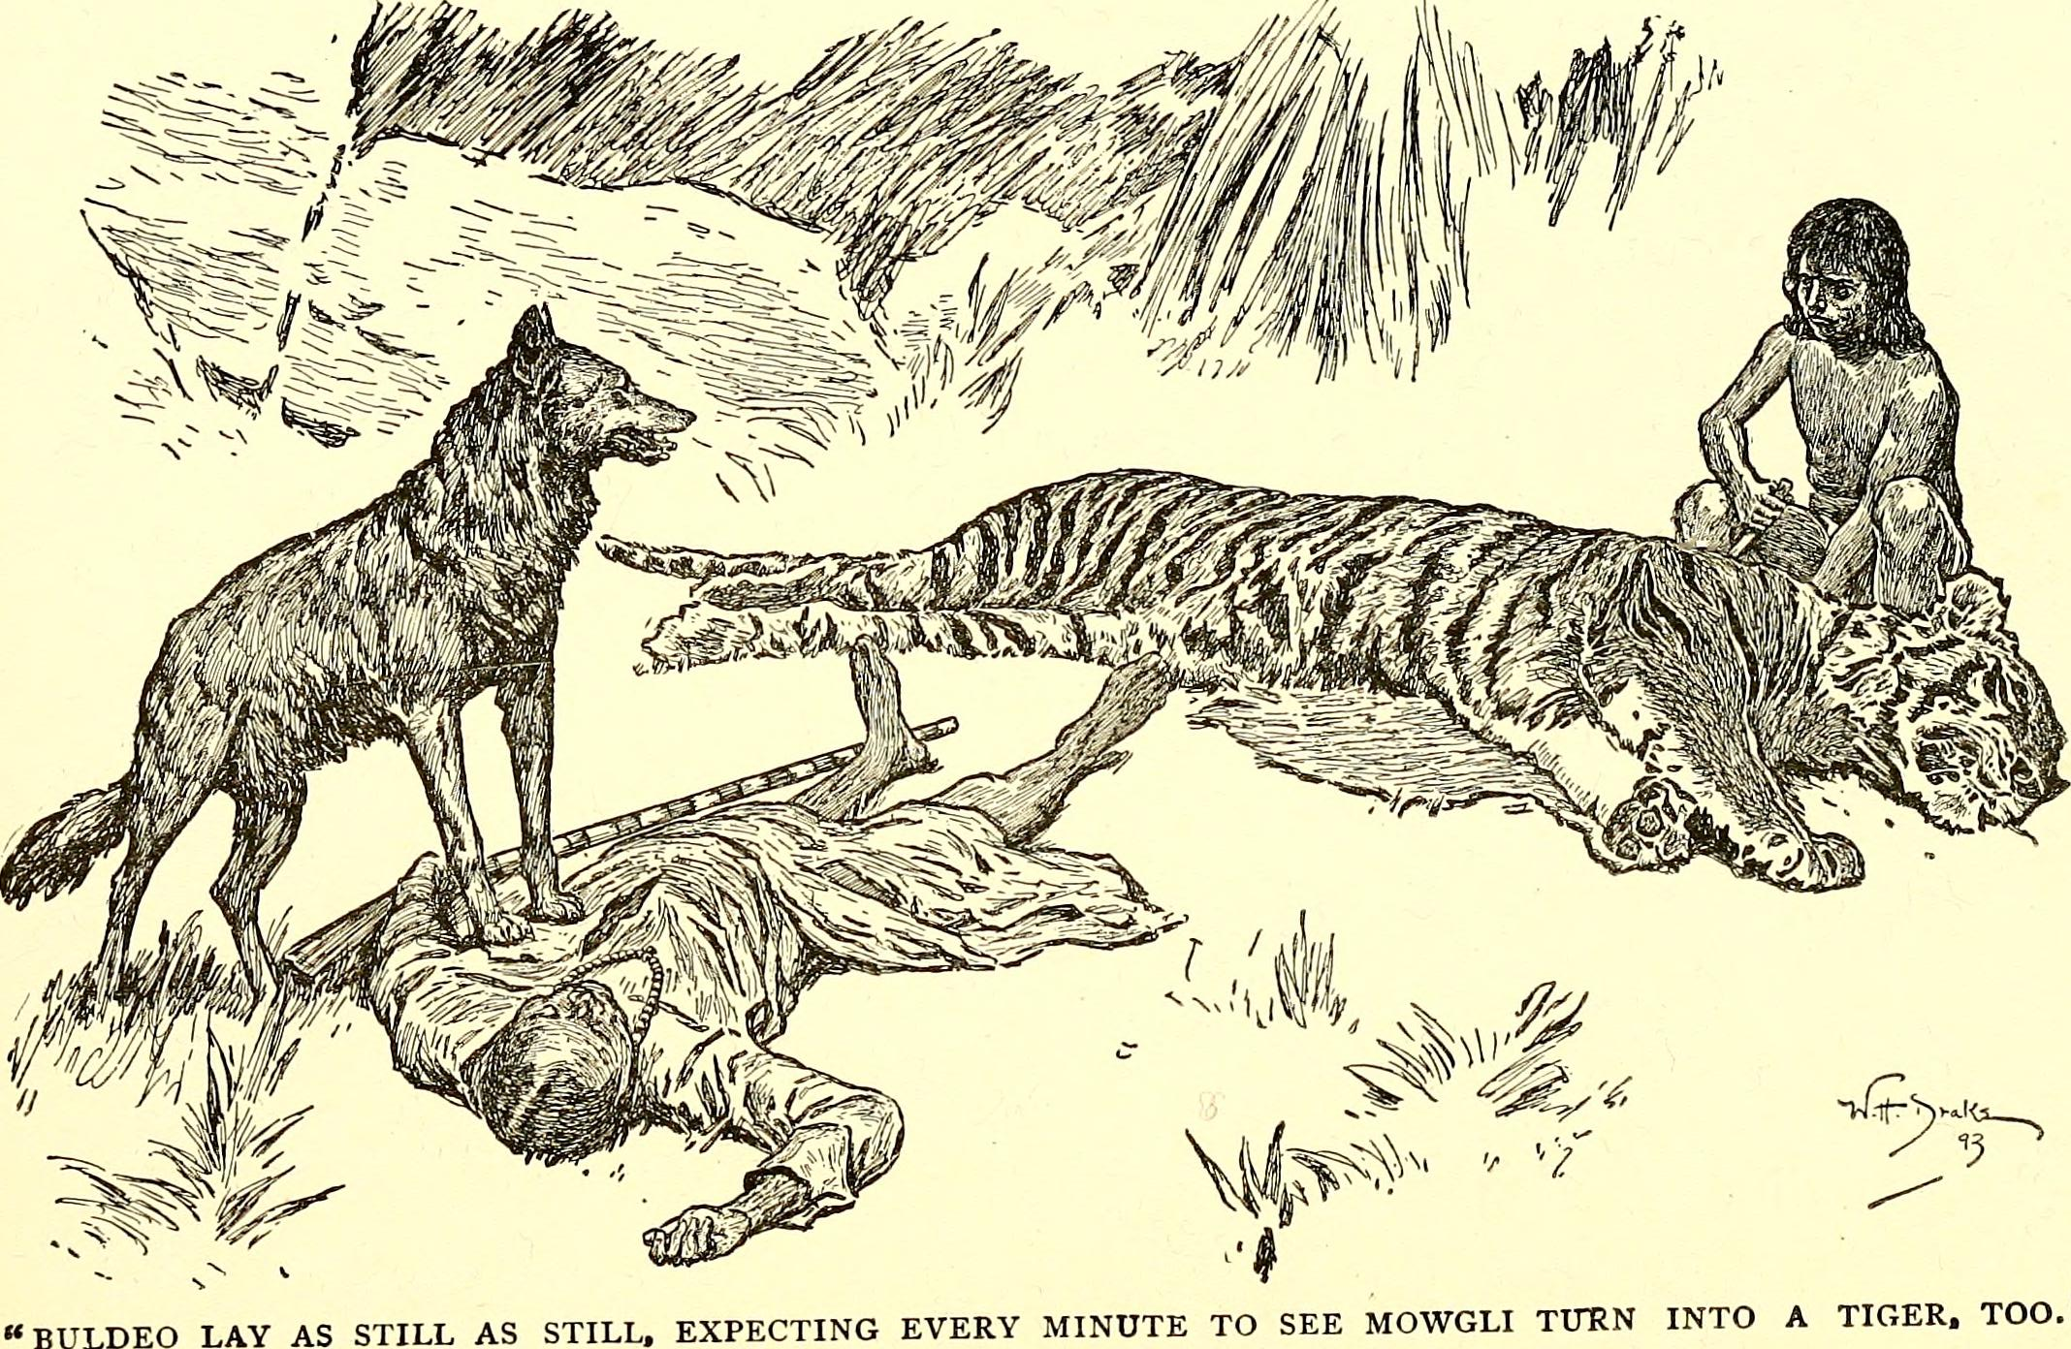

Rudyard Kipling died in 1936. Thirty-one years later, Walt Disney’s Jungle Book came out in movie theaters in 1967. Disney’s movie tells the story of Mowgli and his wolf family from the first thee chapters of Kipling’s Jungle Book.

Because copyrights used to expire after seventeen years, Walt Disney didn’t have to pay Rudyard Kipling’s family any money to turn his book into a film. Rudyard Kipling’s Jungle Book made more than a billion dollars for the Walt Disney Company and is considered one of the best loved children’s movies of all time.

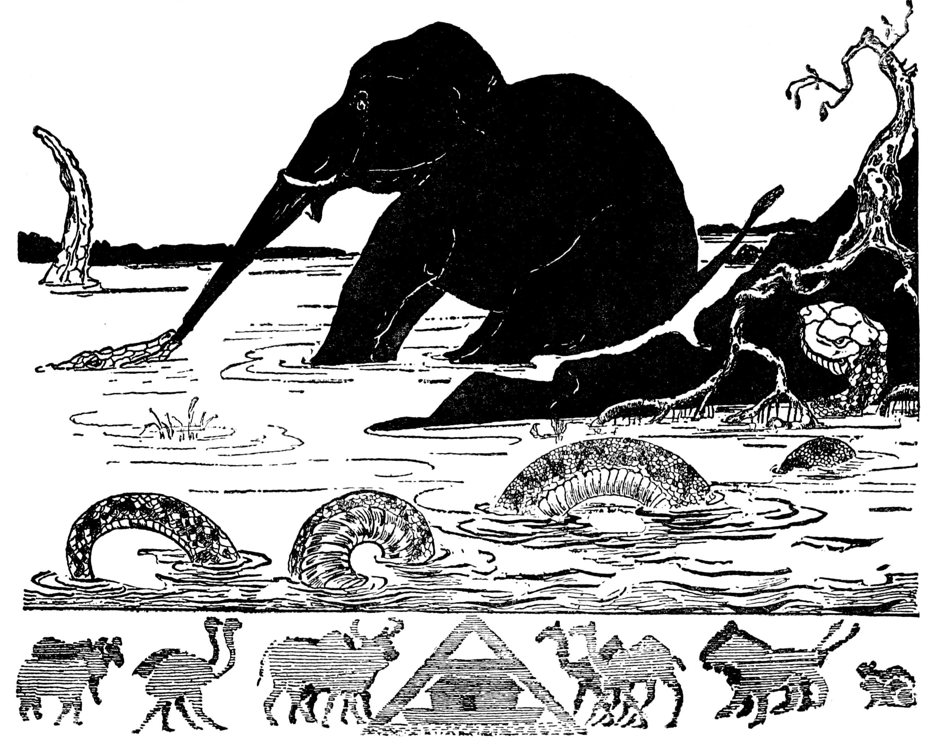

Source: https://www.biography.com/people/rudyard-kipling-9365581

***Kipling’s poem, “If” is the most famous poem in the English language.*** 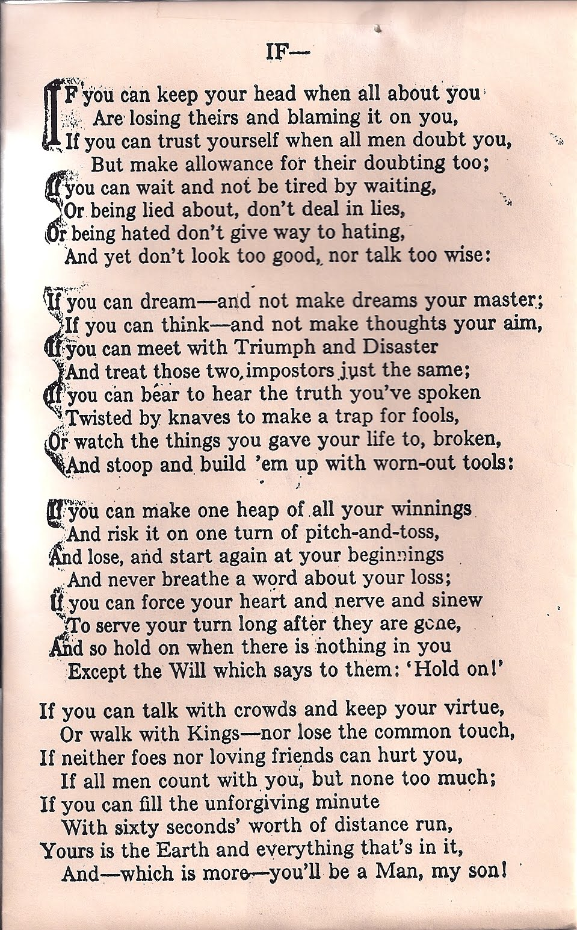

**D B N V P I K E L G N U J G F**

**T W O X R L B E W C N G J X K**

**S H Q O I V I O W T M E N T Y**

**E M G V K R I Y M Y X U T D K**

**I B R I R L R B R L R D D I R**

**N L E A R X I V T E V E T W W**

**O Z C R Y Y D Z N W H V L I J**

**L L C E I R P G V Y F E M B Z**

**O B M V A P L O G E M R J I H**

**C S R Y R A M P C N F M C I P**

**O H D I N G I E W S A O N P J**

**V U L D T Y I N D I A N Z G N**

**R Y N F Y I T C U D V T W V U**

**N B V F C U S K N J P L G U X**

**G X U A J E O H K I P L I N G**

**BOOK ENGLAND**

**BRITISH INDIA**

**CARRIE RUDYARD**

**COLONIES KIPLING**

**COPYRIGHT VERMONT**

**DISNEY EMPIRE**

**INDIA**

***Circle the correct answer:***

**Rudyard Kipling’s childhood in India was…**

**Very good Very bad Not sure**

**Rudyard Kipling’s childhood in England was…**

**Very good Very bad Not sure**

**What two things helped Rudyard survive his childhood in England?**

**Imagination Sports Books**

**When Rudyard and Carrie were married, they moved to…**

**Japan Vermont India**

**After the Jungle Book was published, Rudyard Kipling was…**

**Very famous a little famous Not famous**

**My favorite character in the Jungle book is…**

**­­­­­**

**Two words that describe my favorite character are…**