Hummus!

Hummus is a middle-eastern snack food.

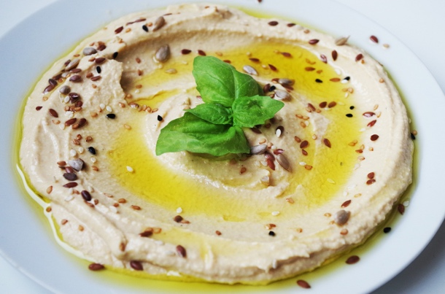

It is made by mashing chickpeas, lemon juice, garlic, and tahini (a sesame paste) together.

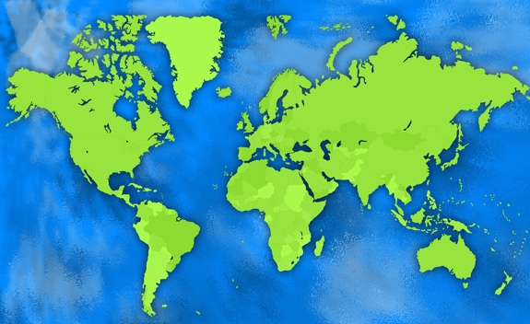

The Middle East is a part of the world between Asia and Africa. Some countries in the Middle East are neighbors, like Israel and Palestine, but they don’t always get along

.

Even though they don’t always get along, all countries in the Middle East consider hummus an important part of their diet. Hummus shows that even if we are different, we can always find common ground.

What is something you have in common with your neighbor? Write it in this bowl of hummus:

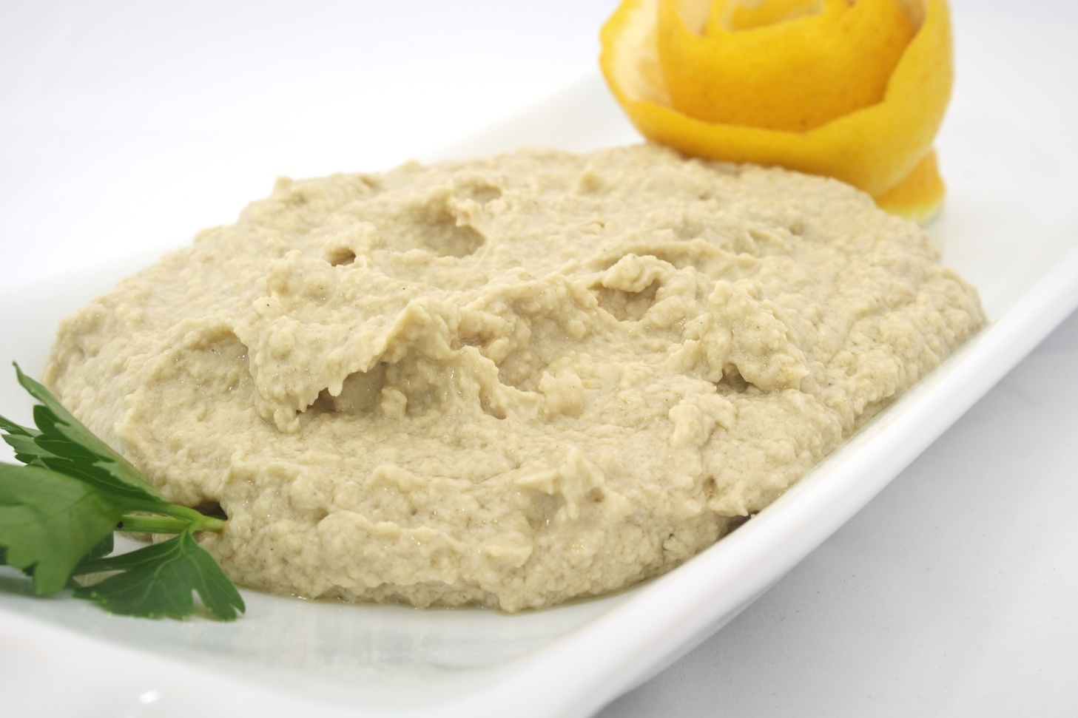

Homemade Hummus

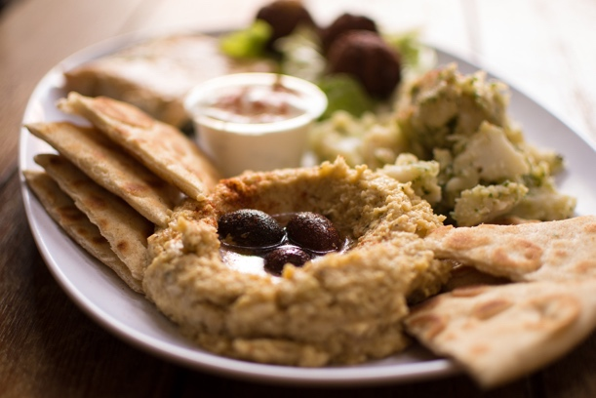

Ingredients:

* 1 can of chickpeas
* Lemon juice
* Garlic
* Olive Oil

To Make:

1. Add the chickpeas, lemon juice and garlic to a blender.

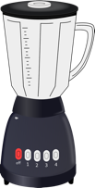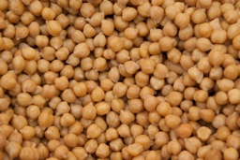

1. Blend!



1. Add olive oil until the hummus becomes smooth and creamy.



1. Enjoy with vegetables and crackers!