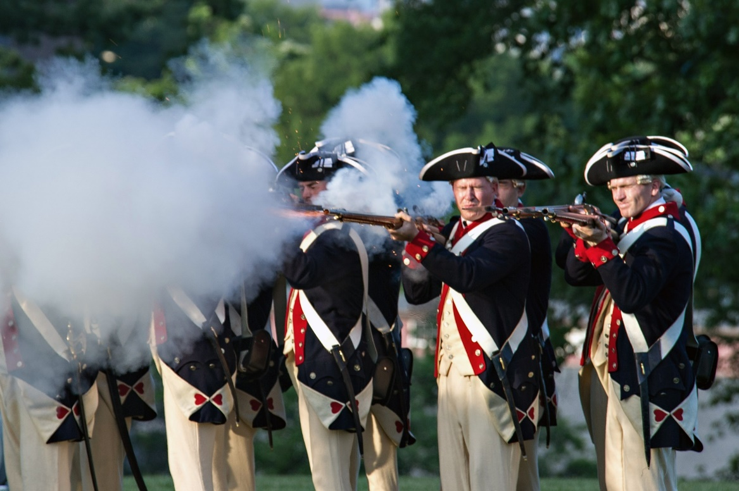
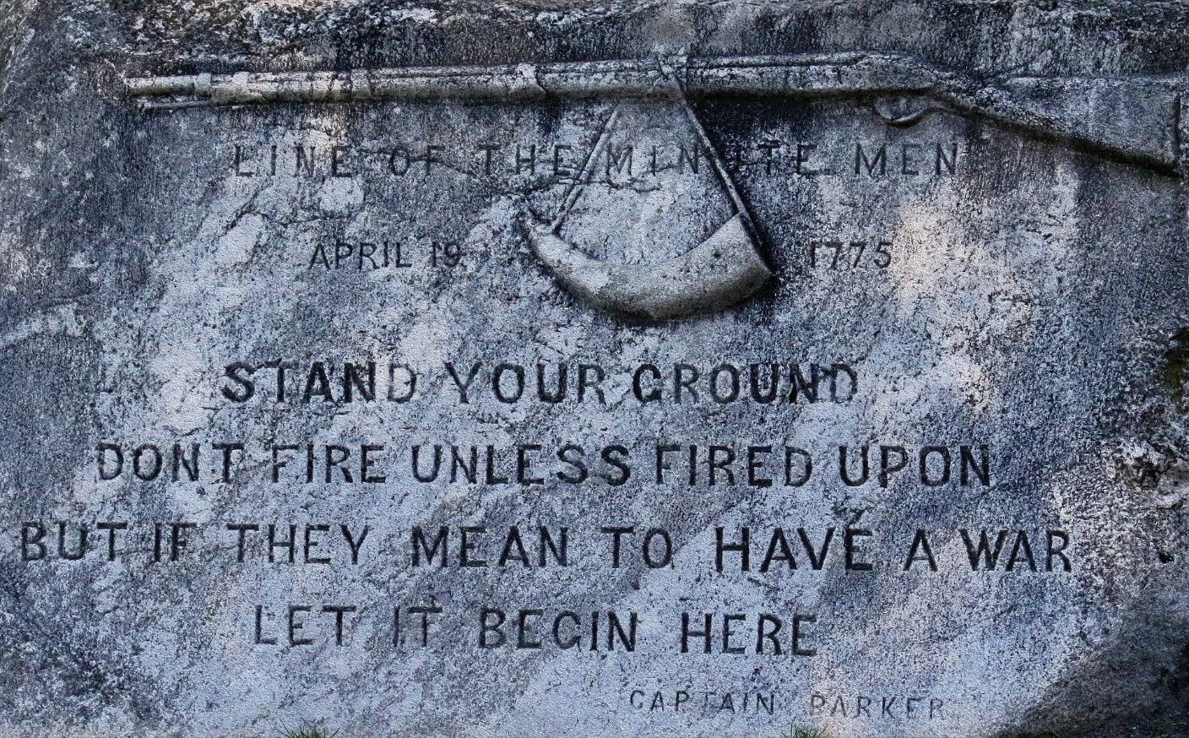
The First Shots of the Revolution were fired in 1775 at the Battles of Lexington and Concord

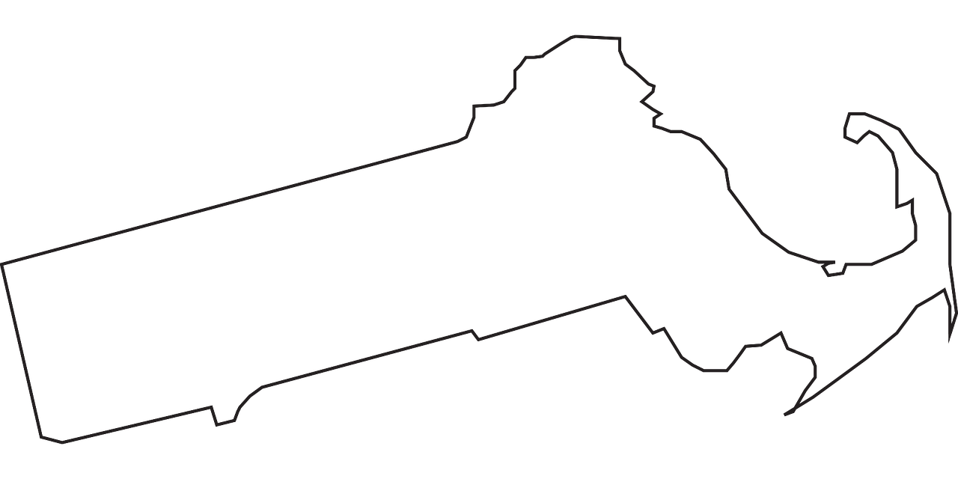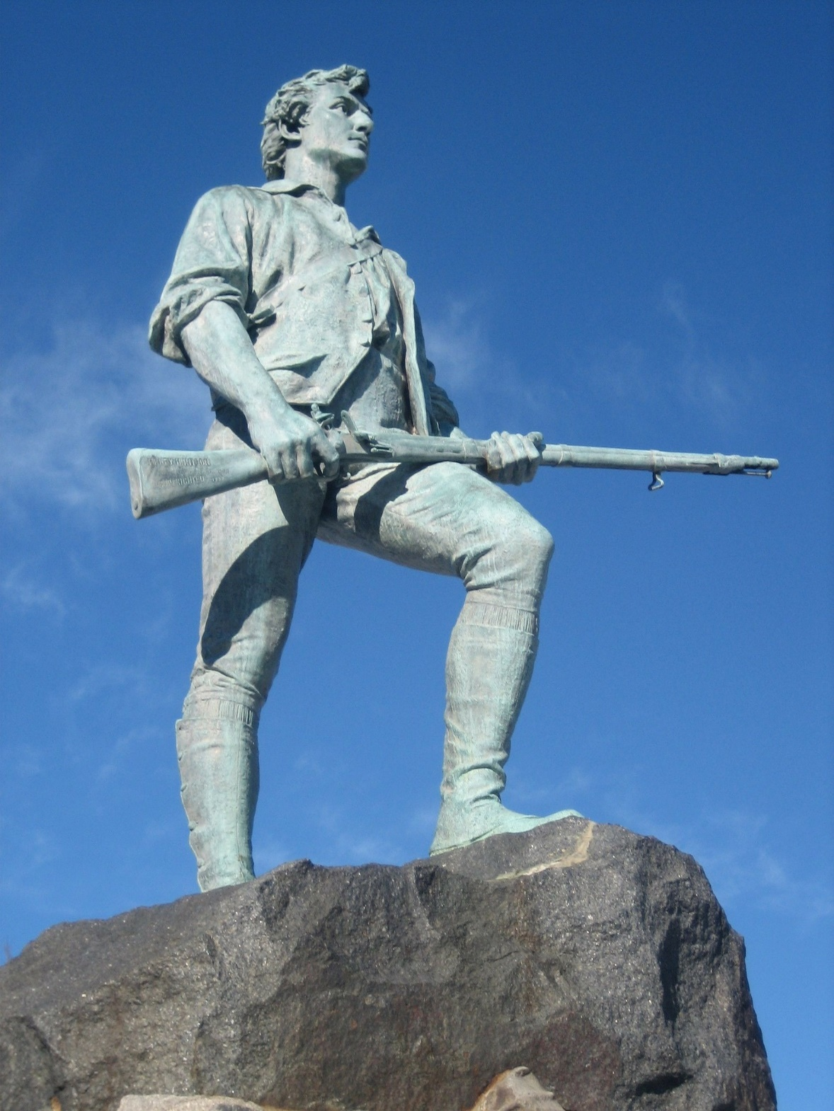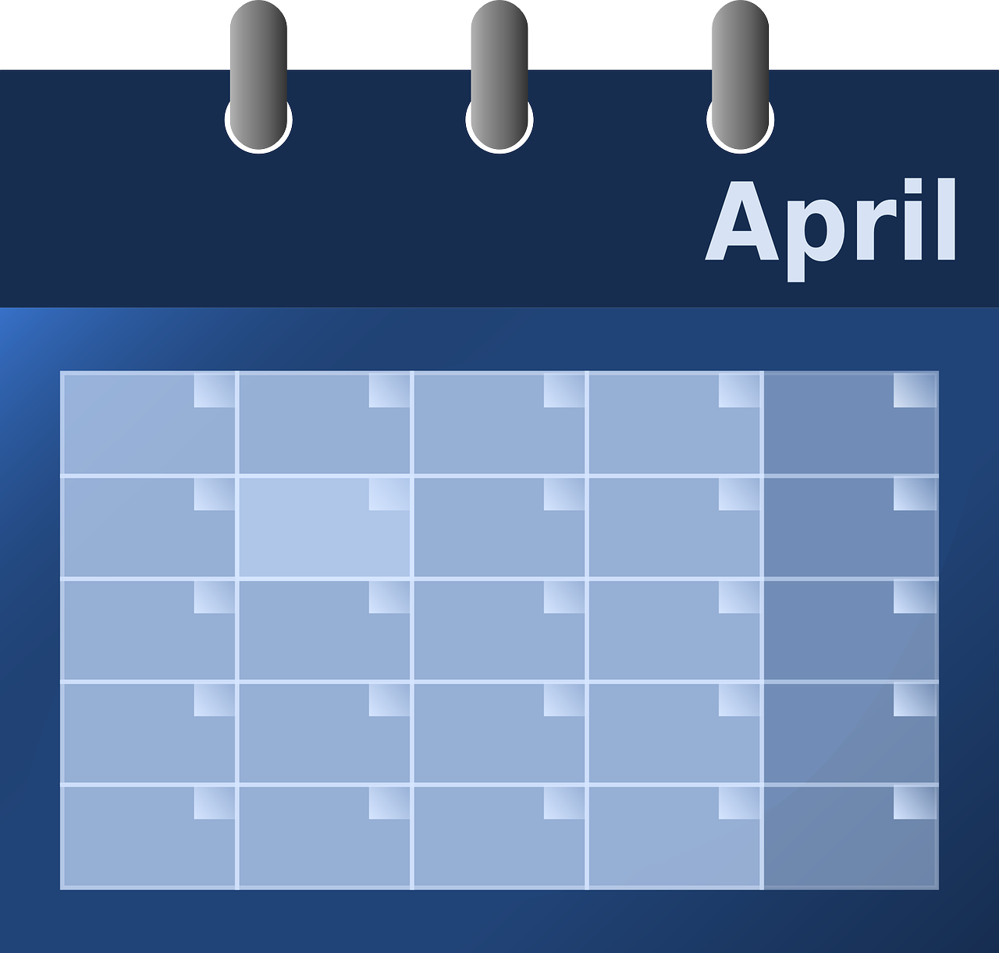
Massachusetts

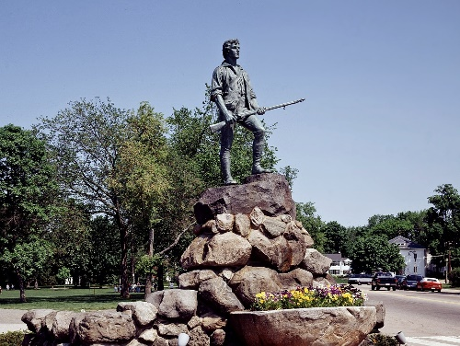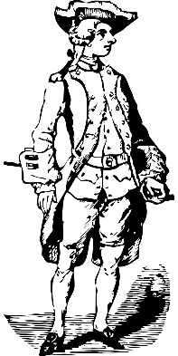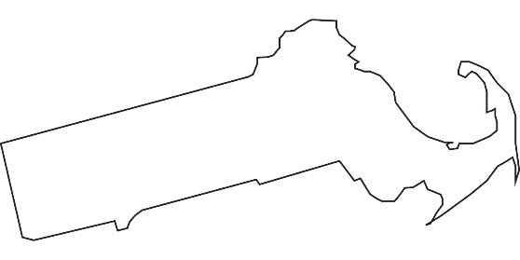
Massachusetts Bay Colony
Redcoat
Minuteman

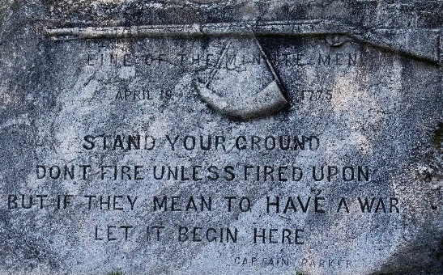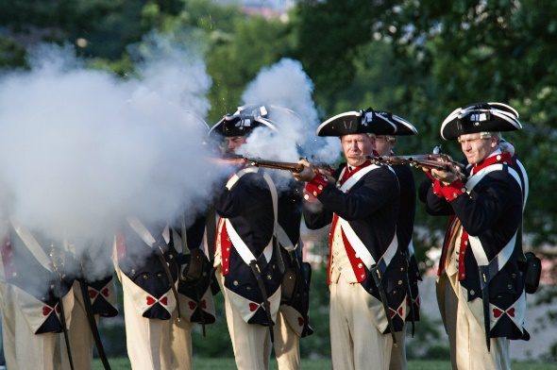

Lexington Green Shot Heard Round the World

“The Battle of Lexington Green”
Before the Revolutionary War, the USA did not exist. Massachusetts was called Massachusetts Bay Colony and it was ruled by the King of England. The Revolutionary War began on the morning of April 19, 1775. Nobody knows who fired the first shot, but the instant that either a Massachusetts soldier, called a Minuteman, or a British soldier, called a Redcoat, fired the “Shot Heard Round the World” was the beginning of the Battle of Lexington Green, the first Battle of the Revolutionary War.

“The Battle of Lexington Green”

Before the Revolutionary War, the USA did not exist.
Massachusetts was called ____________________
________________________________ and it was
ruled by the King of England. The Revolutionary War
began on the morning of __________________
_________ Nobody knows who fired the first shot,
but the instant that either a Massachusetts soldier,
called a ______________________________, or a
British soldier, called a _____________________,
fired the ___________________________________
_____________________ was the beginning of the
Battle of
___________________________________, the first
Battle of the Revolutionary War.

WORD BANK

Minuteman Shot Heard Round the World
Lexington Green Massachusetts Bay Colony
April 19, 1775 Redcoat

