**History of Halloween**

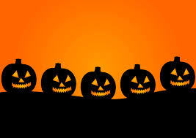

Have you ever wondered why we celebrate **Halloween** on **October 31** every year?

The story of Halloween begins more than 2,000 years ago with the **Celtic** people, called Celts, of Ireland, Scotland, England and France. They celebrated their **New Year** the day after October 31, on **November 1**. This was the time after the summer’s harvest was over and before the cold dark winter began.

***The date we celebrate Halloween is… _____________________________________***

***The date the Celts celebrated New Year’s was… _____________________________________***

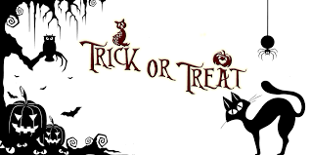

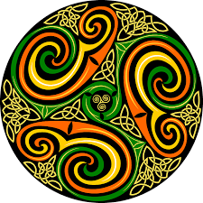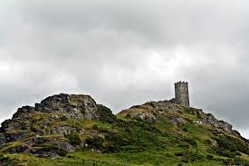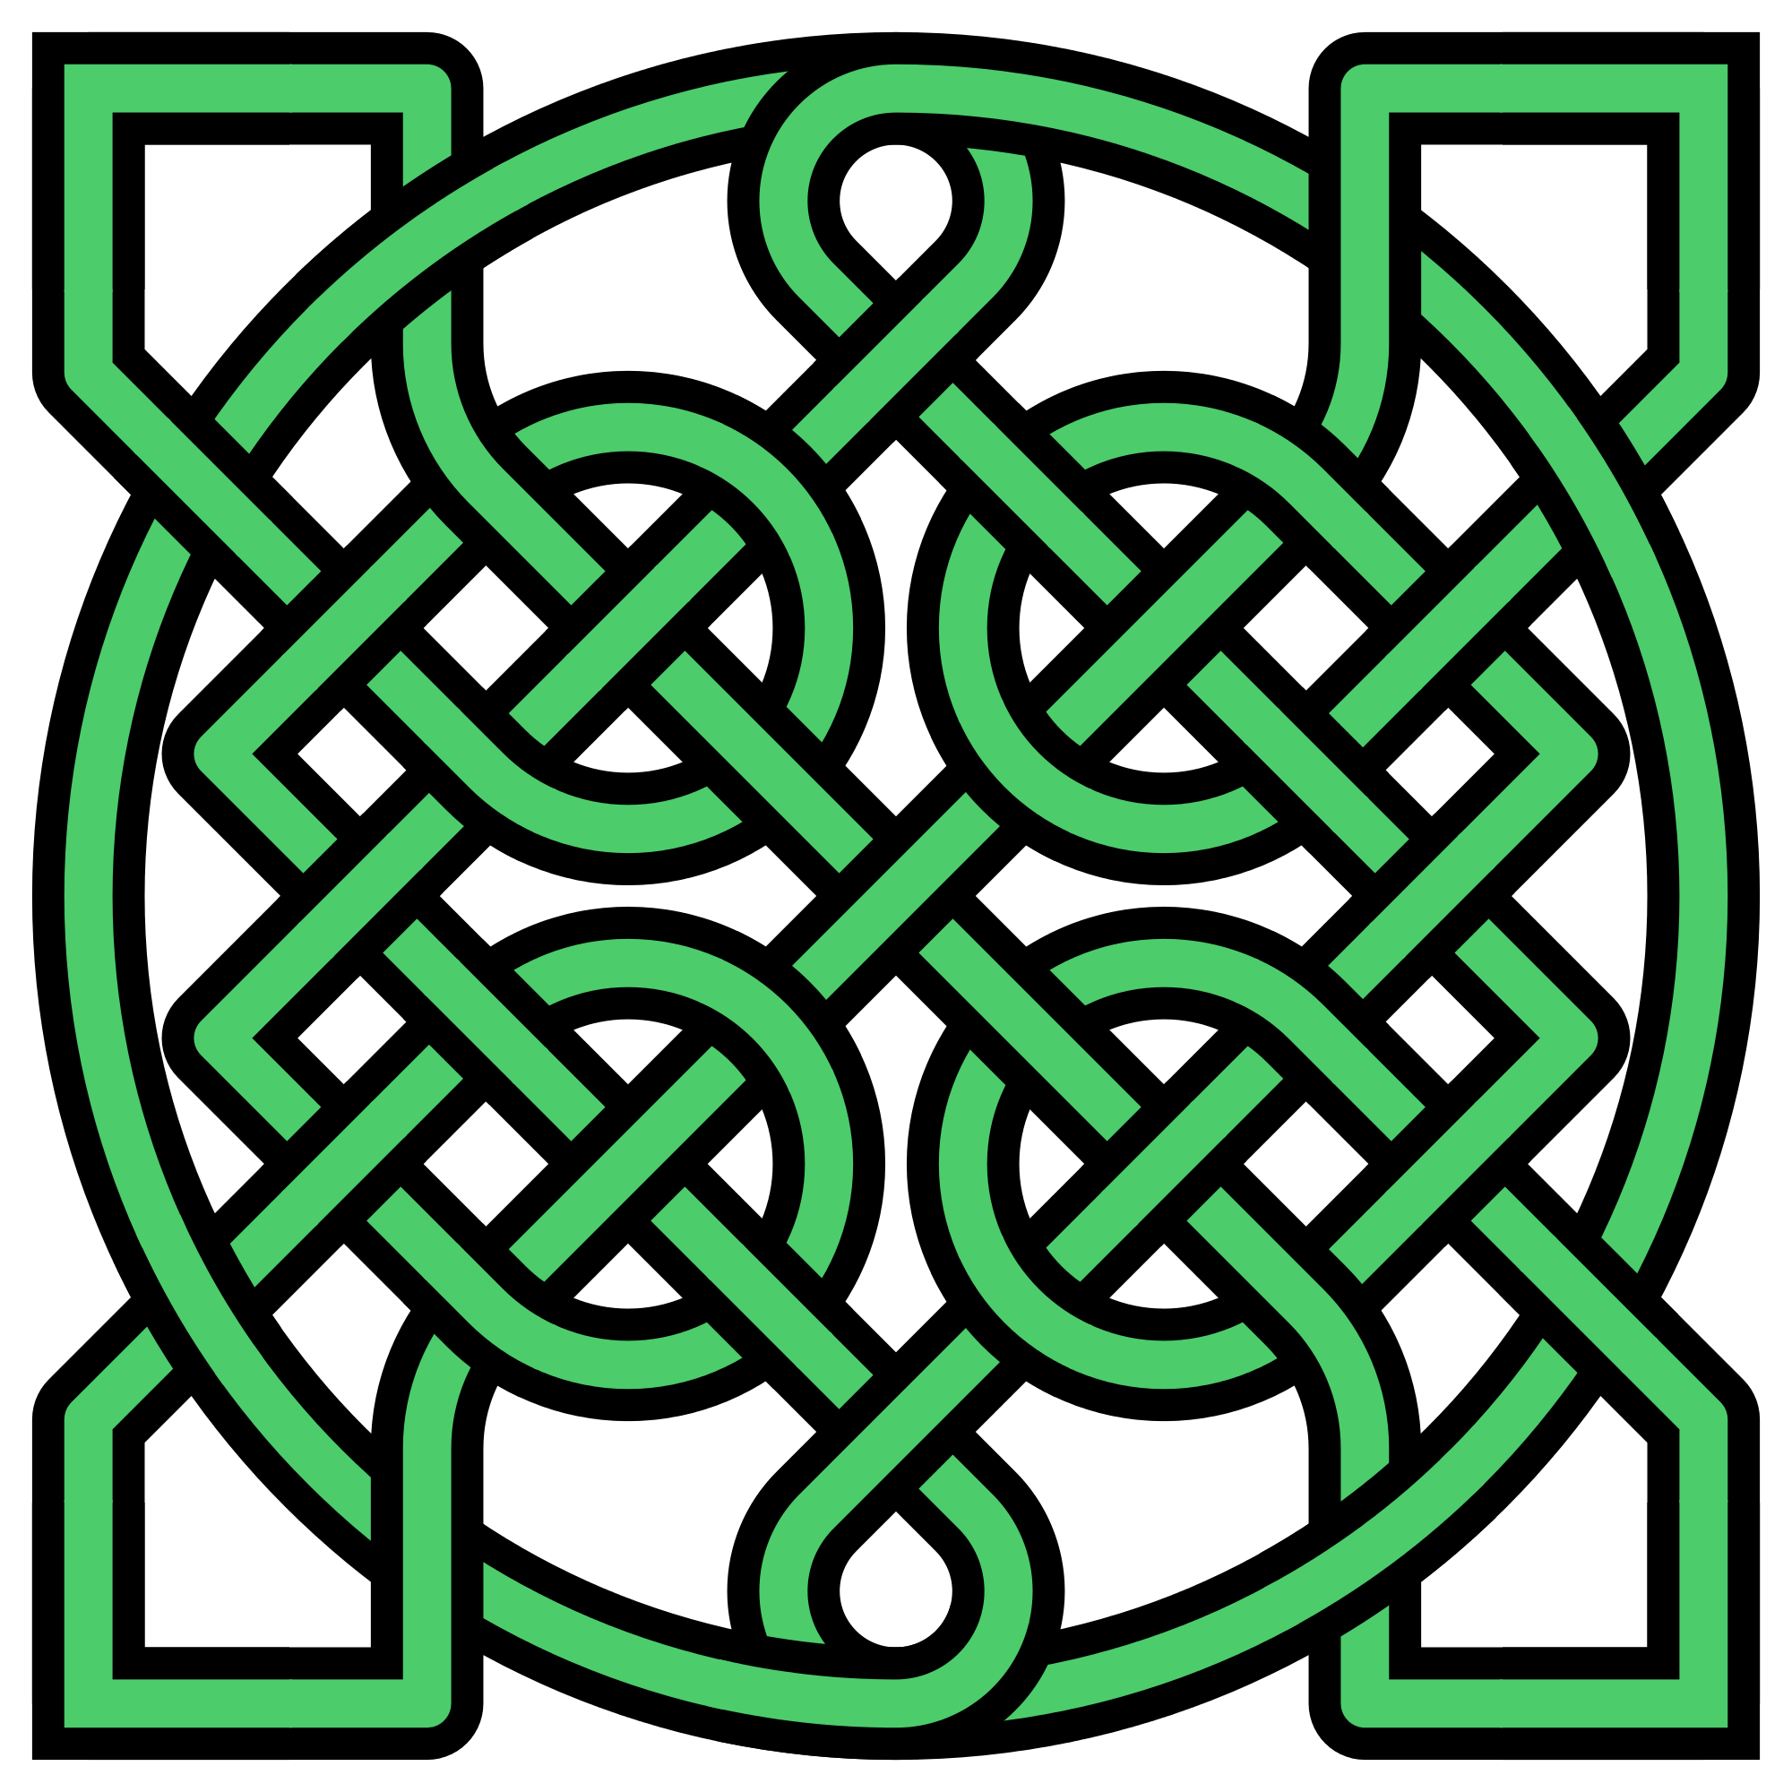

The Celts believed that the day before their new year, October 31, was a time where the line between living people and their dead ancestors became fuzzy and unclear. On the night of October 31 they celebrated **Samhain** (pronounced Sew-In). On the night of Samhain the Celts believed that the ghosts of the dead returned to Earth. For the Celtic people, this was a night of **real life magic** and mystery.

On the night of Samhain Celts built giant sacred fires, dressed up as animals, and believed that holy priests called **Druids** could see into the future. At the end of the celebration they would bring a torch from the fire back to their homes to light the fireplaces they used for cooking. This was done for good luck and to protect their families in the new year.

*The Celtic night of the dead is called.. ______________*

*Celtic priests were called… ________________*

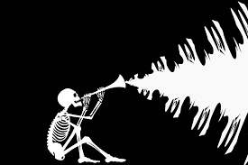

When people love a holiday, it is very hard to take it away. After the Romans conquered the Celtic lands they combined two of their own holidays with Samhain. The Romans knew that Samhain was so popular and important to the Celts, that they couldn’t get rid of it completely.

Hundreds of years later, the Catholic church used the same strategy and created “All Souls Day” on November 1 to celebrate the souls of the Christian dead. In Celtic lands, the church just combined their new holiday celebration with the ancient festival of Samhain. That way, everyone was happy. All Saints Day was also called All Hallows Day and the night before was called Hallow’s Eve. In time, Hallow’s Eve became known as Halloween.

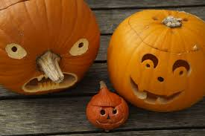

Source: <http://www.history.com/topics/halloween/history-of-halloween>

I celebrated Halloween when I was young.

Yes No Not Sure

I think Halloween is a little scary.

Yes No Not Sure

I still celebrate Halloween every year.

Yes No Not Sure

I will wear a Halloween costume this year.

Yes No Not Sure

If “Yes”, my costume this year is…

________________________________________

My favorite Halloween Costume I ever wore was…

________________________________________

My favorite candy to get on Halloween is called…

________________________________________

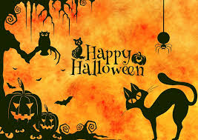

**History of Halloween**

N I A H M A S N E J L C H L U

D R U A I G O V X W R U A L N

R A E Y G V E W M C C Y L A O

Y E K B E Q O Z N B W T L Q C

Q E R M O A C O Z O E H O D E

Q W B I O T C E L T I C W R U

V E I B F R C L N E W J E U Q

R X H H M U A O Y W L P E I W

G D L A Y H O P C O O C N D R

E Z G B A G L Q Y Z C I J V S

H I D O D S D F D M Y G T W P

C H A B I H O Q Y R P T Y Y X

I R Q O L S Z U S R J D W T W

M P J T O C H V L Z W Y M N Q

I D F Y H S P R N S F N V N A

**ALL CELTIC**

**DRUID EVE**

**FIRE HALLOW**

**HALLOWEEN HOLIDAY**

**MAGIC NEW**

**NOVEMBER OCTOBER**

**SAMHAIN SOULS**

**YEAR**

