**NAME: ______________________________________________ Date: ___________________________**

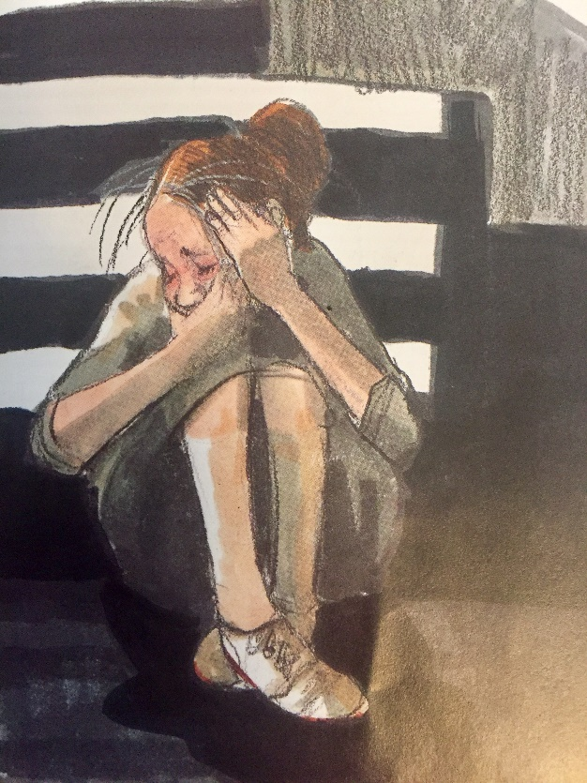

*photo taken from *Thank You Mr. Falker* by Patricia Polacco

**NAME: ______________________________________________ Date: ___________________________**

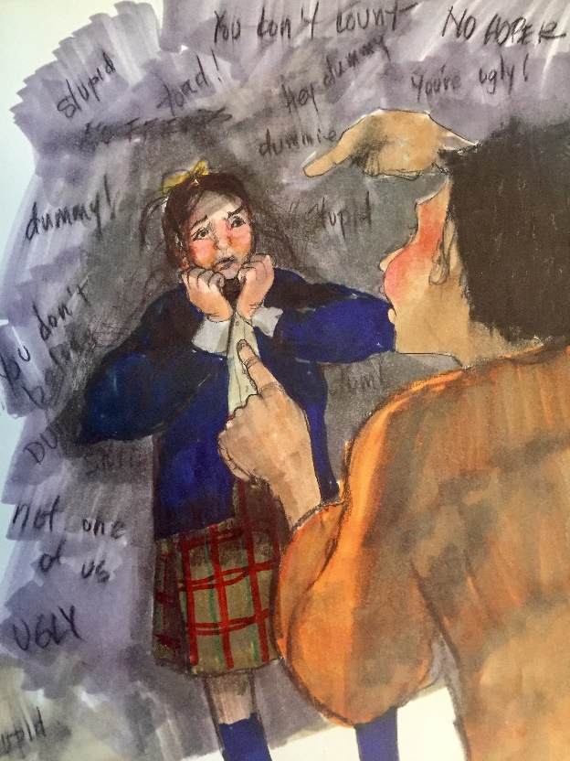

*photo taken from *Thank You Mr. Falker* by Patricia Polacco

**NAME: ______________________________________________ Date: ___________________________**

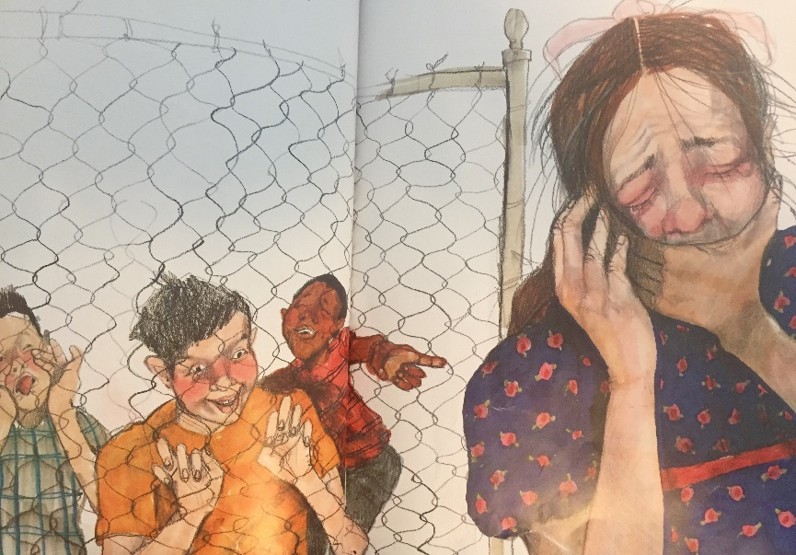

*photo taken from *Thank You Mr. Falker* by Patricia Polacco

**NAME: ______________________________________________ Date: ___________________________**

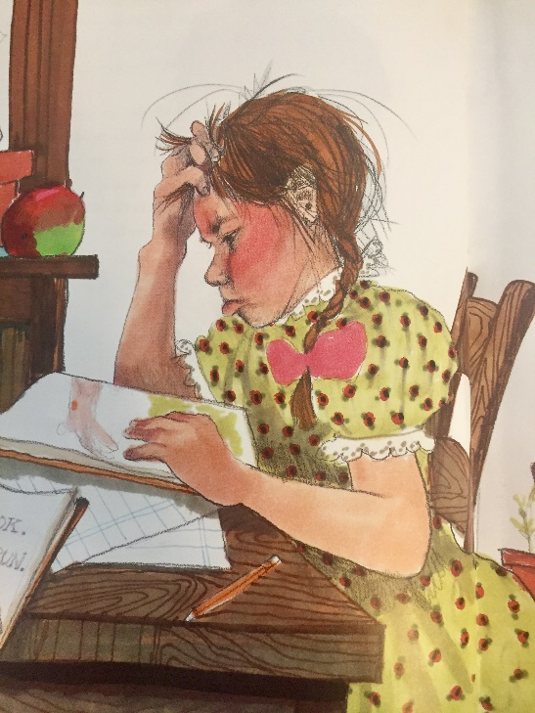

*photo taken from *Thank You Mr. Falker* by Patricia Polacco

NAME: ____________________________Date: ___________________________

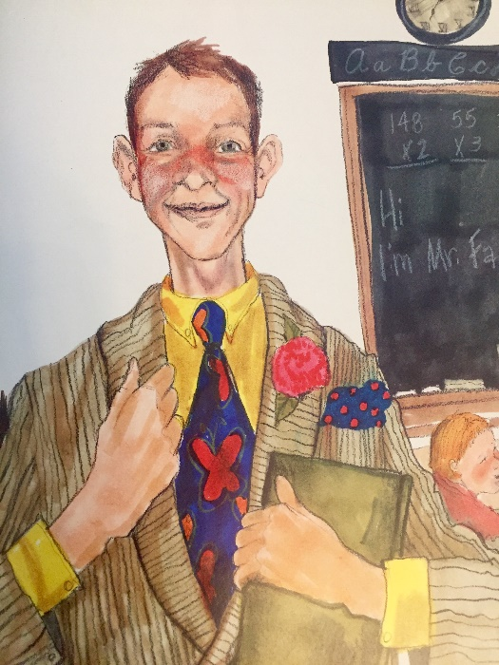

*photo taken from *Thank You Mr. Falker* by Patricia Polacco

Which teacher inspired or inspires you the most (makes you want) to be your best self?

What are the qualities in this person that made you be your best self?

___________________________________________________________________

If you could see this teacher today, what would you say?

Would you like to write this teacher on a different day?

* Yes
* No
* Maybe
* Not sure

**Draw an image of what your inspiring teacher/person looked/looks like—Remember that representational drawing isn’t needed. One can always imagine this teacher/person in symbols, shapes, colors, fun lines, etc.**



