We like to present our best selves to the world. Part of this means being kind, generous and happy.

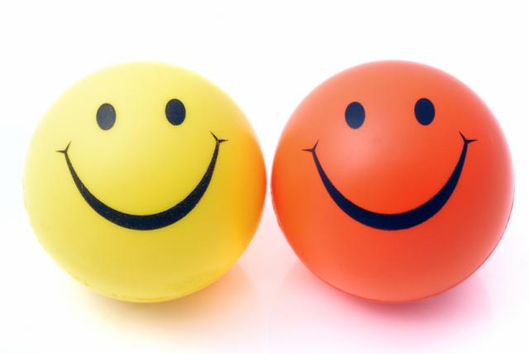

______, you are one of the most kind, generous and happy people I know.

Insert photo of __________ here

Another thing that helps us be our best selves is creating routines. Routines are things we do in a special order.

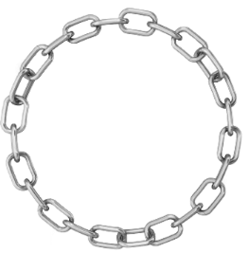

**There are some routines that we do every day, like:**

Showering 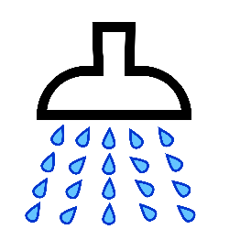

Getting Dressed 

**There are some routines that we do twice a day, like:**

Brushing our teeth 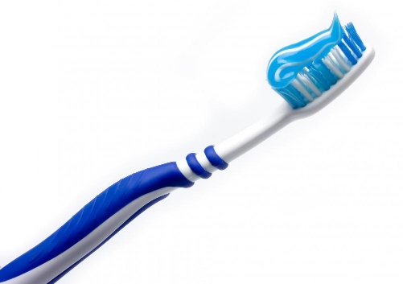

Sometimes, we need to do things throughout the day to help stay clean and fresh. This is why you brush your teeth at 3LPlace every morning. Having healthy teeth is important for a full life. Routines are something we can build in as a skill, just like brushing your teeth.

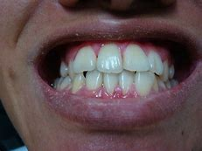

**Deodorant** helps with body odor. Everyone I know uses deodorant. **Deodorant** is also important for a full life. Let’s start a routine to put on deodorant every day.

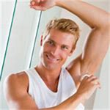

**Here is the routine:**

Every afternoon at ______, I will put on deodorant in the bathroom with ________’s help. If I do not want _______’s help and would like to put on my deodorant independently, I can say, ‘independent’ or ‘do it myself’

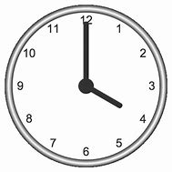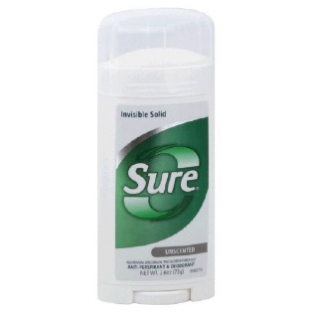

So, _________, will you try out this routine? Check 1 box.

YES NO

At the drugstore today, let’s choose one stick of deodorant for you to buy. Here are 3 choices. Circle the choice you want:

