**The New Balance Story**

**Rewritten by Meghan Montgomery**

**Source taken from** https://en.wikipedia.org/wiki/New_Balance

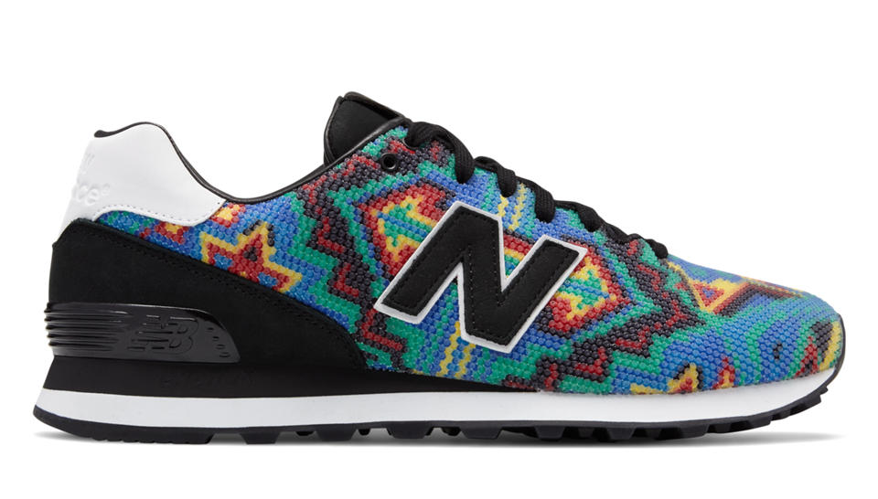

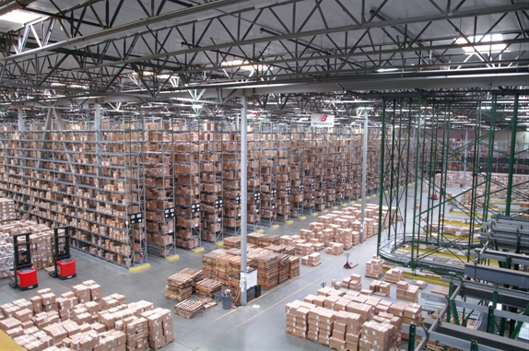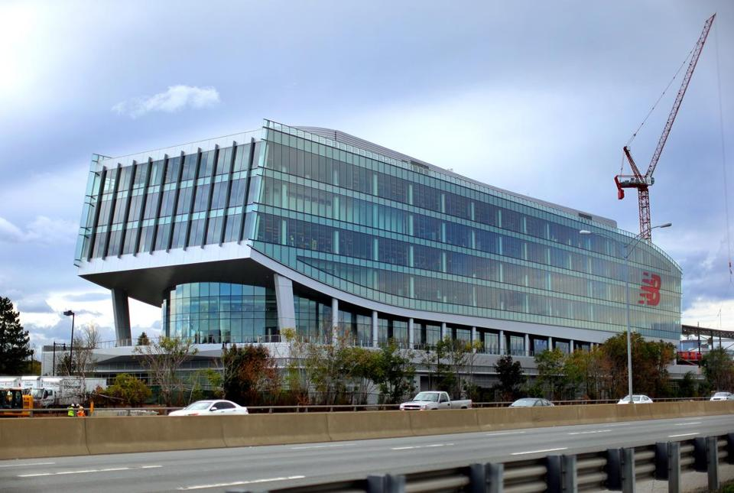

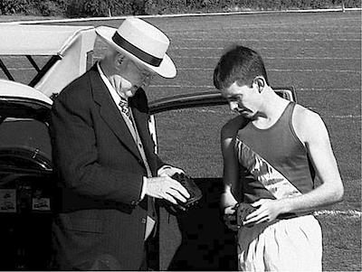

In 1906, William J. Riley—who came from England, founded the **New Balance Arch Support Company** in Brighton, MA**.** In the beginning, they made supports for shoes so that shoes would fit and feel better. One support was called an “Arch Support”. This particular support was designed with three support points. This idea came from a chicken’s foot, which has 3-prongs, which create strong balance for chickens. William J. Riley, thought that his designs would create better balance, similar to chickens, which led to the name of his company, **New Balance.**

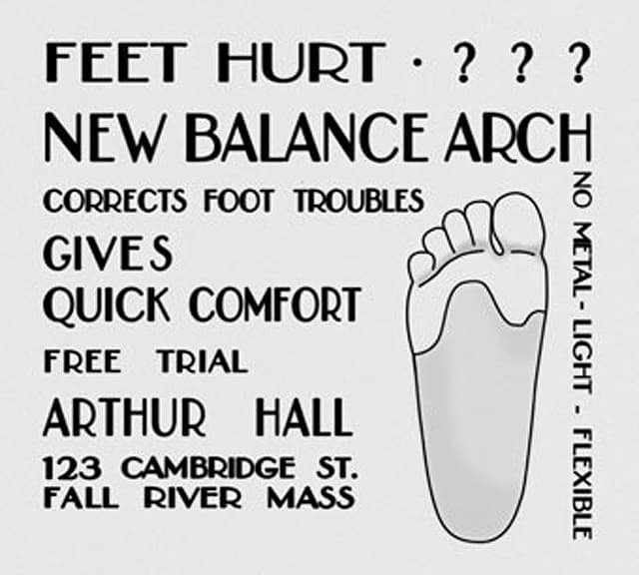

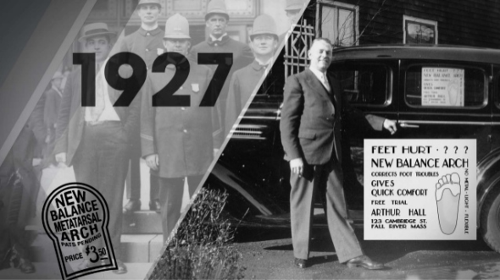

In 1927, William J. Riley hired Arthur Hall to be a salesman. In 1934, Arthur Hall became a business partner and focused his work energy on people whose jobs required them to stand on their feet for long periods of time. In 1956, Arthur Hall sold the business to his daughter Eleanor and husband Paul Kidd.

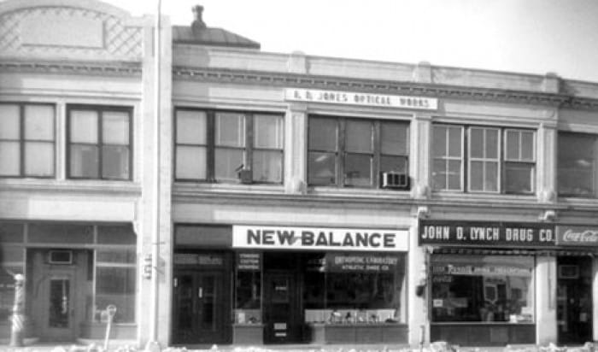

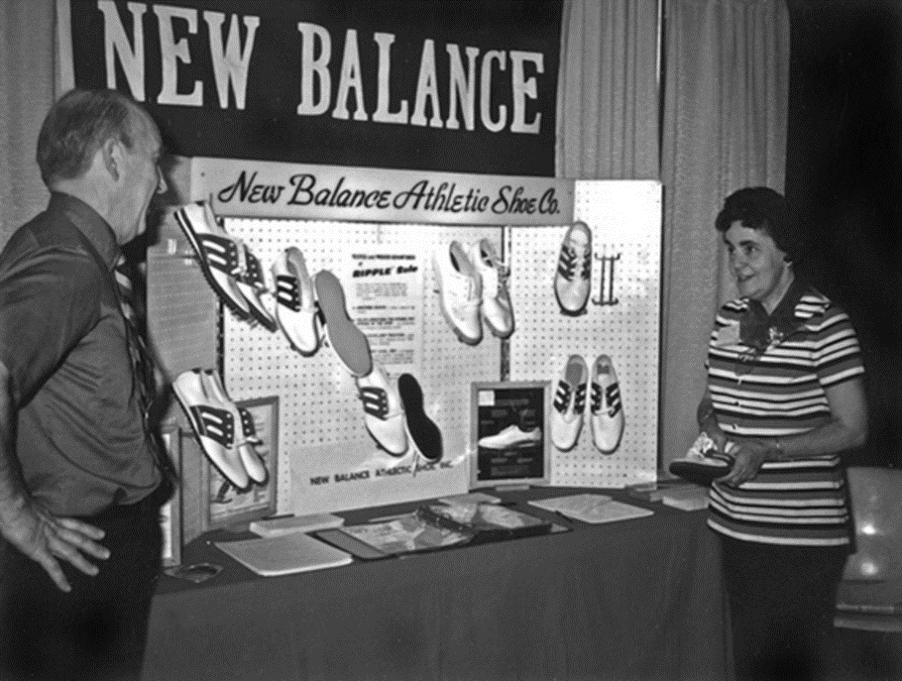

Eleanor and Paul Kidd continued to sell arch supports until 1960 when they designed a running shoe, which they called the **“Trackster.”** This was the world’s first running shoe with a ripple sole and also the first running shoe that came in a variety of widths (narrow, medium, wide, extra wide). The YMCA and running teams such as MIT, Tufts, and BU adopted the **“Trackster”** as their team shoe! Many other colleges and universities followed suit!

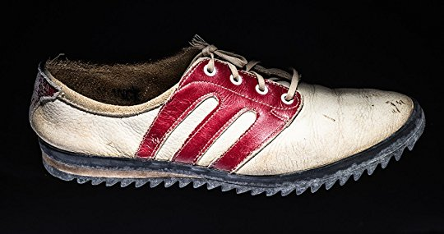 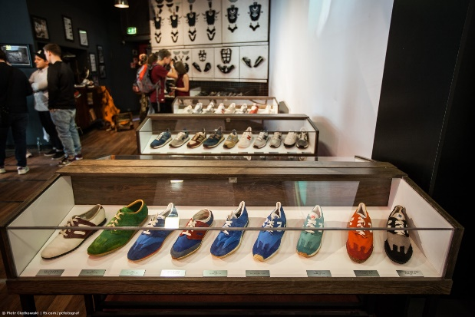

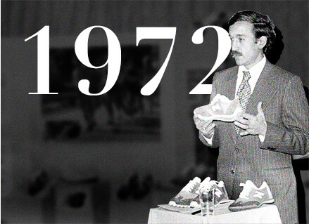

In 1972, Jim Davis (a current chairman at that time) bought the New Balance Company on Boston’s Marathon Monday! At the time, the company consisted of 6 people making 30 pairs of shoes daily and selling products mostly through mail-order with a few stores. Jim’s wife Anne joined the company in 1978 and focused on building a distinct New Balance business culture for its employees and customers.

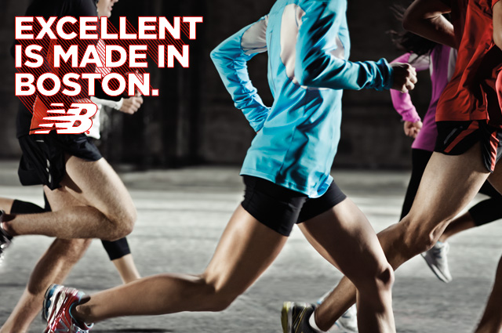

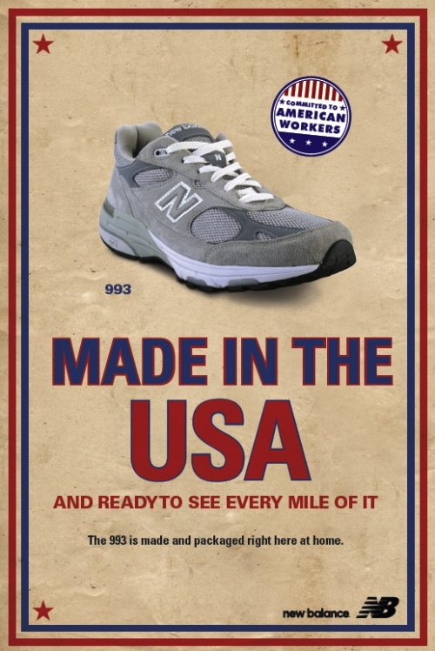 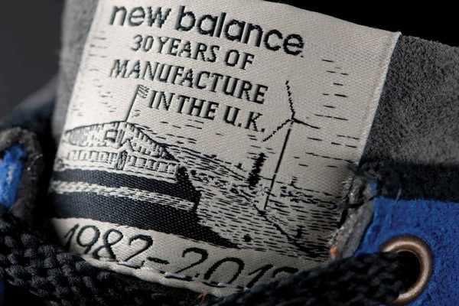

The timing of New Balances 1970s business boom was perfect! The US was ready to run and soon after the world was too! New Balance continued to thrive in the 70s and 80s becoming a shoe store staple. Soon after the Davis’ expanded to a global company.

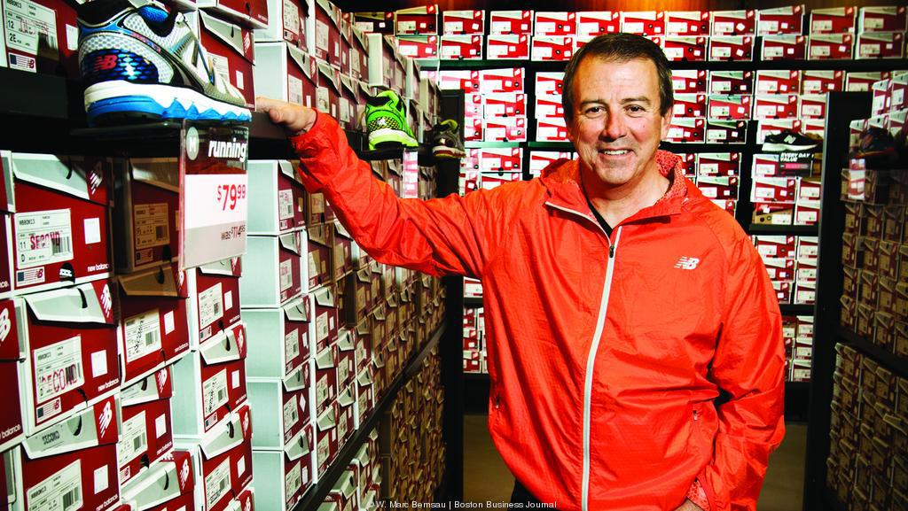 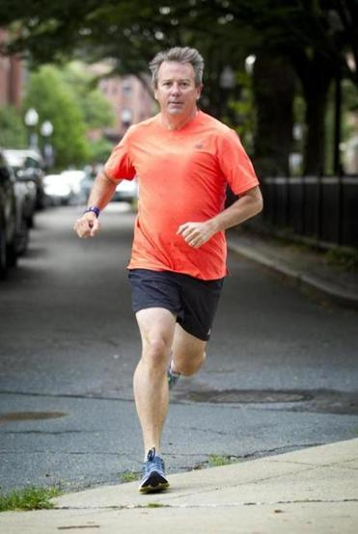

Rob DeMartini, an avid runner, joined New Balance in 2007 and currently runs the company! He continues to grow the market and spread the word about comfy and supportive shoes for all. Go NB!

**“GOODNESS OF FIT GUIDE”**WHAT TO LOOK FOR WHEN TRYING ON A SHOE!

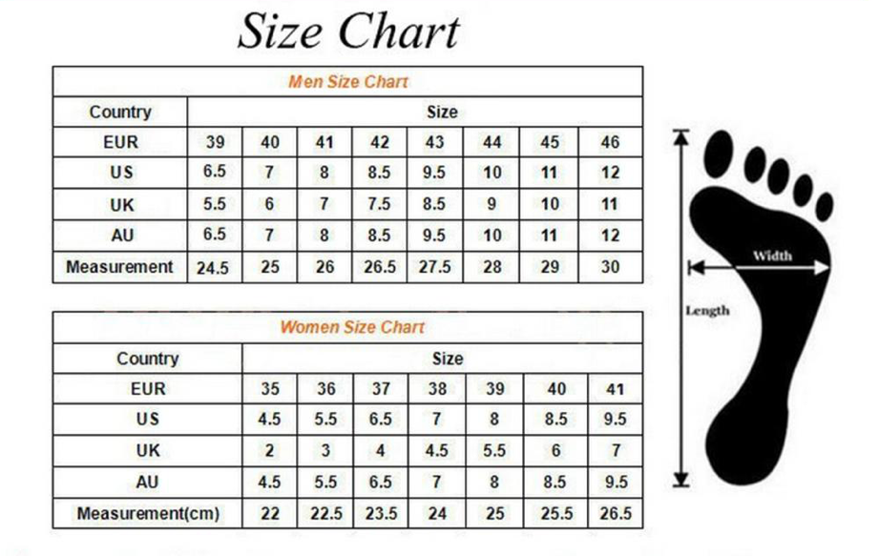

**SIZE—**How long is your foot from top to bottom?

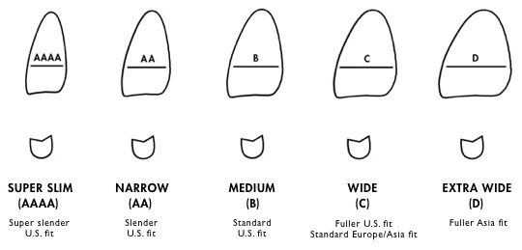

**WIDTH**—How wide is your foot from side to side?

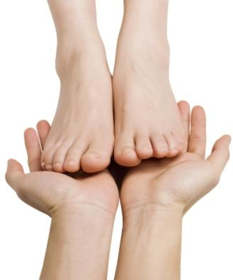

**COMFORT—**How comfortable is the shoe you are trying on?

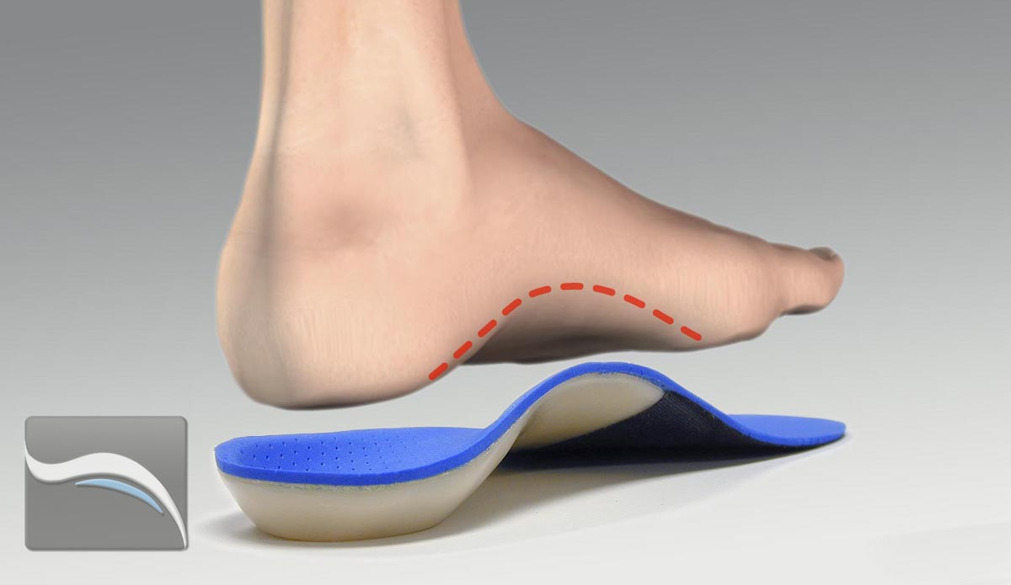

**ARCH SUPPORT**—How high or low is your arch? Is it supported?

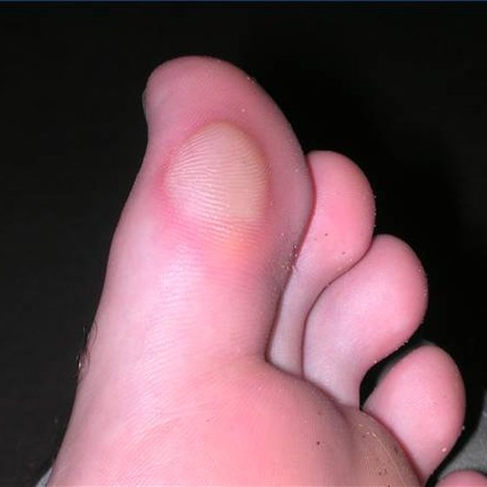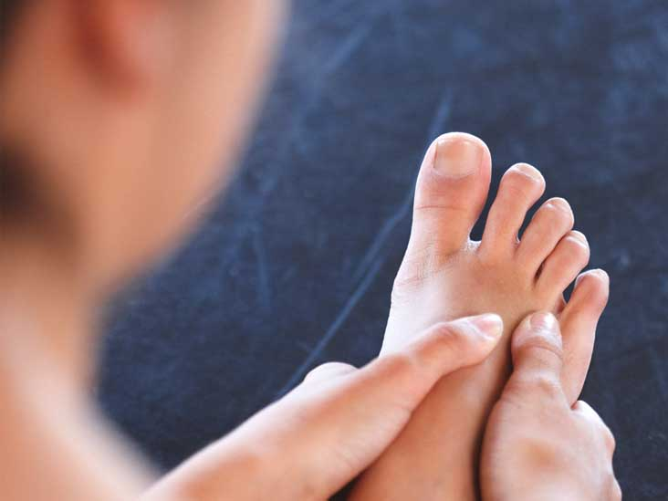

**UNCOMFORTABLE**—BUMPING OR HURTING ANYWHERE—IF

YOU ARE SAYING, “OUCH” FROM THE START, IT’S A BAD FIT!

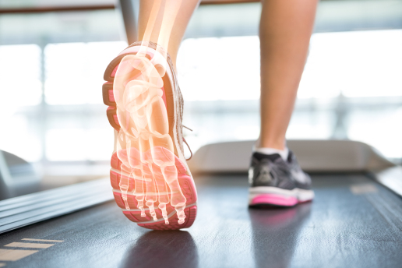

**SUPPORT**—How safe does your foot feel in your shoe?

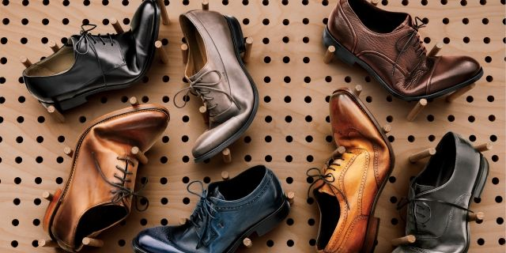

**FLEXIBILITY**—Do your shoes feel soft or stiff or in between? Which do you prefer?

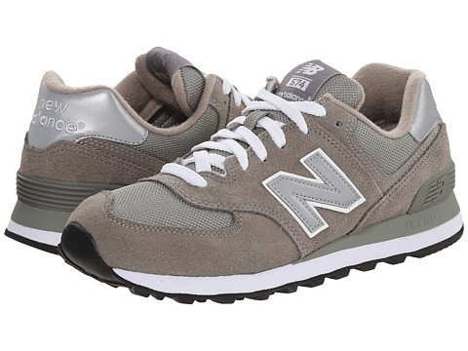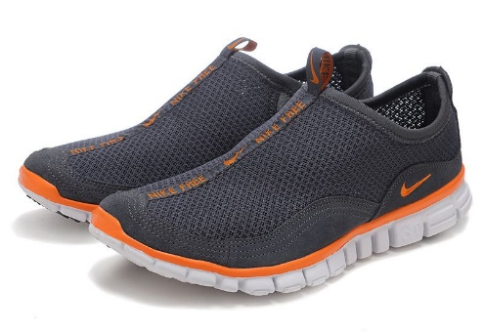

**LACES, LACE FREE, OR ADAPTIVE LACES**—How’s your fine motor and/or your patience for laces?

**ALL ABOUT OUR SHOES and FEET!**

Answer the following questions below…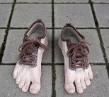

1. 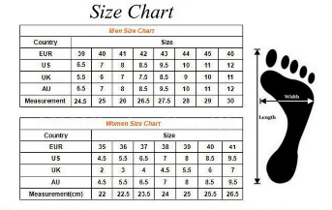**Let’s look inside your shoe?** Size #:________
2. 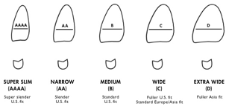 **Are your shoes**

* Wide
* Narrow
* Medium

1. **Do your shoes feel** (Circle One)

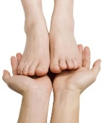 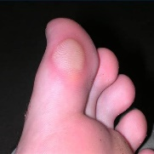

comfortable uncomfortable

1. **Do you shoes feel supportive—as in, do your feet, legs and body feel safe and stabile in your shoes?** ______________

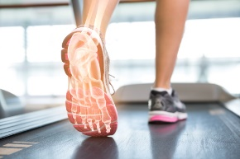

1. **Do you like**

* Soft and flexible shoes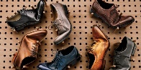
* Stiff shoes 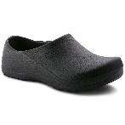
* In between—not too soft, not too stiff

1. **I prefer**

* Shoes with laces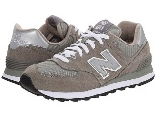
* Slip on shoes without laces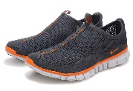
* Shoes with adaptive laces that I don’t need to worry about



1. **Did you choose your shoes?**

* Yes
* No
* Not sure

1. **Do you like the way your shoes look?**

* Yes
* No
* Not sure

1. **Are your treads worn or rough?**

* Worn Out
* Fresh
* Normal

**FINAL QUESTION FOR NOW….DO YOU THINK YOU NEED NEW SHOES? WHY?** _______________________________________

____________________________________________________

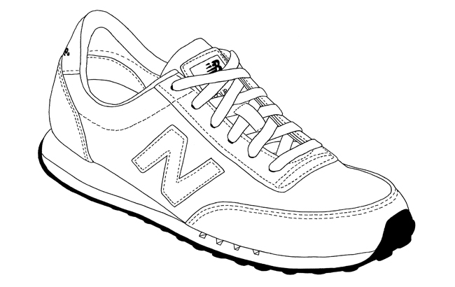

Design your own New Balance Sneaker—

Add any colors, patterns and designs to your sneaker!

What’s the name and number of your shoe?

**New Balance Model #:** ________________________ **Sneaker name**________________________