Flexible Thinking Social Script
by Rachel S



Life is not always simple. When we feel happy, we may smile. When we feel sad, we may frown. But not all feelings are happy and sad. Sometimes we can’t name how we feel.


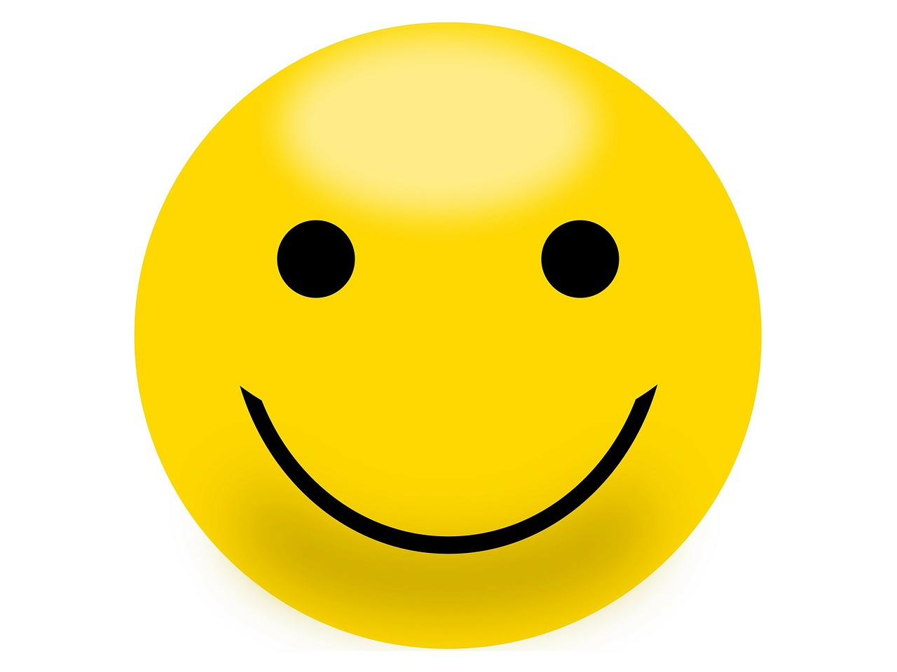

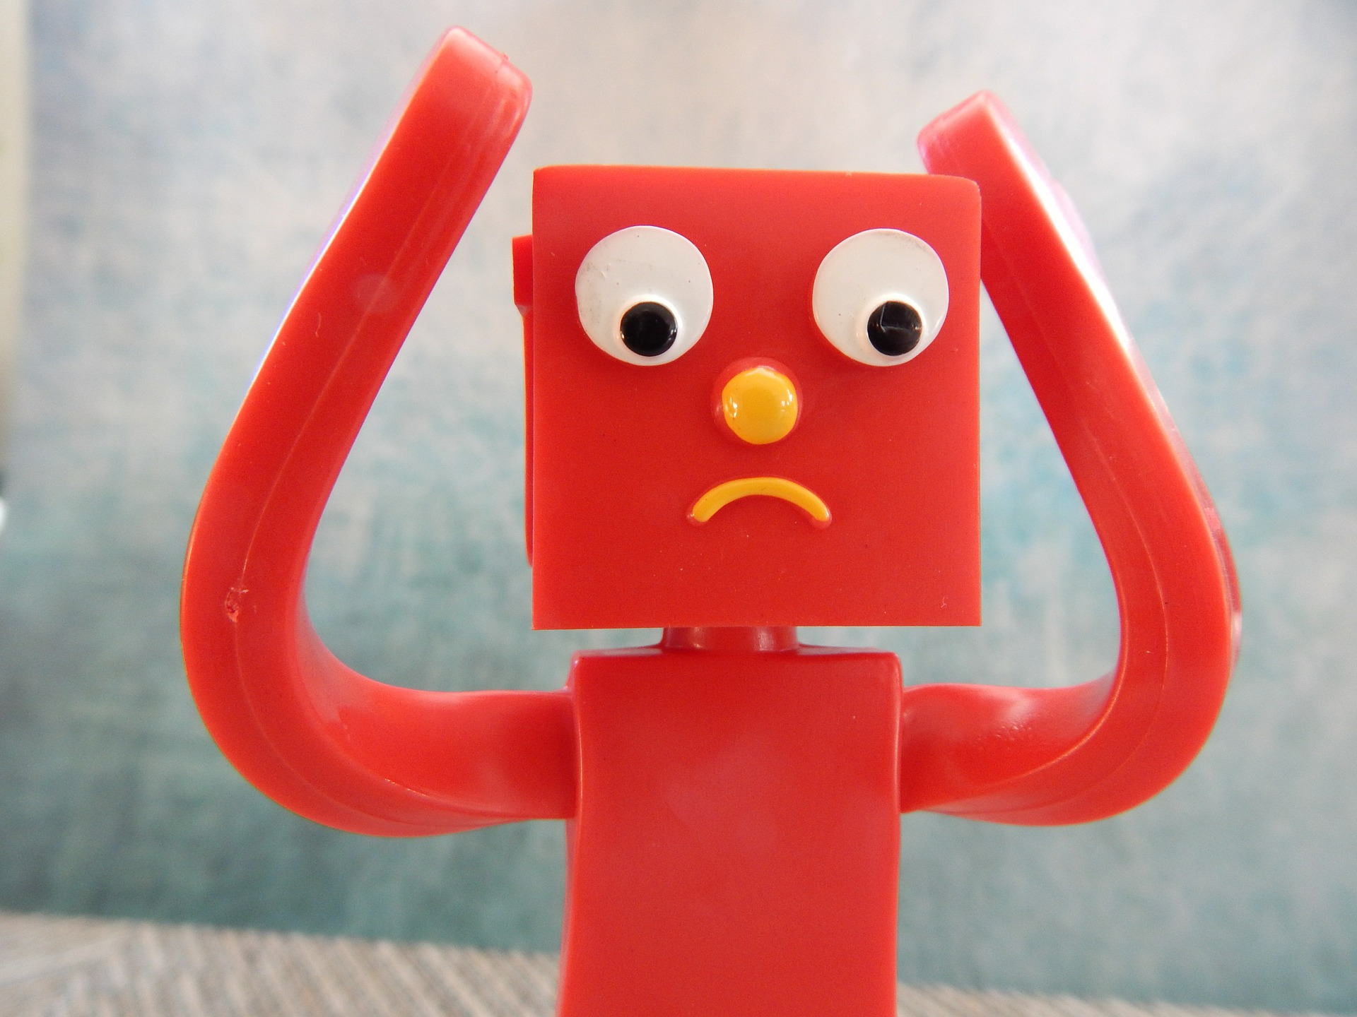

Keeping our bodies safe, even when we feel something confusing, is so important. People remember our words and actions and we want them to remember us as our best selves.

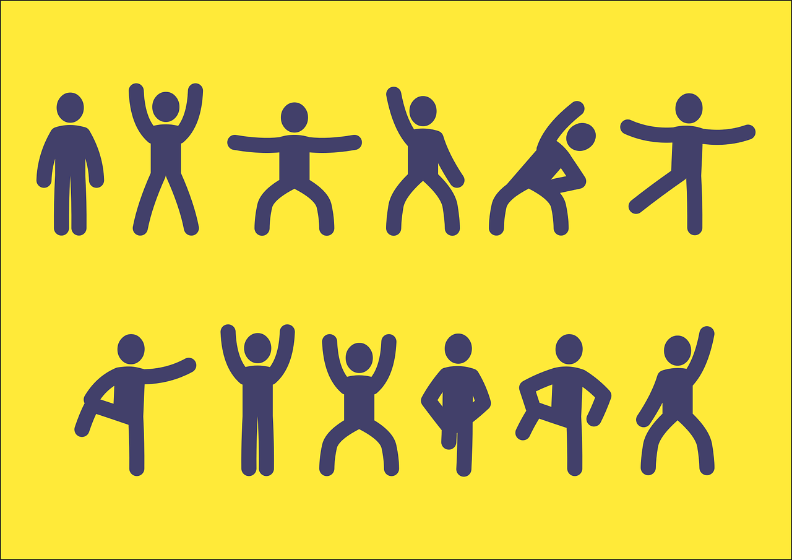
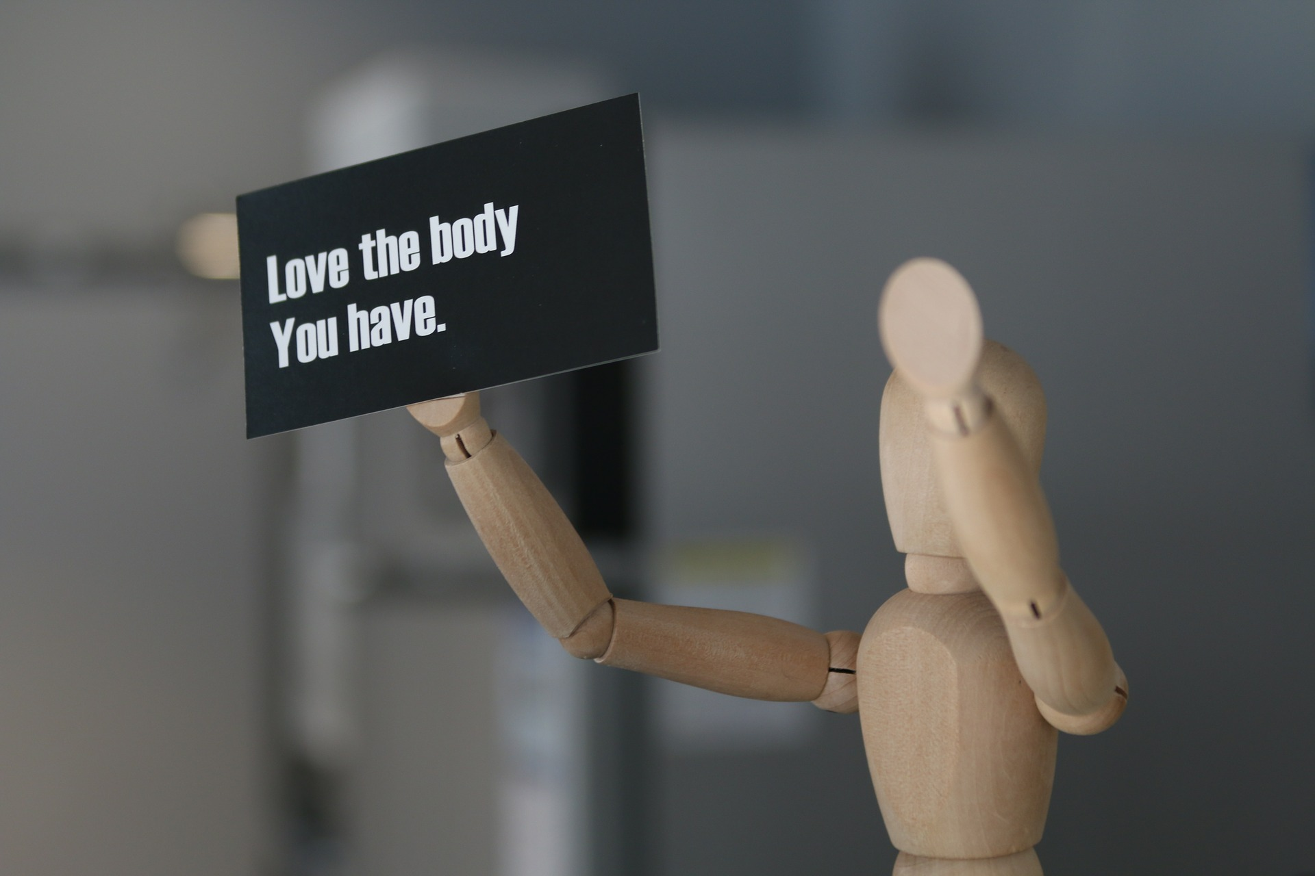

When I am upset or confused, I may do things to my body, mind, and heart that hurt it. I may say ‘no’ a lot and push staff hands away or I may bang my head against a wall.




Our feelings are real. When we are upset, it hurts our minds and hearts. But we must find strategies to calm down that don’t hurt our bodies.





Being flexible means finding new ways to think and react. When we are flexible, we can try new things. Being flexible helps us stay happy and healthy.

Palm trees are flexible because they sway in the wind but don’t fall over.

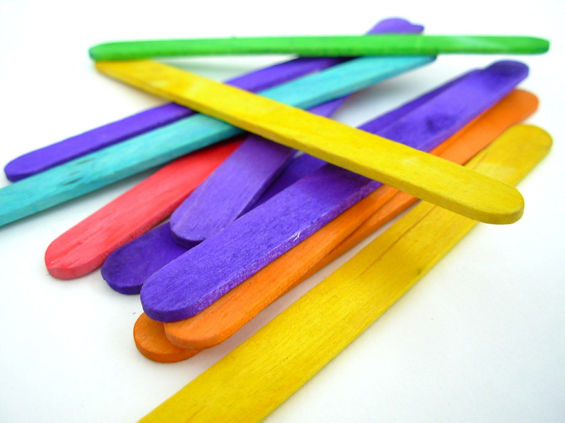

Popsicle sticks are not flexible because they will break if you try to bend them.
When I am anxious or confused about my feelings, I will try my hardest to be flexible. If I want to hurt my body, I will try to take the opportunity to tell staff I’M MAD or even just say MAD before I do.

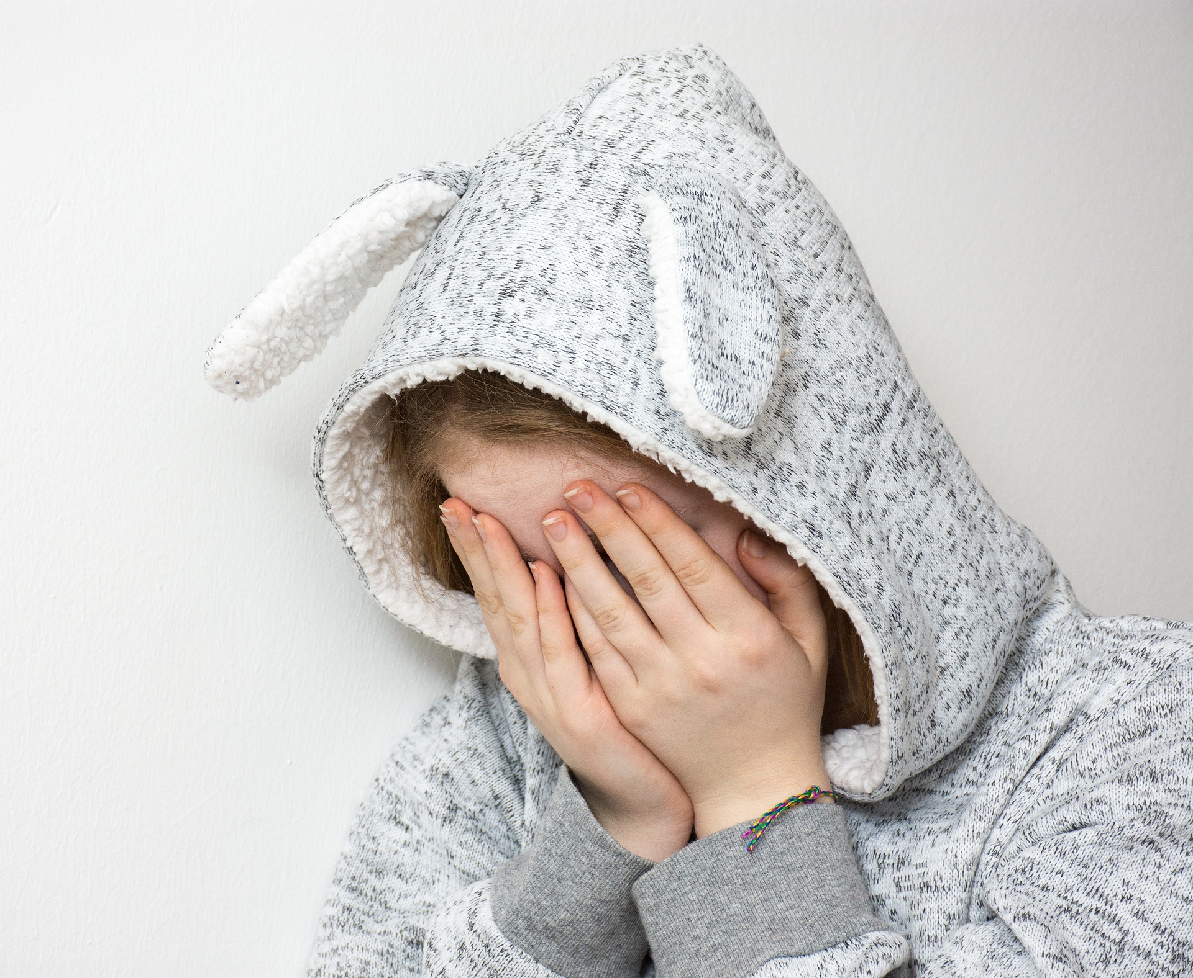
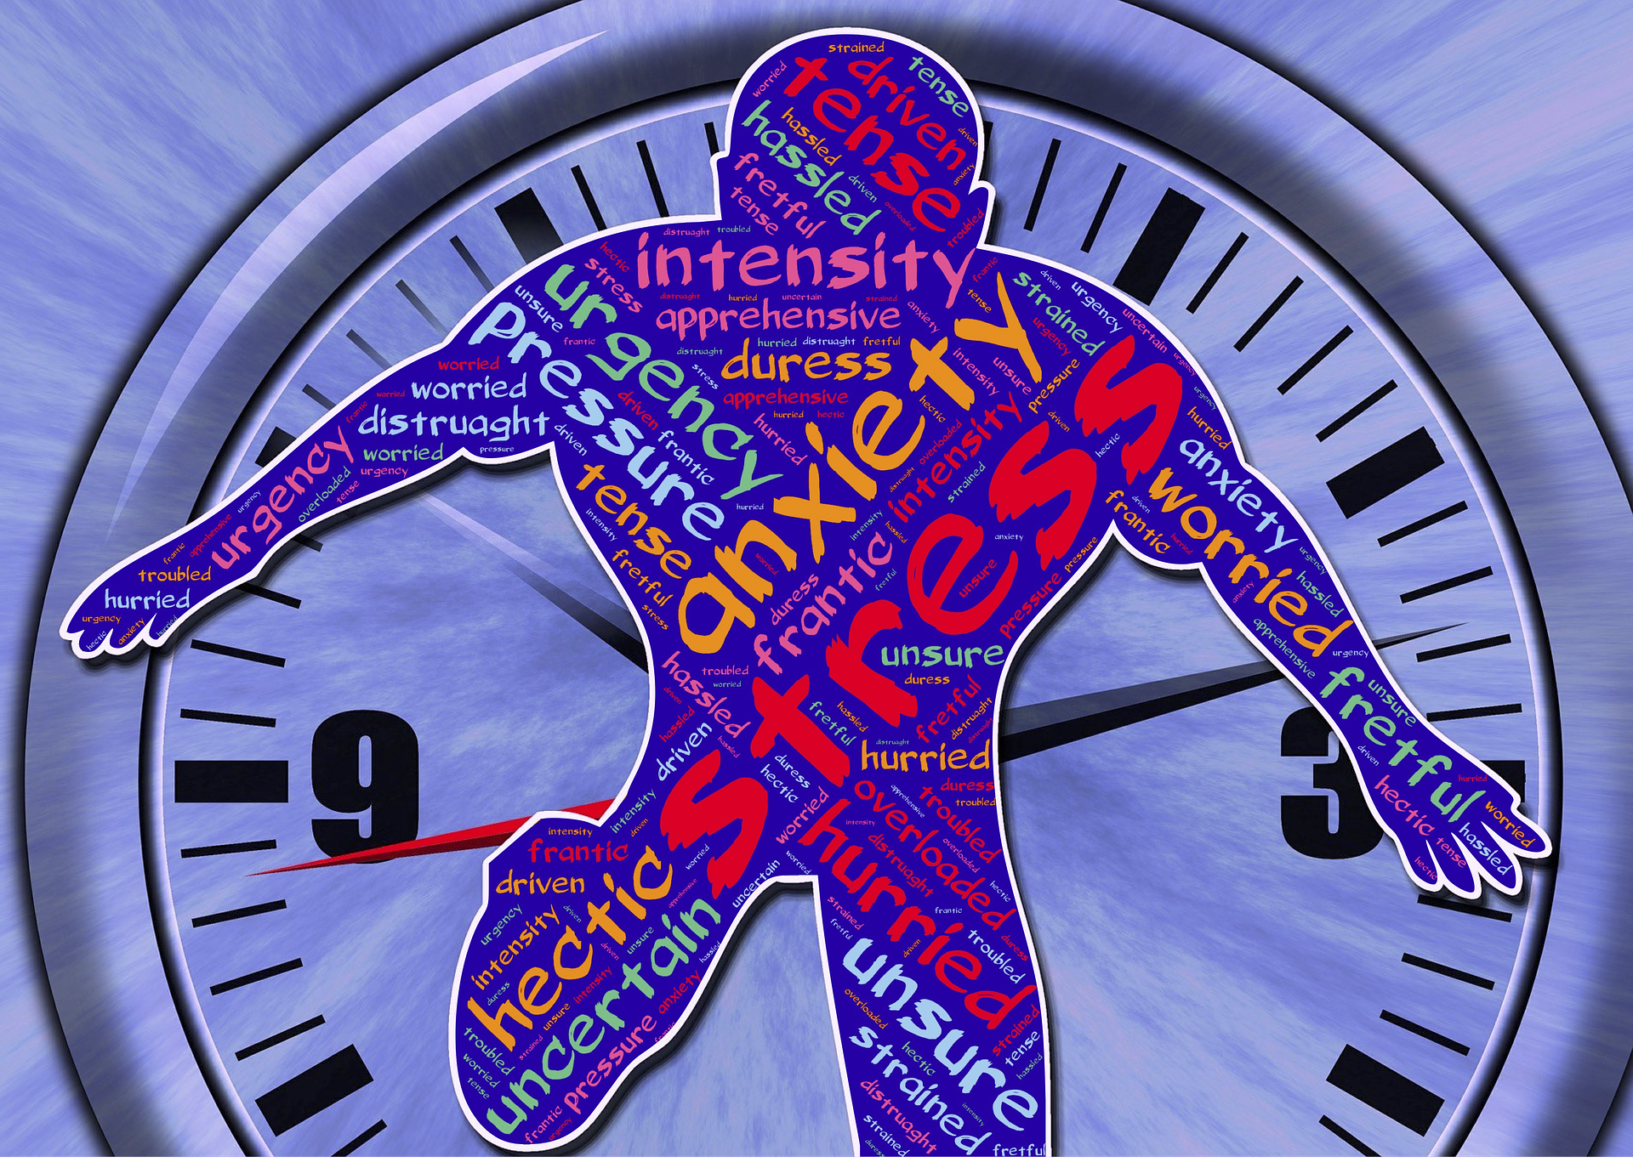

Staff will help remind me to be flexible and that I may need a moment for my body to calm down. They may also say BREAK THE CHAIN or 3, 2, 1, COOLDOWN.

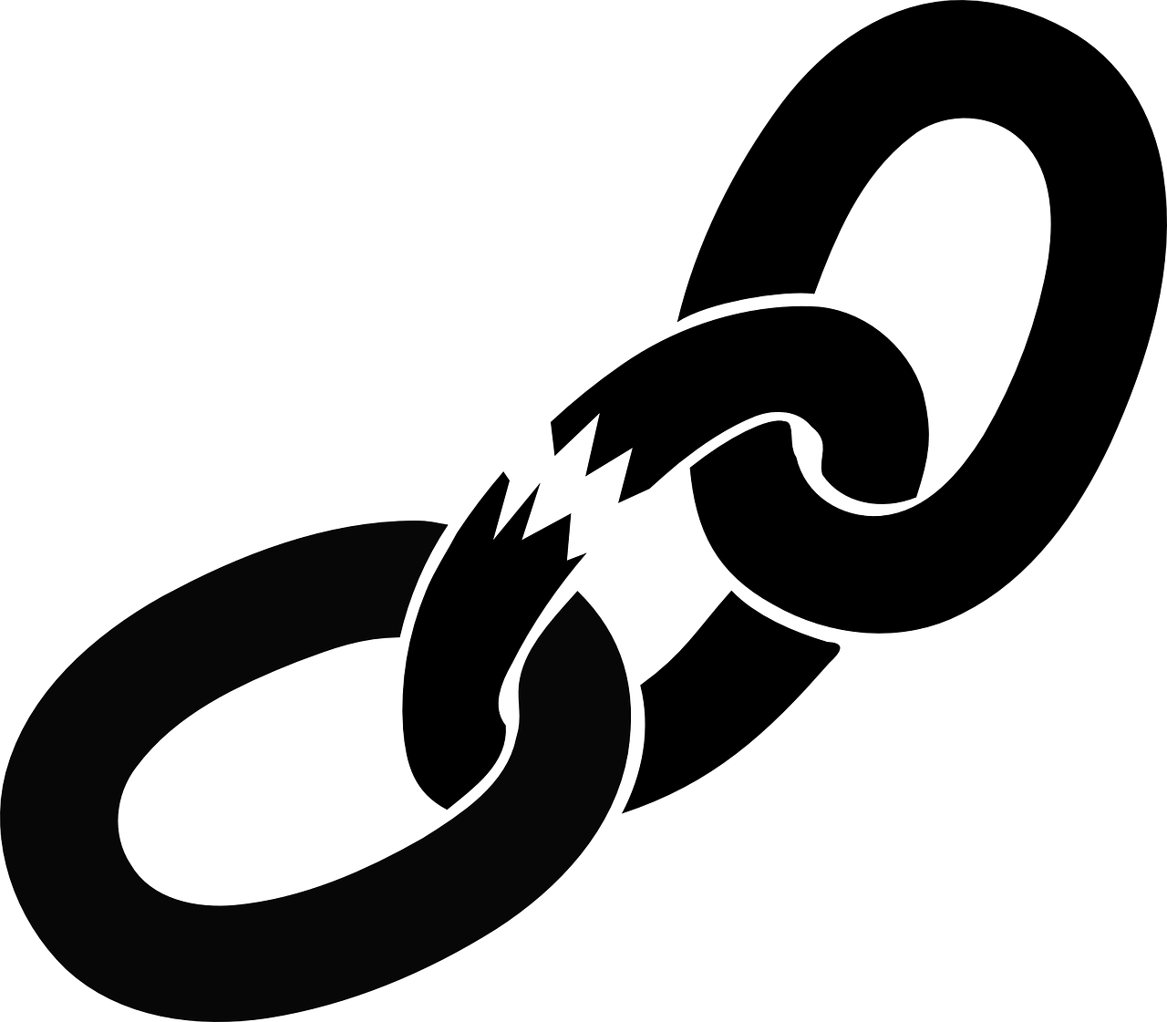
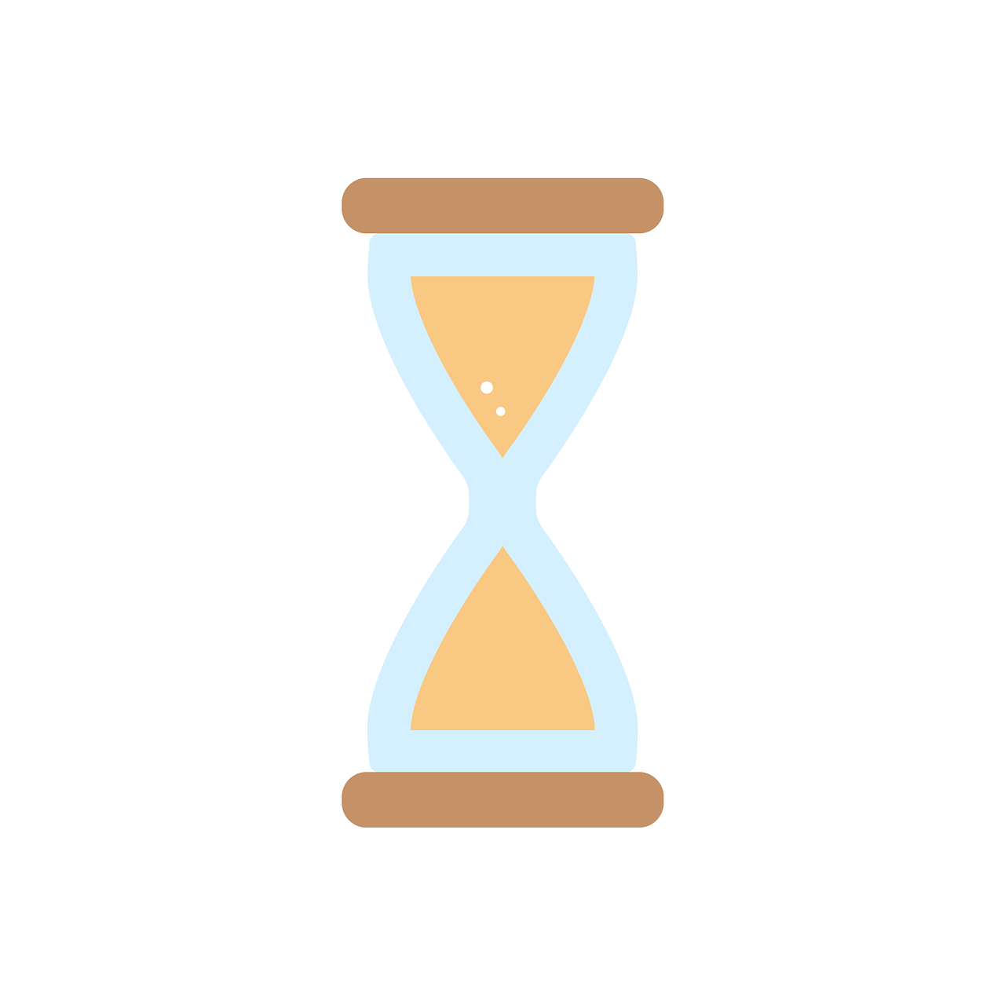

Let’s be flexible together!

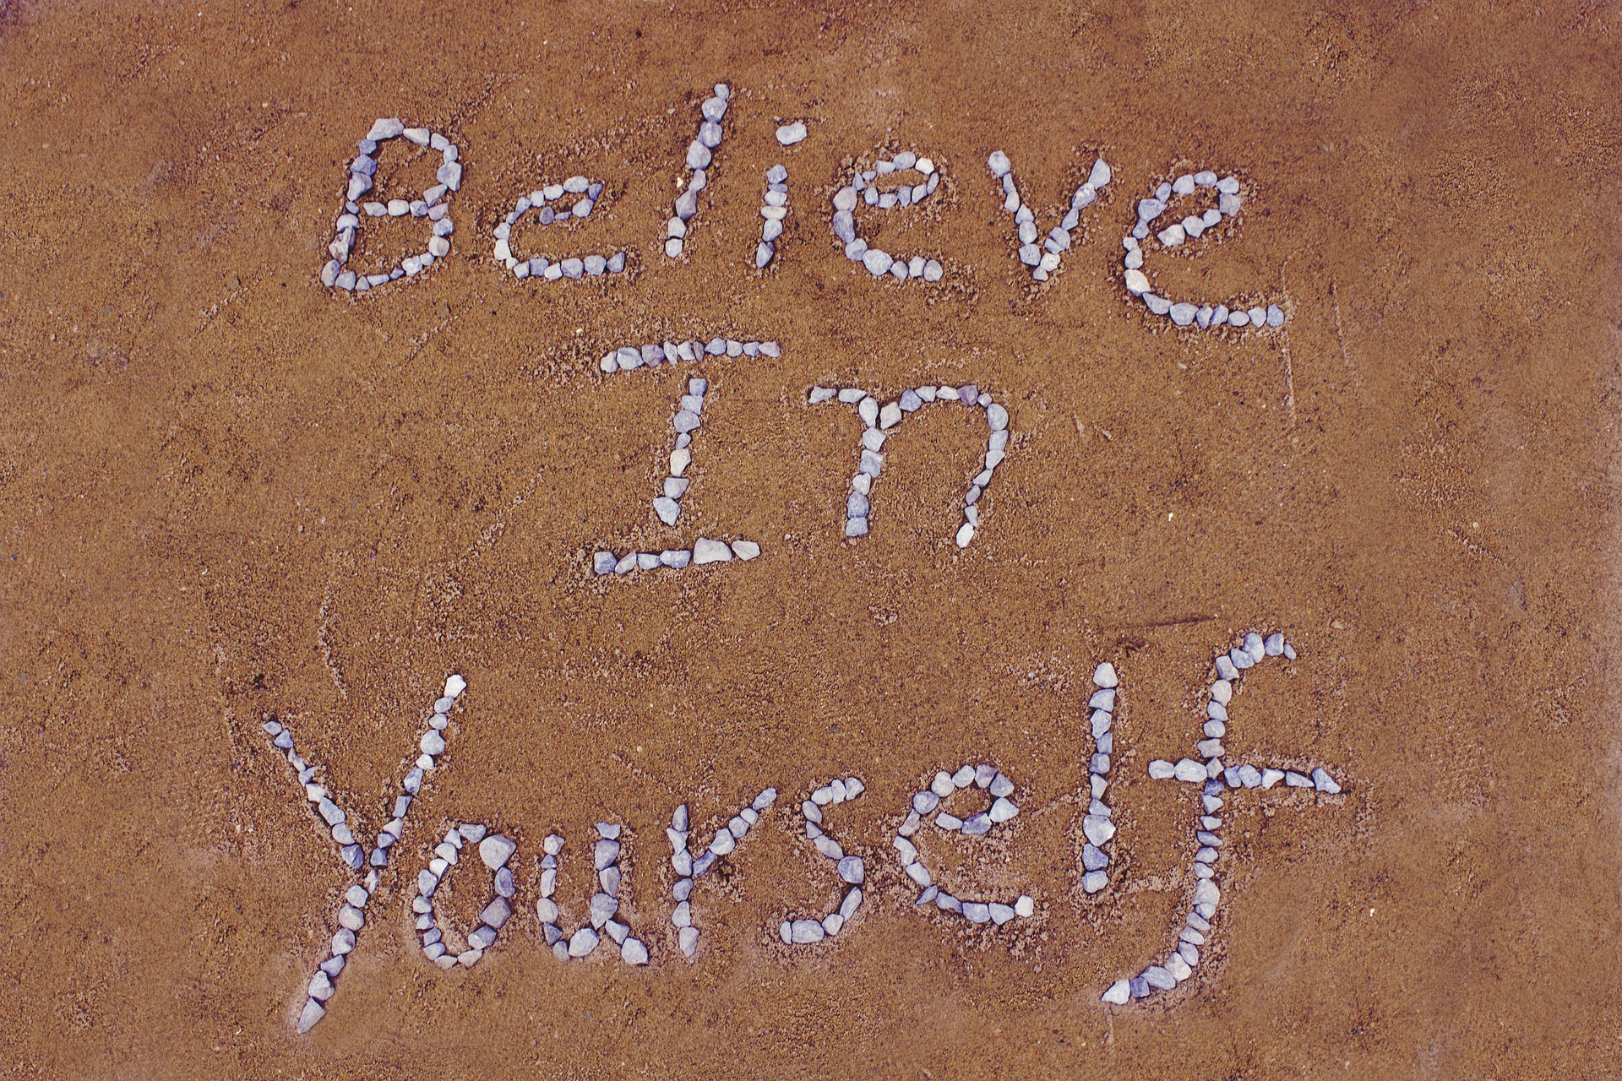

Facing uncomfortable feelings is not easy. Let’s work and
grow together. We know how awesome your best self is because we have seen it. It is a guy with so many talents and abilities. That is why we KNOW you can do this. We believe in you! You deserve to shine!

Love,
3L Place

