My Weekly Dinner Menu
Monday | Fish Filets and 20 French Fries  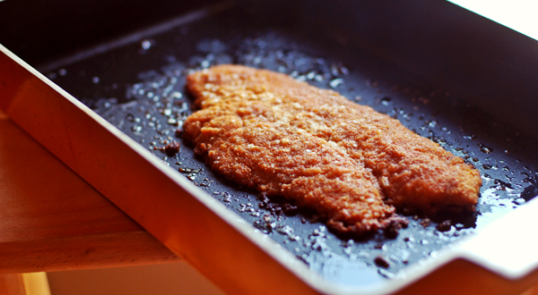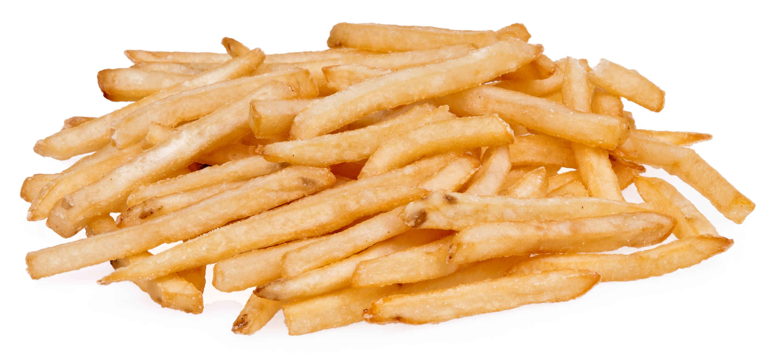  This Photo by Unknown Author is licensed under CC BY-NC-ND  This Photo by Unknown Author is licensed under CC BY-SA
Tuesday | Fish Filets and Rice Pilaf  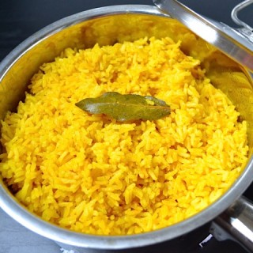  This Photo by Unknown Author is licensed under CC BY-NC
Wednesday | Mac and Cheese and 1 Egg  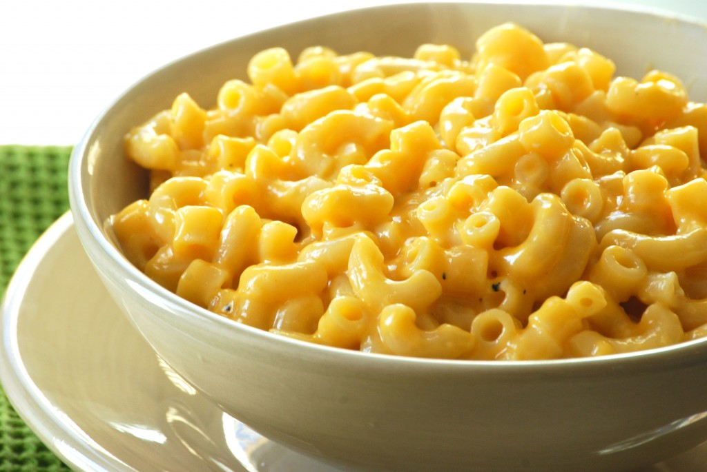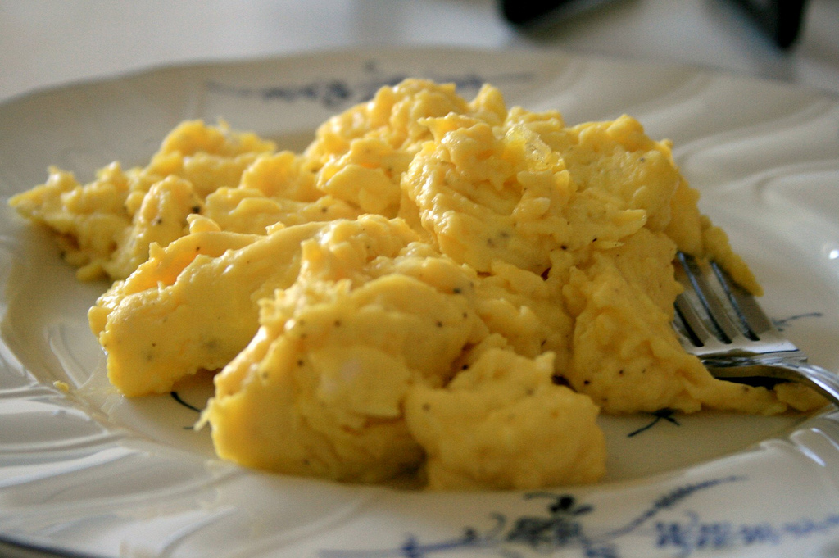  This Photo by Unknown Author is licensed under CC BY-NC-ND  This Photo by Unknown Author is licensed under CC BY-NC-ND
Thursday | Pancake, Bacon and 1 Egg  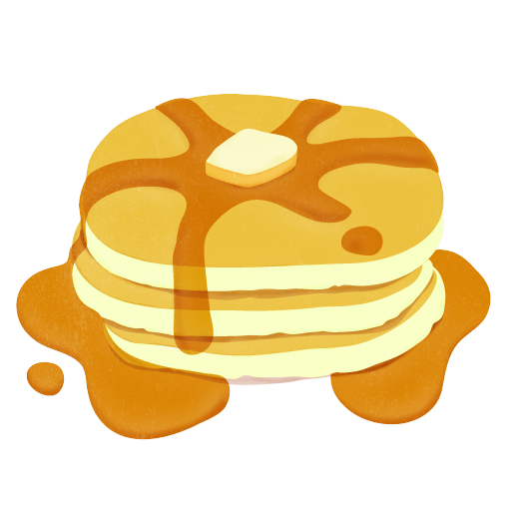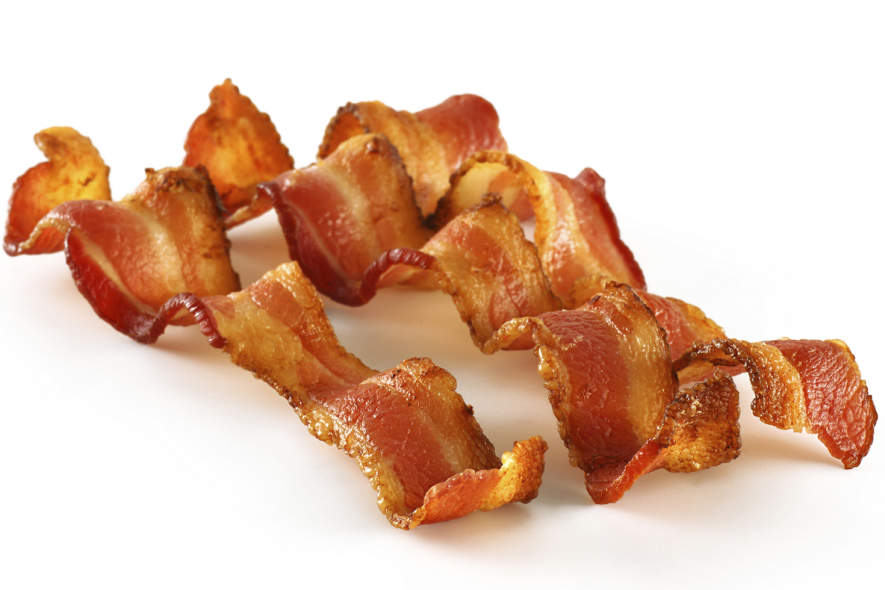  This Photo by Unknown Author is licensed under CC BY-SA  This Photo by Unknown Author is licensed under CC BY-NC-SA  This Photo by Unknown Author is licensed under CC BY-NC-ND
Friday | Fish Filets and 20 French Fries  This Photo by Unknown Author is licensed under CC BY-SA

