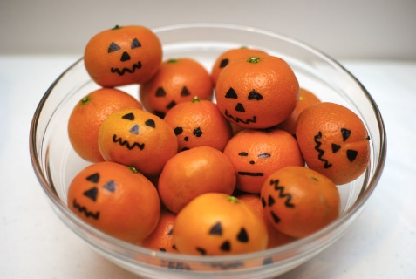 **DESIGN YOUR OWN**

**CLEMENTINE JACK O LANTERN!**

|  |  |  |
| --- | --- | --- |
| Image result for jack o lantern faces | Related image | Image result for pumpkin jack o lantern faces |
| Image result for pumpkin jack o lantern faces | Image result for pumpkin jack o lantern faces | Image result for happy pumpkin jack o lantern faces |
| Image result for pumpkin jack o lantern faces | Image result for clementine jack o lantern faces |  |