Name/Initials: | Chore: | Steps: | Initial when done:
 | Crumb Buster!  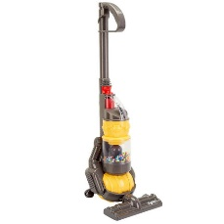 | - Pull all chairs out from under the table  - Vacuum under the table  - Double check and touch up  - Push chairs back in

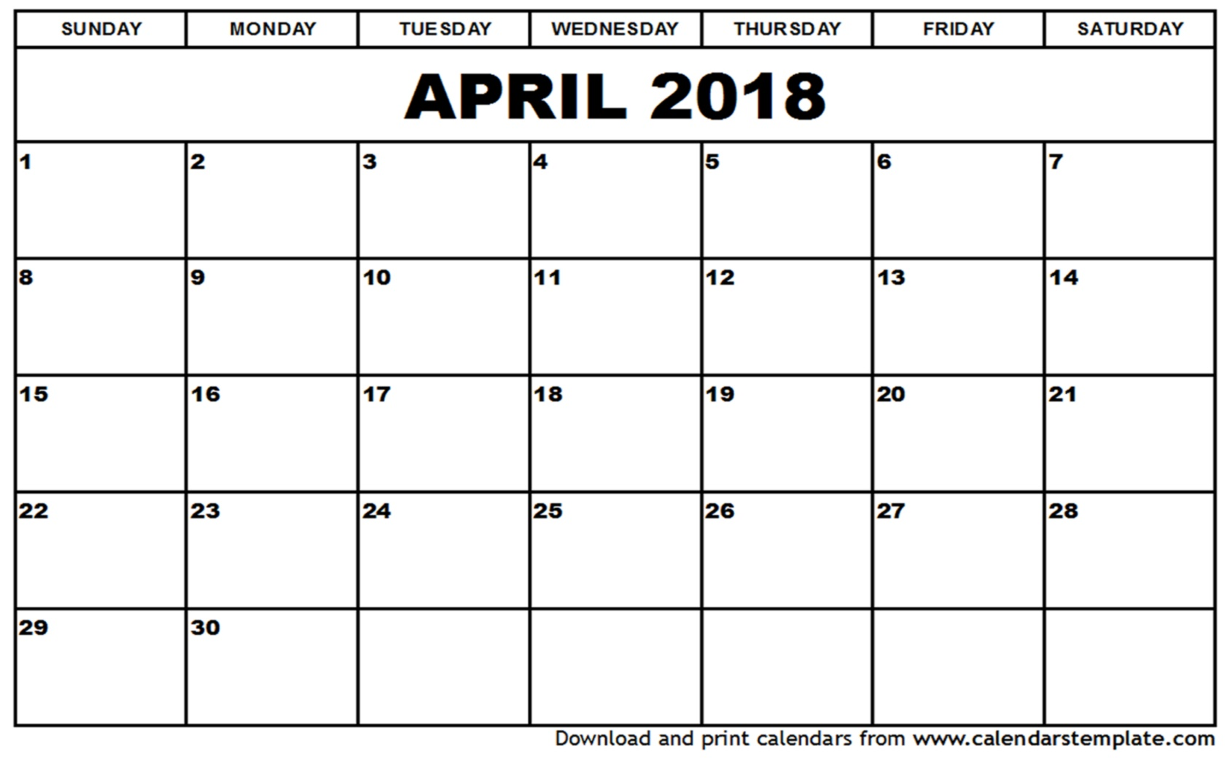

Name/Initials: | Chore: | Steps: | Initial when done:
 | DISHWASHER EMPTIER  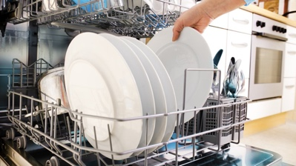 | - Wash hands very well  - Open dishwasher  - Put dishes away  - Put confusing dishes in dish drain  - Close dishwasher and cabinets/drawers

Name/Initials: | Chore: | Steps: | Initial when done:
 | Cleaning the Table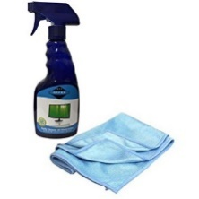 | - Spraying the table  - Wiping down the table  - Dry the table one more time  - Put supplies away

Name/Initials: | Chore: | Steps: | Initial when done:
 | Recycler of all rooms  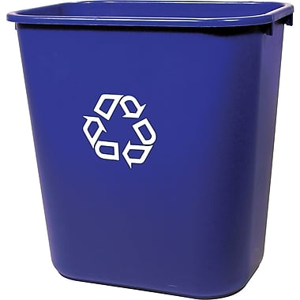 | - Get the big recycling bin and collect recycling from middle room  - Get Katie’s recycling  - Unplug the shredder, dump the shreds, put lid back on  - Bring recycling outside

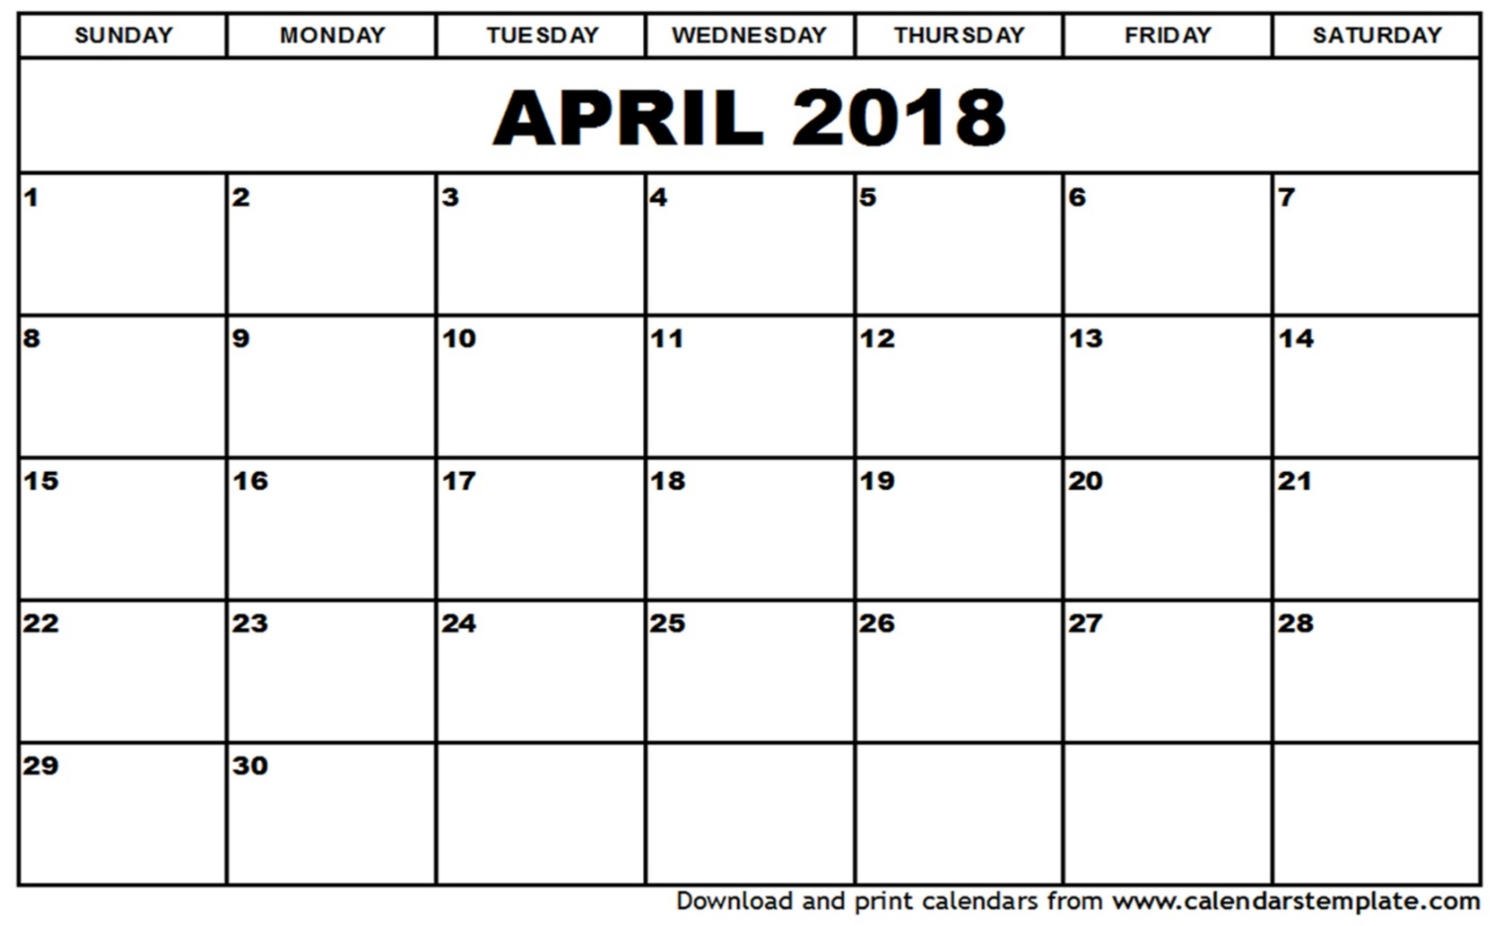

Name/Initials: | Chore: | Steps: | Initial when done:
 | Toilet Paper Restocker  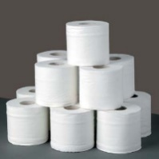 | - Check the bathrooms for TP  - Put two rolls of TP near all 3 toilets  - Recycle any empty roll

Name/Initials: | Chore: | Steps: | Initial when done:
 | Mirror Washer  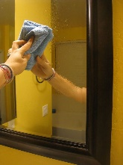 | - Spray the mirror in the bathroom and dry  - Spray the mirrors downstairs and dry.  - Spray the mudroom mirror and dry

