**SSI: Supplemental Security Income**

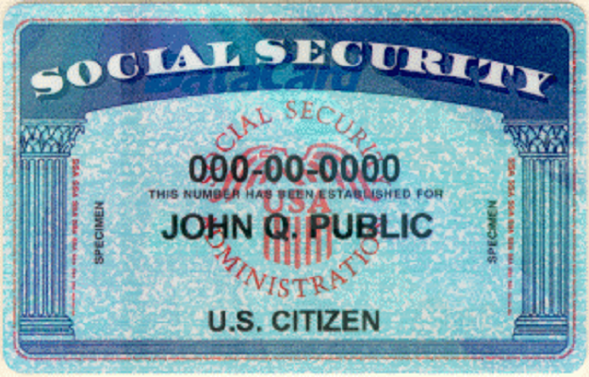

**There is a department of the United States Government called the Social Security Administration. Social Security was created by a great President named FDR. FDR stands for Franklin Delano Roosevelt. FDR believed that Americans needed a financial safety net so Americans would have enough food to eat and money to pay for a place to live.**

**One of the important things that the Social Security Administration does is pay money to people who have disabilities. This money is called SSI, Supplemental Security Income. All 3L Members receive an SSI check from the government every month.**

**Do you know how much SSI money you get every month?**

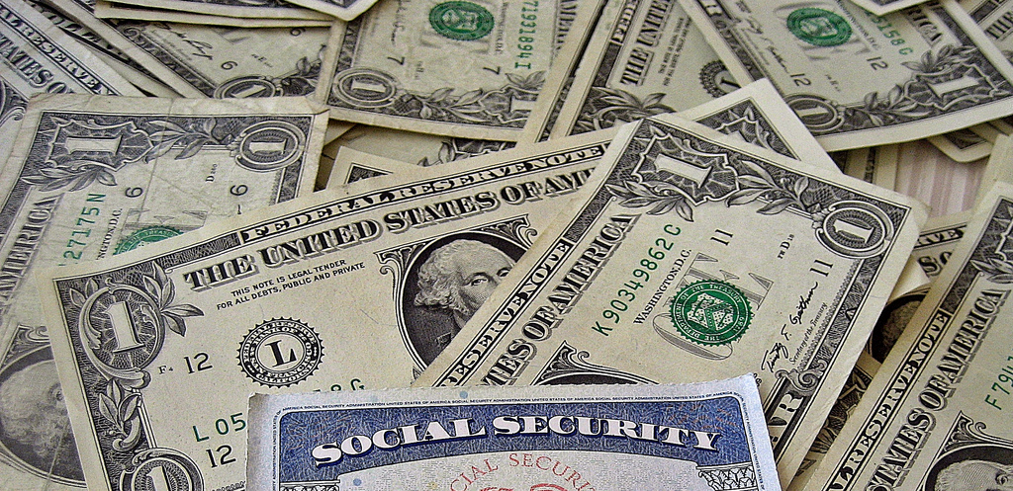

**The government has a lot of strict rules about who gets SSI money and how it is supposed to be spent. The government wants to make sure that only people who need it get SSI checks. They also care that the money is going to be used to pay for important things that the disabled person needs like food, medicine and rent. The government tries to make sure that nobody except the disabled person use the SSI money.**

**Have you ever been to a Social Security Office? Usually there is a lot of waiting and the place is pretty boring. If you go there with a parent, your parent might be stressed out or worried. SSI is a very important resource that nobody ever wants to lose. That’s why it is so important that everyone follows the rules!**