**Boston Society for Arts and Crafts**

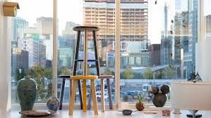

***“In a world of sameness, craft illuminates difference”***

In the late nineteenth century, arts and crafts were a huge deal in the United States. A **craft** **movement** took off in England and it quickly moved to the US. Americans wanted well-made crafts created by skilled artists. People were not interested in buying things that were mass produced. People wanted well made, beautiful objects that were handcrafted with patience and care.

This “**American** **Craftsman**” movement began with a famous New York furniture maker named **Gustav** **Stickley**. He believed that carefully building each part of one’s home by hand was a way to find beauty, meaning and comfort in daily life. He once said, “When a man's home is born out of his heart and developed through his labor and perfected through his sense of beauty, it is the very cornerstone of life.”

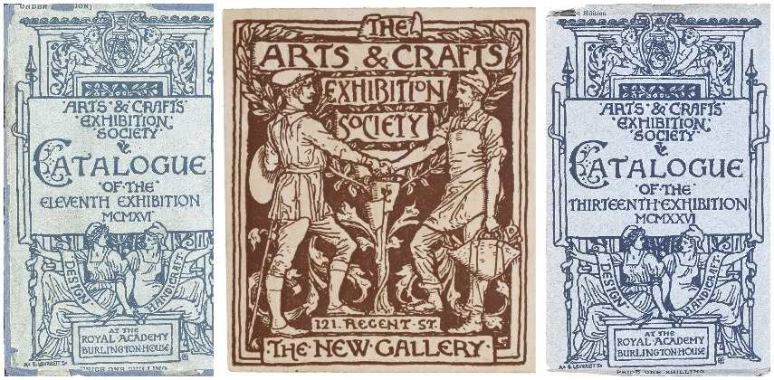

The American Craftsman movement led to the creation of **Boston’s Society of Arts and Crafts** in **1892**. Boston’s Society of Arts and Crafts is still thriving today in South Boston’s waterfront.

According to their website, “Society of Arts and Crafts has been at the forefront of the American craft movement, fostering the development, sales, recognition, and education of crafts for over one hundred years. Our highly committed founders developed standards of excellence in design and technical mastery for crafts that inspired the American Arts and Crafts Movement.”

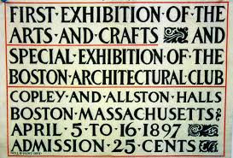

“The dual mission of the Society of Arts and Crafts is to encourage the **creation**, **collection**, and **promotion** of the work of **contemporary** craft artists and to advance public appreciation of fine craft. To fulfill our mission, the Society sponsors **exhibitions**, the **Artist** **Awards** **Programs**, and **educational programming**. We also promote the work of over 400 craft artists in both our galleries on an ongoing basis.”

“We are **dreamers** and **makers**. We are **artists** and **artisans**. We are masters of materials and inventors of forms. We are **creative thinkers** and **tireless tinkerers**. We are **stewards of tradition** and **champions of change**. We are **entrepreneurs** and **teachers**. We are **curators** and **collectors**. Together, we are a **community** of people who, through our skill and our passion, bear the standard for the field of contemporary craft.

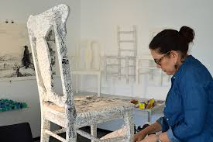

Source: https://www.societyofcrafts.org/about

*3L Place has been invited to visit the Society for Arts and Crafts on Friday, October 20, 2017. What are some questions we have for the artist craft-makers who work there?*

_________________

_________________

_________________

_________________

_________________

_________________

_________________

_________________

_________________

_________________

**Boston Society of Arts and Crafts**

Y P S K I I Y K K C A J N O X

G R R D Z P G E D Q A O K A K

E T A O H E W U C O T A S N M

X V I R M Z L E J S M L F I O

I U I J O O J F O E I P S T O

J A C T I P T B R J I N N I P

F Z Z H A Y M I F Z O K O N T

W B I R B E C E O I Y Y I K U

K C Q N B A R A T N T T T E Z

T Q M P N Q F C R N G E I R T

Z N O I T A E R C T O I B E X

G X J O E L C J B L S C I R Y

Y Y B Q L C R A F T S O H S M

V I G O M N D I D G E S X T P

B S C R A F T S M A N U E V K

AMERICAN CREATION

ARTS EXHIBITIONS

BOSTON CREATIVE

COLLECTION PROMOTION

CONTEMPORARY SOCIETY

CRAFTS TINKERERS

CRAFTSMAN

**https://www.youtube.com/watch?v=MOl0-9TLXIM**

**STAINED GLASS LION**

