**Diversity**

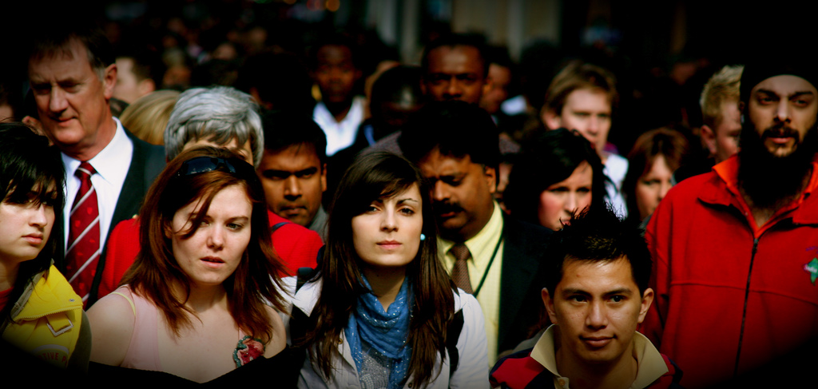

The human race is amazingly diverse. There are 7.6 billion people alive on the earth today and no two of us are exactly alike.

We have different skin colors, nationalities, religions, abilities, disabilities, genders, gender identities, sexual orientations, ages, and socio-economic statuses. We have different hopes, dreams, hobbies and passions. We are all perfectly unique.

Diversity is the nature of our world as humans and it always has been. Without diversity, everyone would look, think, talk and act exactly the same way. Without diversity, our lives would be terribly boring!

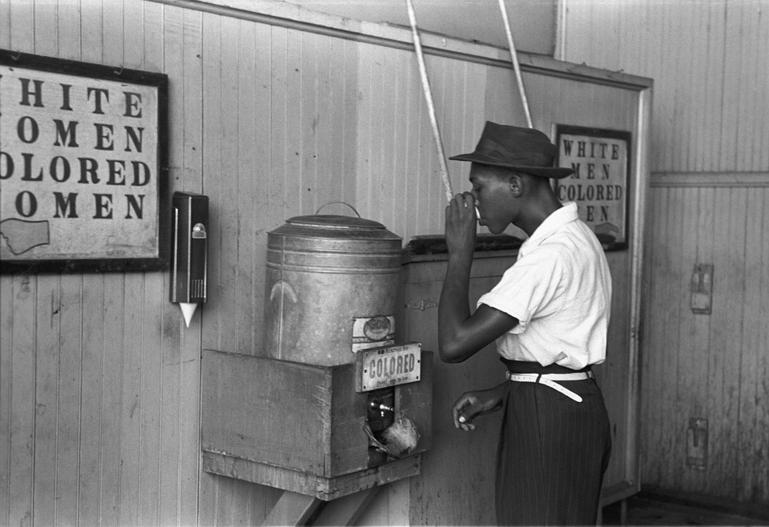

Even though diversity is an unchangeable fact of human life, humans are often full of prejudice and discrimination. Many people make harsh and negative judgements about a person just because of the way they look or sound. It is called prejudice or discrimination when a person treats another person as less valuable or worthy because of the skin, language, brain, voice or body they were born with.

For most of American history, white people believed it was OK to treat people with brown skin like they weren’t really human. Even after slavery ended, black and brown skinned Americans weren’t allowed to eat at the same restaurants, or use the same bathrooms and water fountains as white people.

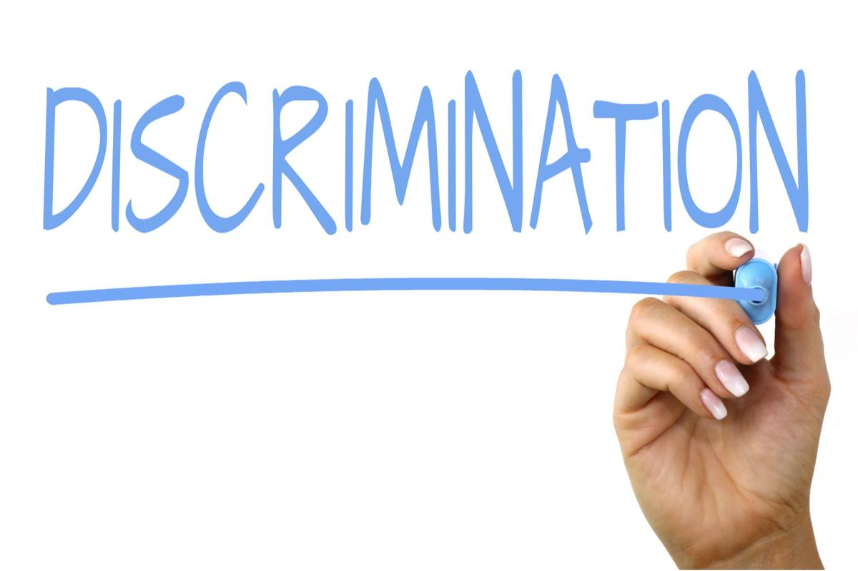

**Disability Discrimination**

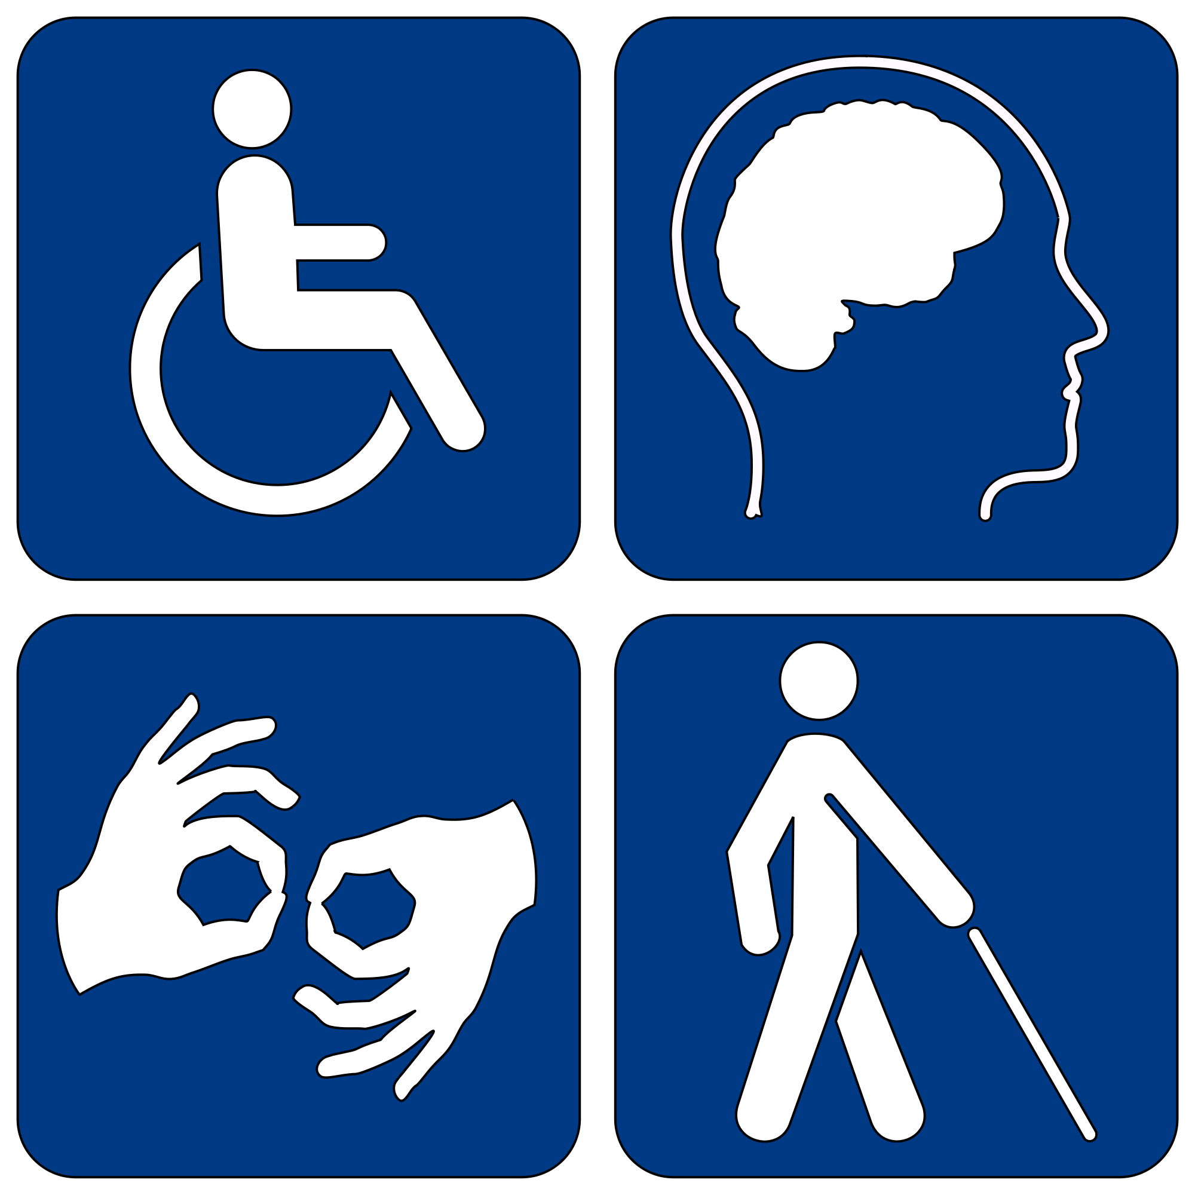

One very dangerous type of prejudice is Disability Discrimination. For most of human history, people with disabilities have been treated like they were less than human. There have been countless times throughout history where innocent people were murdered just because they were born with a disability.

At 3L Place, we have Zero Tolerance for discrimination. That means that we never allow anyone to treat someone as if they are less smart or less valuable just because of the way they were born.

Some of us have very strong voices where it is very easy for us to speak and be understood. Some of us have less strong and quieter voices where it can be much harder to speak and be understood. The strength of our voice has absolutely nothing to do with the strength of our mind. At 3L Place, we never allow anyone to judge another person’s intelligence based on the way that they speak or don’t speak. We believe that there are many types of intelligence and some of them are very quiet.

**Neurodiversity**

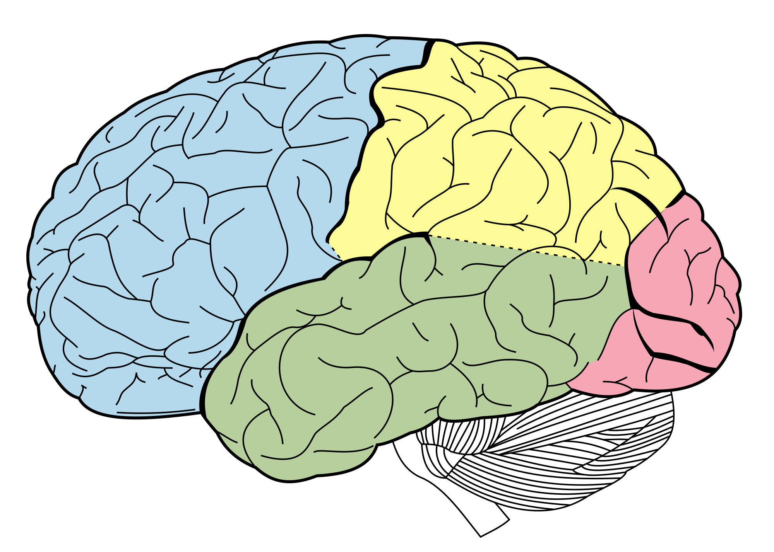

The word Neurodiversity combines the word “Neuro”, meaning brain with the word Diversity. People who celebrate Neurodiversity are proud of the amazing variety and complexity of different human brains. The national Symposium on Neurodiversity describes it this way:

“Neurodiversity is a concept where neurological differences are to be recognized and respected as any other human variation. These differences can include those labeled with Dyspraxia, Dyslexia, Attention Deficit Hyperactivity Disorder, Dyscalculia, Autistic Spectrum, Tourette Syndrome, and others.

For many autistic people, neurodiversity is viewed is a concept and social movement that advocates for viewing autism as a variation of human wiring, rather than a disease. As such, neurodiversity activists reject the idea that autism should be cured, advocating instead for celebrating autistic forms of communication and self-expression, and for promoting support systems that allow autistic people to live as autistic people.”

**https://neurodiversitysymposium.wordpress.com/what-is-neurodiversity/**

**America is for Everybody!**

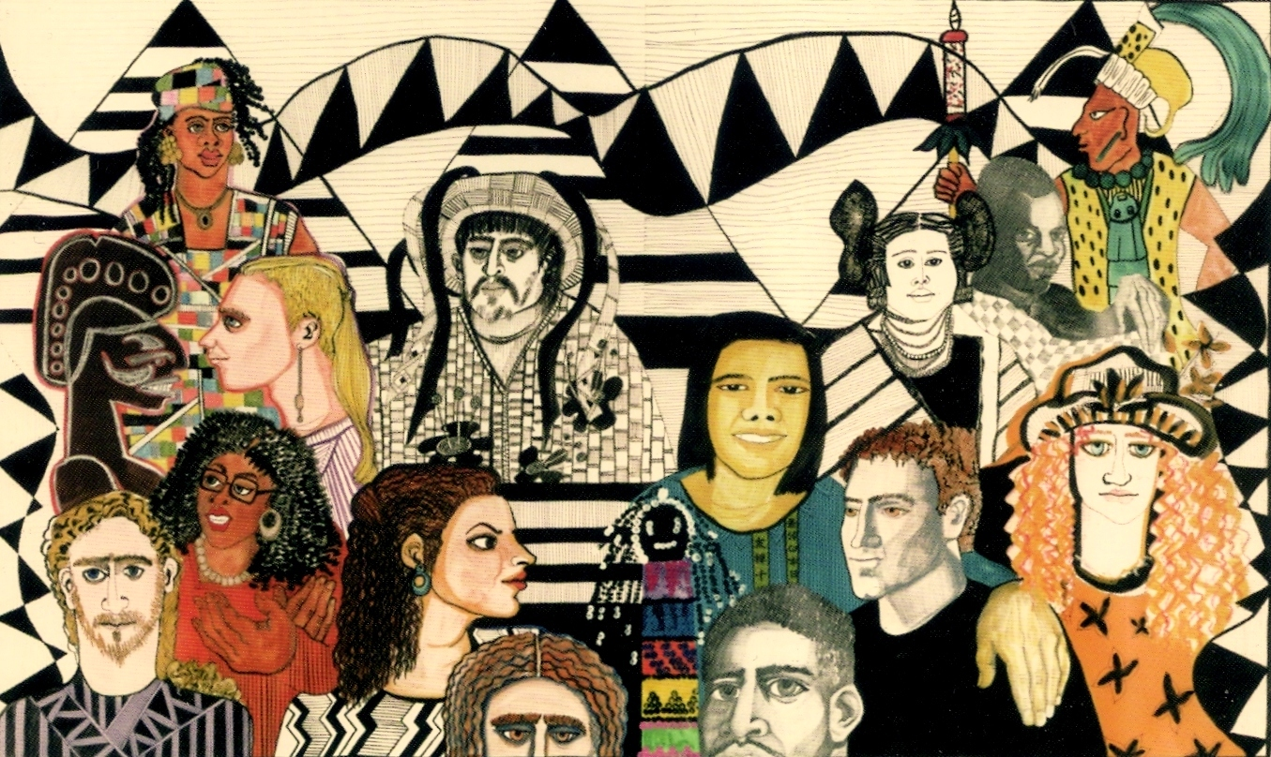

America is for everybody and 3L Place is for everybody. We never discriminate against anybody because of the way that they were born. We believe that diversity makes America stronger and we believe that diversity makes 3L Place stronger!

The next page explore our personal experiences with diversity and discrimination. Please try your best to be honest and know that it is OK if you have had prejudiced thoughts or acted with prejudice in the past. Nobody is perfect, but we can all get better every day at celebrating diversity and making America and 3L Place the best that we can be!

People can be discriminated against because of their skin color, nationality, age, religion, the amount of money they have, their gender, gender identity, sexual preferences, disability and many other reasons. Have you ever felt discriminated against?

1. I have definitely felt very discriminated against.
2. I have felt somewhat discriminated against.
3. I am not sure if I have been discriminated against.
4. I don’t think I have ever been discriminated against.
5. I’ve definitely never been discriminated against.

Write your answer: ___________________________________

__________________________________________________

1. I have definitely felt very discriminated against because of the way that I speak!
2. I have felt somewhat discriminated against because of the way that I speak.
3. I am not sure if I have been discriminated against because of the way I speak.

4. I don’t think I have ever been discriminated against because. of the way I speak.

1. I’ve definitely never been discriminated against because of the way I speak.

Write your answer: ____________________________________________

____________________________________________

# Diversity

D D B D Z A A H Y K Q I N N V

C I S B G G B U J V A V O N W

Q I V E D I S A B I L I T Y G

Z N O E K Y I U K L T X P D J

C C X P R A T X Y A B R L Q U

L L O T I S L I N D E K L G M

I U A E X H I I T J W S T G V

B S G S W S M T U N M C W N R

Q I Q G S I E D Y D E G E I A

K O U N R G I B O P J D I K C

B N V C Y C W T S A W X I A E

P Y S T E H G E N D E R O E E

E I E C N A R E L O T G L P M

D N E Q B Q Q C J C P M P S F

Y S M B F P Y V U R K H Y T C

AGE CLASS

DISABILITY DISCRIMINATION

DIVERSITY GENDER

IDENTITY INCLUSION

PREJUDICE RACE

RESPECT SPEAKING

TOLERANCE