**MBTA Charlie Card**

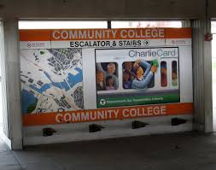

Did you know that when you were born there was no such thing as a Charlie Card or Charlie Ticket? Until 2006, we used to have to buy a special coin called a subway token if we wanted to get on the subway.

Charlie cards are great because they save you money. Without a Charlie card, it cost $2.75 every time you take the subway. If you use a Charlie Card, it only costs $2.25, so you save 50 cents every time you use the card!

Do you have a disability? If you do, you can apply for a Disabled Charlie Card called a TAP. T.A.P. stands for Transportation Access Pass and it will get you on all subway, bus, commuter train, or MBTA boats for only half the price of a regular Charlie Card.

***T.A.P. stands for*** _____________________________

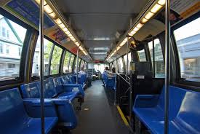

We have access to TAP cards because most tax paying citizens of Massachusetts agree that people with disabilities deserve special rights and protections to help us live positive and productive lives in our community. Most taxpayers in Massachusetts agree with the American’s with Disability Act, A.D.A., that disabled people deserve a “level playing field” with everyone else. “A level playing field” means that disabled people deserve the same chances to be successful and happy as people who don’t have disabilities.

***“A level playing field” means that***__________________

______________________________________________

______________________________________________

**Circle all that answers that are true.** A Disabled TAP Charlie Card gets disabled people half price access on…

**Subways Busses Commuter Trains**

**MBTA Boats Airplanes**

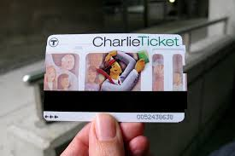

Did you know that Charlie Cards are named after the made-up character “Charlie” from an old protest song called “Charlie and the MTA”? The song is protesting a fare increase where riders were forced to pay an extra five cents in order to leave the subway station at the end of the ride. In the song, Charlie doesn’t have the extra nickel so he can never get off the train and his wife has to throw him a sandwich every day through the open train window so that he has food to eat.

It is not clear why his wife doesn’t also give him a nickel so that he can pay to leave the subway station.

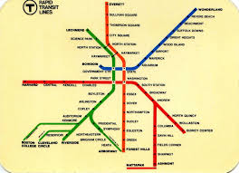

Well, let me tell you of the story of a man named Charlie  
On a tragic and fateful day  
He put ten cents in his pocket, kissed his wife and family  
Went to ride on the MTA

Well, did he ever return?  
No he never returned and his fate is still unlearned (what a pity)  
He may ride forever 'neath the streets of Boston  
He's the man who never returned

Charlie handed in his dime at the Kendall Square station  
And he changed for Jamaica Plain  
When he got there the conductor told him, "one more nickel"  
Charlie couldn't get off of that train!

But did he ever return?  
No he never returned and his fate is still unlearned (poor old Charlie)  
He may ride forever 'neath the streets of Boston  
He's the man who never returned

Now, all night long Charlie rides through the station  
Crying, "what will become of me?  
How can I afford to see my sister in Chelsea  
Or my cousin in Roxbury?"

But did he ever return?  
No he never returned and his fate is still unlearned (shame and scandal)  
He may ride forever 'neath the streets of Boston  
He's the man who never returned

**N V V T D S F P M M A M Y K M**

**M A R E T U M M O C B R A Q A**

**T A O B C A E F H H W T B K S**

**N Q I U A S K F U Y C K A U S**

**Q K T O R I H Y R A H O A A A**

**O E W I D S O R V E I U V H C**

**T R A N S P O R T A T I O N H**

**J G O E L N F N W H B D R V U**

**F T C I R H A P O M P F S D S**

**H C D L N L A R K A U Q X Y E**

**A V W R J S I H T V A W M L T**

**S P X A S T N U N V L V Q U T**

**V S X H Y S U B W A Y I U V S**

**B U S C Z L F W M O K U A G M**

**C O P Y I F Y H K T C P M R X**

**ACCESS COMMUTER**

**AUTHORITY MASSACHUSETTS**

**BAY TRANSPORTATION**

**BOAT TRANSIT**

**SUBWAY MBTA**

**TAP CARDBUS PASS**

**RAIL**

# Do you have your own Charlie Card that saves you money when you use the bus or train?

Yes No I’m not sure

Do you have a disabled Charlie Card that gets you on all busses and trains for half price?

Yes No I’m not sure

Would you like to have your own Disabled Charlie Card to help you save lots of money?

Yes No I’m not sure

One person in my life that can help me apply for a Disabled Charlie Card is…

­­­­­______________________________________________

Circle the answer that matches your choice: When we walk to Davis Square T station I want to put this much money on my Charlie Card…

$0 $5 $10 More than $10

I am glad that the state of Massachusetts provides discounted TAP passes for people with disabilities.

Yes No I’m not sure