

# 121st Boston Marathon

T I S N P G U G Y S G D C R E

I J M A E T Z F U A P V G S C

R T Y J R I C N D V D E K K A

I H B D S F I N I S H N E Z R

P F O L E F Z D E N N H O D O

S P A I V S R E K A E N S M G

I D P Q E L C B H O G M Q N P

Q S B E R H M M Z A M K O Z R

X D R S E P A X E D L R Y I I

R U N E B R U S Z S T O Q U D

S E R I A I Z M K S C W R M E

H F C T X C O J Y U Q Z R D B

R Z H A I O H E V A D F I S M

Y O Z P P P N T Z Q H G J Z S

N P S A R S R S B O K V I F G

* **CHEER**
* **FINISH**
* **IPOD**
* **MARATHON**
* **MONDAY**
* **PACE**
* **PERSEVERE**
* **PRIDE**
* **RACE**
* **RUN**
* **SNEAKERS**
* **SPEED**
* **SPIRIT**
* **STRONG**
* **TEAM**

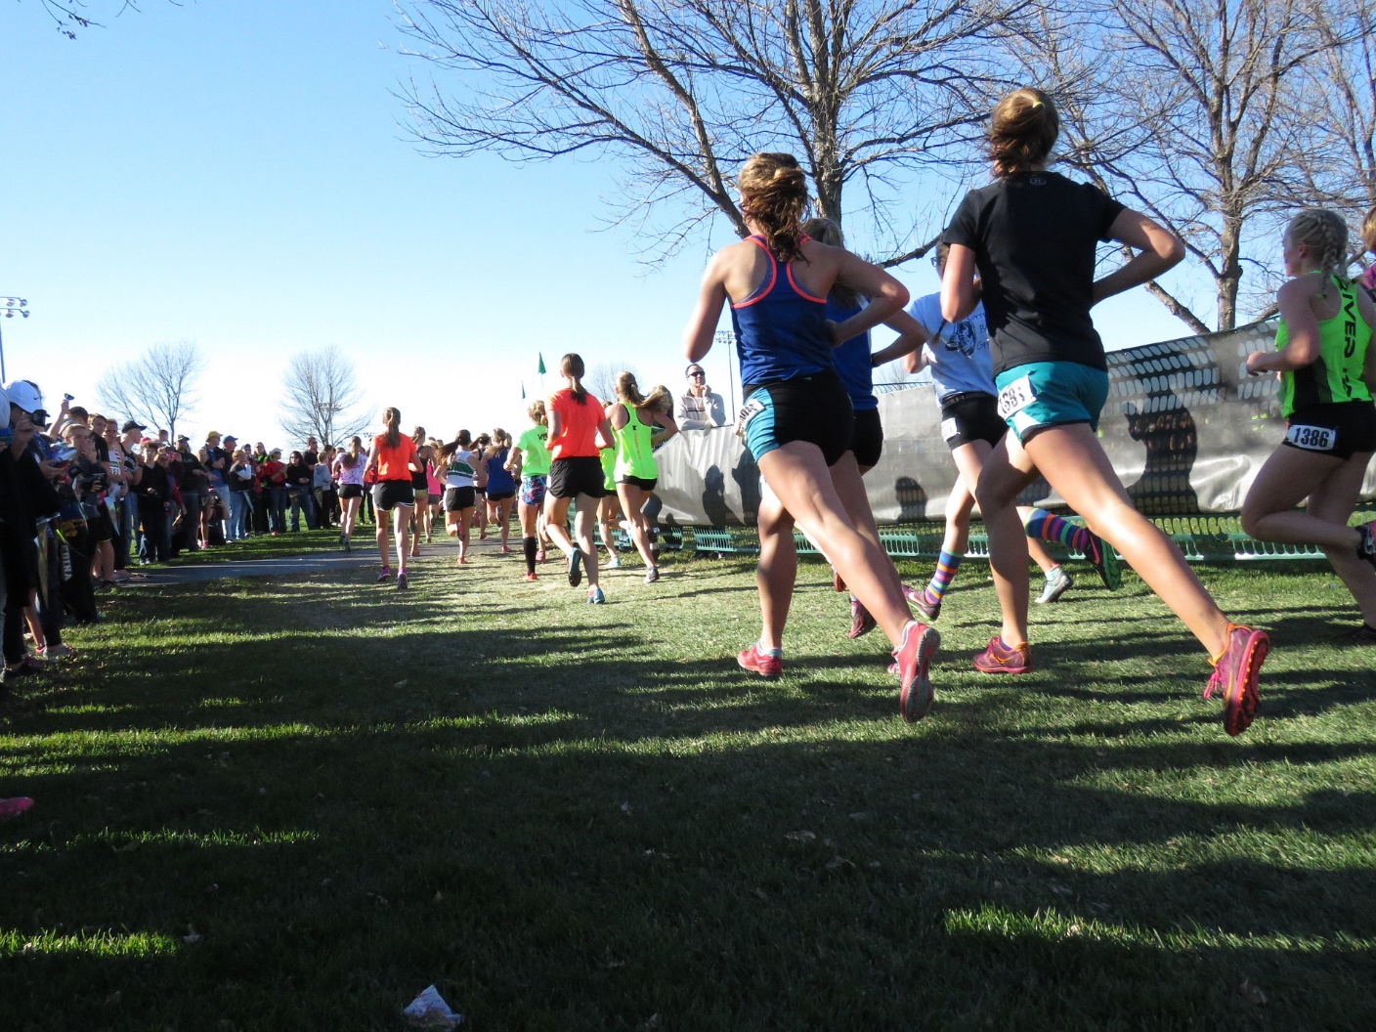

**Discuss whether or not members would like to go and cheer on Boston Marathon runners, either this year and/or next year!**

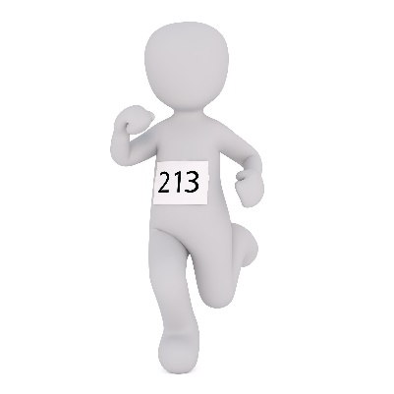

* I would like to **run** in a marathon this year **because**

__________________________________________

* I would like to **run** in a marathon next year **because**

__________________________________________

* I am not sure I am a **runner** or that I want to **run** in a marathon. I’d rather:

_________________________________________

**Say a little more:**

_____________________________________

**FURTHER AREAS TO DISCUSS:**

**What** is a marathon about (look at signs)?

**Where** might you stand (near or far from the finish line, relativity to crowds)?

_____________________________________________________

**Who** might you cheer (anyone running you know)?

_____________________________________________________

**Why** do people of all backgrounds, races, and abilities want to run?

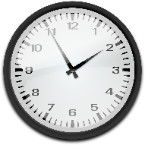**When** might you want to try a marathon (of any length and any sport)?