COOL DOWN JUGS

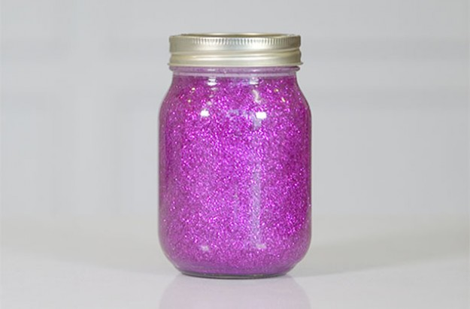

These magical glitter jars are the perfect sensory experience for people of all ages.

**You will need:**

* A jar or plastic bottle
* A jug of warm water
* 60ml glitter glue
* 3 drops of gel food colouring
* 60g-80g glitter

**Step 1:**

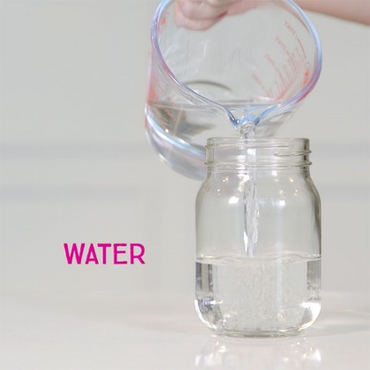

Add warm water to your jar or bottle until it reaches around a third of the way up.

*\*all photos taken from* <http://www.goodtoknow.co.uk/craft/547673/glitter-jars-how-to-calm-down-jar>

**Step 2:**

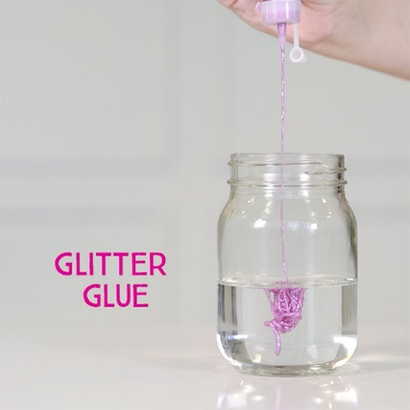  
Add the glitter glue and stir until it combined with the water.

**Step 3:**

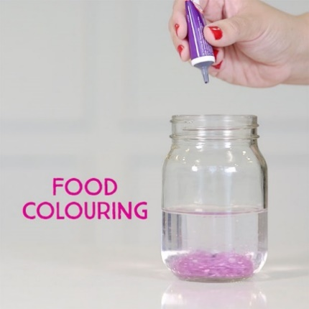

Add around 3 drops of food color and stir. You can add more or less depending on your preferred shade, but remember not to add too much or the mixture will become very dark and it will become hard to see the glitter.

**Step 4:**

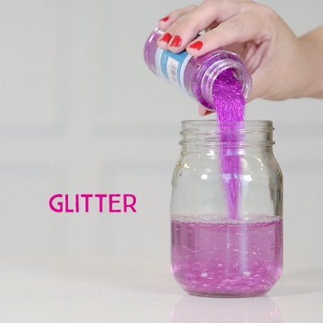

Pour in the glitter! Again, you can use more or less than suggested, or go for a mix of chunky and fine glitter to give more texture to your jar. Stir well until combined with the existing mixture.

**Step 5:**

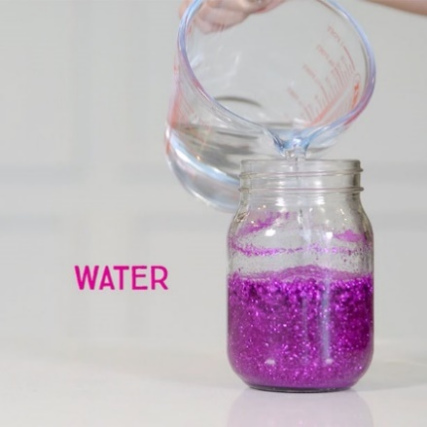

Top up your jar with the rest of the warm water, until it is almost full. Leave a little gap at the top of the jar to allow the mixture to move.

**Step 6:**



Shake and let the jar settle. Be proud of your hard work!