**About the Western Lowland Gorilla**

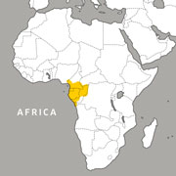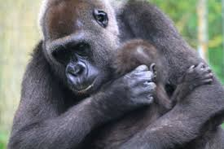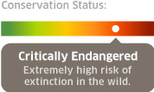**Gorillas** are the world’s largest living **primates**. Male **western lowland gorillas** can grow to 5.5-feet tall and weigh up to 450 pounds. Females can grow to 4.5-feet tall and weigh up to 250 pounds. Western lowland gorillas live in groups, or “bands” in or near African forests. The **alpha male** leads the band and those who challenge him are scared by his impressive shows of physical power—he may throw things, make aggressive charges, pound his huge chest while barking out powerful hoots, or unleash a frightening roar.

***\_\_\_\_\_\_\_\_\_\_\_\_ are the world’s \_\_\_\_\_\_\_\_\_\_\_***

***living \_\_\_\_\_\_\_\_\_\_\_.***

***http://www.zoonewengland.org/franklin-park-zoo/our-animals/mammals/primates/western-lowland-gorilla***

## Little Joe Escapes

## 1064849698_8085.jpeg

## http://cache.boston.com/bonzai-fba/Globe\_Photo/2003/09/29/1064849698\_8085

## In 2003, a Western Lowland Gorilla named Little Joe escaped from the Franklin Park Zoo. Back then, the gorillas lived in the Serengeti Crossing area that is now home to the wildebeest. Little Joe had escaped from the exhibit one time before, but the second time he was able to get all the way out of the zoo and was wandering around Boston.

## Little Joe weighed 300 pounds and was very scared and excited to be out of the zoo. He knocked a two year old girl out of a zoo employee’s arms and bit the girl on the back. He also attacked the zoo employee. Both people went to the hospital and were OK.

## Later, police found Little Joe hanging out at a bus stop. They shot him with four tranquilizer darts that were supposed to knock him out but not kill him. Little Joe was so big and excited to have escaped the zoo that the darts only made him a little tired but didn’t knock him out completely. After about two hours, police were able to cover him in nets and bring him safely back to the zoo.

## [*http://archive.boston.com/news/local/articles/2003/09/29/franklin\_park\_gorilla\_escapes\_attacks\_2/*](http://archive.boston.com/news/local/articles/2003/09/29/franklin_park_gorilla_escapes_attacks_2/)

***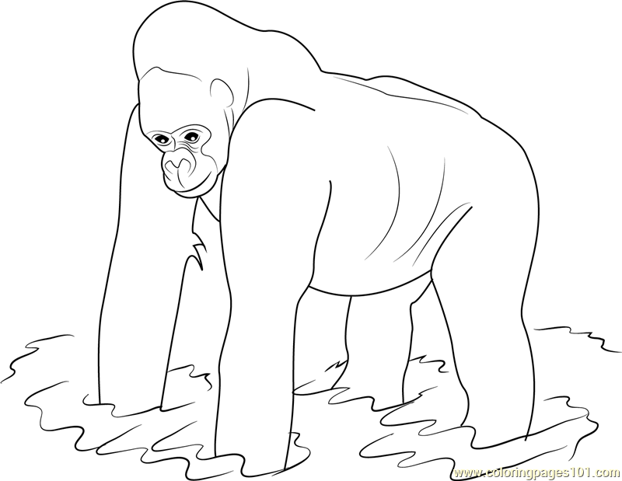***

***http://www.coloringpages101.com/gorilla-coloring-pages/75060-western-lowland-gorilla-coloring-page***

**Saving the Species**

Western Lowland Gorillas are Critically Endangered and are in danger of going **extinct** like the dinosaurs. Their home forests in Africa are home to a very deadly disease called **Ebola**. Ebola has killed nine out of ten gorillas in some parts of the rainforest. Gorillas are also hunted for **meat** and killed when people try to capture baby gorillas for **pets**.

There is an important group called the **World Wildlife Fund** (WWF) that is working very hard to help the species survive. They are funding research looking for a vaccine that can protect gorillas from Ebola. They are also educating local people not to eat gorilla meat and teaching them the importance of saving the forests where Western Lowland Gorillas live.

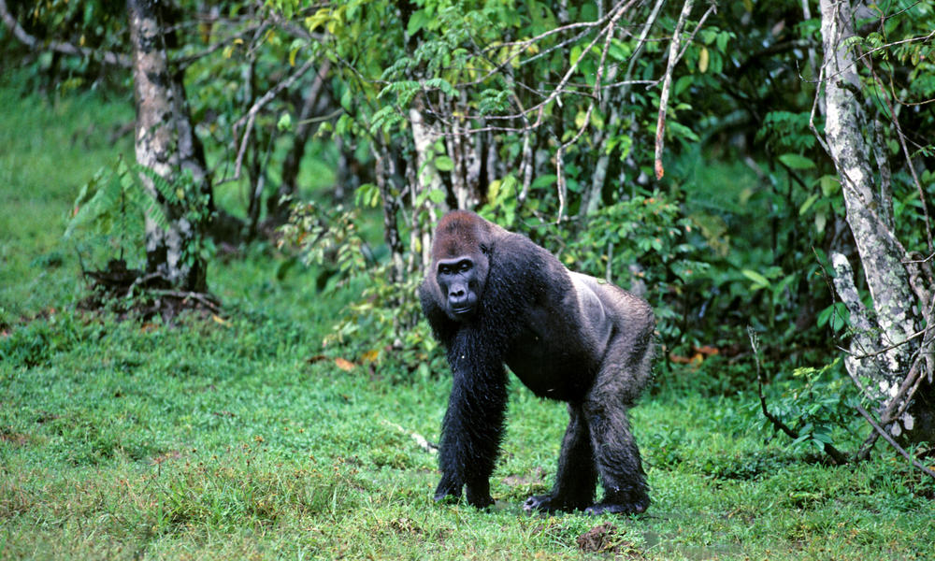

[**https://www.worldwildlife.org/species/western-lowland-gorilla**](https://www.worldwildlife.org/species/western-lowland-gorilla)

**Western Lowland Gorillas**

E O R O W X A L N G Y J L E S

K O W X U R C N H L F O J L W

S Q J I F P F L L K W L E T W

O U A P L J B A T L I P T T O

I O X A U D C V A T A A P I R

H T Z U S I L N B C U R L L L

T B D O T E D I S V T U G N D

K G C I T R X E F X Z S W C S

K C R F T C M M F E P S E Q Q

F C E N D A N G E R E D S R S

A L L I R O G I E P R I T B E

A L P H A M O G T B U R E H M

D N U F A Z Q X G X O B R T A

C F A L W M L O A E E L N K A

V F E W W P E J N Q L V A W T

ALPHA CRITICALLY

EBOLA ENDANGERED

ESCAPE EXTINCT

FUND GORILLA

JOE LITTLE

LOWLAND MALE

WESTERN WILDLIFE

WORLD

Currently, Western Lowland Gorillas are…

Extinct Critically Endangered Not Endangered

Two things threatening gorillas are…

Ants Ebola Hunters

When Little Joe escaped the zoo, he may have felt…

Excited Scared Confused

If I lived in a zoo cage, I might want to…

Escape Stay there Not sure

I think protecting gorillas is…

Very Important Not Important Not sure

I might want to donate some money to help protect gorillas…

Yes No Not sure

If so, I might donate…

$1 $5 More than $5

Words that describe Western Lowland Gorillas are..

\_\_\_\_\_\_\_\_\_\_\_\_\_\_\_\_\_\_\_\_\_\_\_\_\_\_\_\_\_\_\_\_\_\_\_\_\_\_\_\_\_\_\_\_\_\_\_\_\_\_

\_\_\_\_\_\_\_\_\_\_\_\_\_\_\_\_\_\_\_\_\_\_\_\_\_\_\_\_\_\_\_\_\_\_\_\_\_\_\_\_\_\_\_\_\_\_\_\_\_\_