SCROLL DOWN TO SEE IMAGES OF STATION MATERIALS/SUPPLIES, OUTCOMES AND TABLE SUPPORTS FOR EACH STATION
EXAMPLE STATIONS:

- Kinetic Sand Station

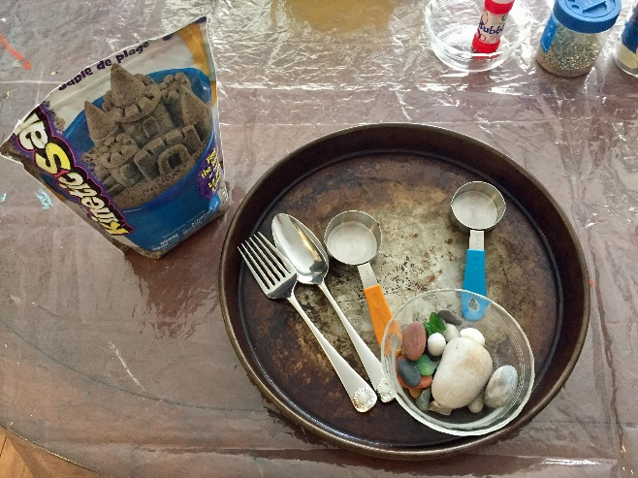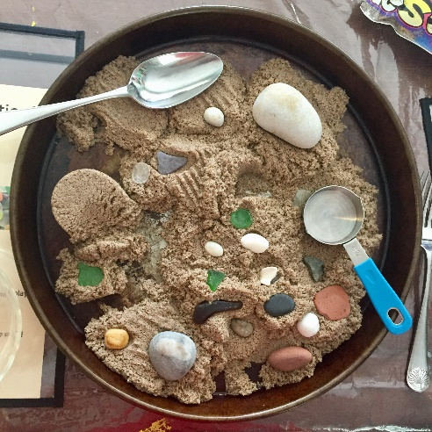
- Water Station
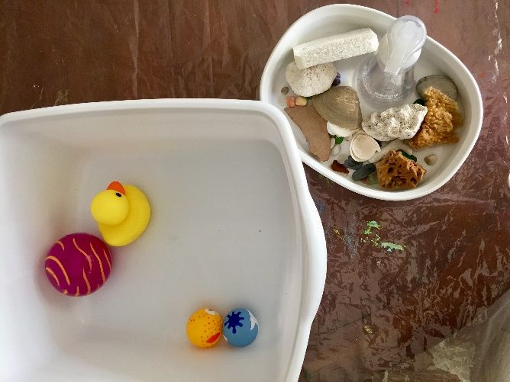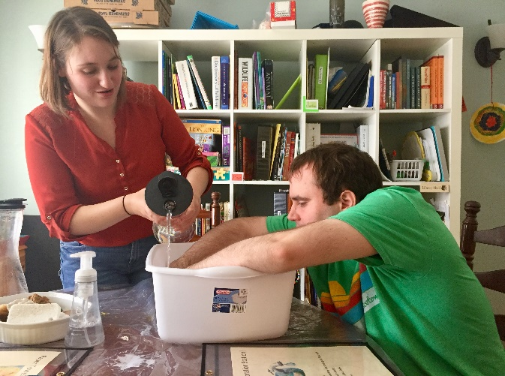
- Paper Towel Tie Dye with Food Coloring Station
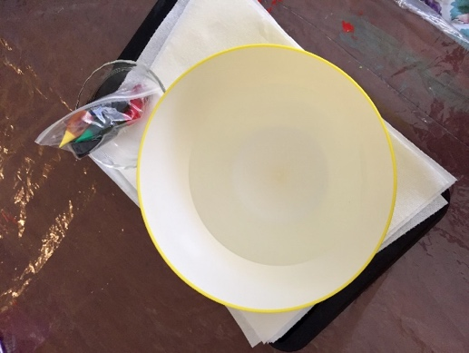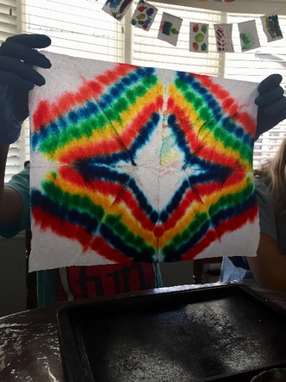

Water Exploration Station!

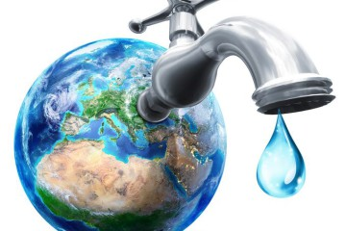
Enjoy making bubbles
Filling and emptying
Sprinkling some glitter
Add a few drops of something that smells good if you wish
Add a few drops of food coloring
Enjoy the stones, sea glass, shells
Enjoy the squeezy toys
Feel the water
How does it feel?
How do you feel?

Sand Exploration Station!
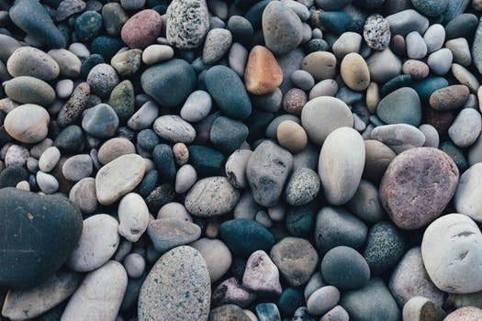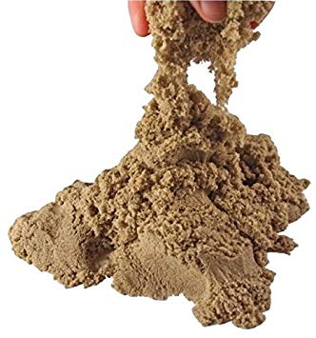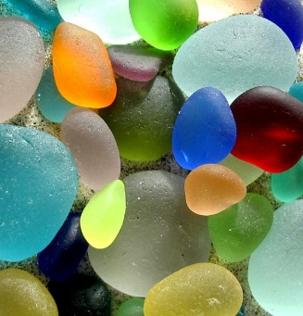
Enjoy the sand
Letting it run through your fingers
Feeling each grain
Feeling the clumps
Remembering fun memories at the beach or doing sand play
Enjoy the stones, sea glass, shells
Enjoy the cups for packing sand and making circles
Use the forks, knife, spoon to rake, spread, explore the sand
How does it feel?
How do you feel?

Paper Towel Tie Dye Art!
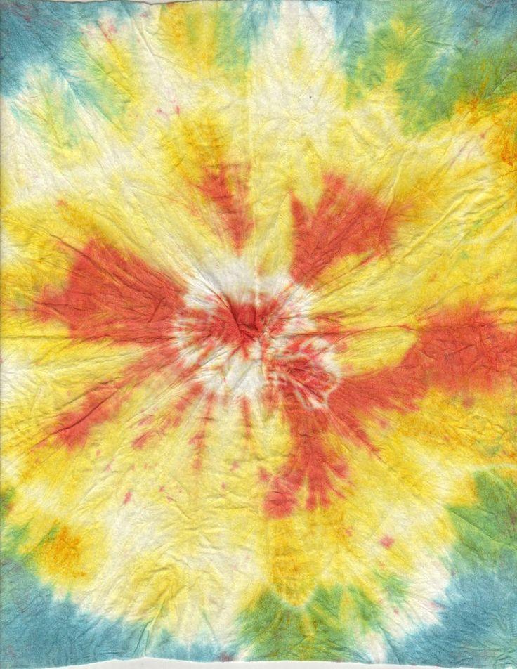
Enjoy folding the paper into triangles
Feel the softness of the material
Press the edges slowly while breathing
Dip the folded triangle into the water
Squeeze the extra water out gently, slowly
Lay your triangle on the cookie sheet
Put drops of food color on one side
Turn over and put the color on the same are on the other side
Keep repeating
Enjoy the colors as they spread and breathe
When done, unfold and let dry
How does it feel?
How do you feel?

