TABLE CLEANER
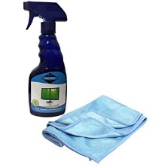

- Spraying the table
- Wiping down the table
- Dry the table one more time
- Put supplies away
- CHECK OFF CHORE CHART!
CHORE LANYARDS

TP RESTOCKER
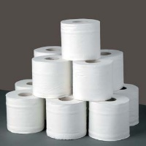

- Check the bathrooms for TP
- Put two rolls of TP near all 3 toilets
- Recycle any empty roll
- Replace toilet paper on reel if almost empty. Place almost empty roll on back of toilet.
- CHECK OFF CHORE CHART!

MIRROR WASHER
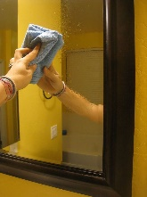
- Spray the mirror in the bathroom and dry
- Spray the mirrors downstairs and dry.
- Spray the mudroom mirror and dry
- CHECK OFF CHORE CHART!

3LPLACE RECYCLER

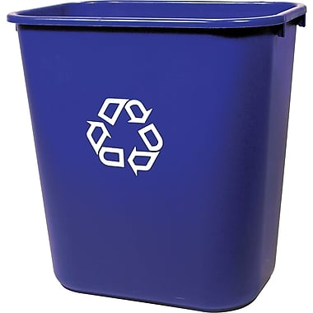

- Get the big recycling bin and collect recycling from middle room
- Get Katie’s recycling
- Unplug the shredder, dump the shreds, put lid back on
- Bring recycling outside (slippers are ok)
- CHECK OFF CHORE CHART!

DISHWASHER EMPTIER

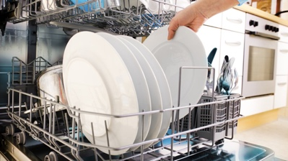

- Wash hands very well
- Open dishwasher
- Put dishes away
- Put confusing dishes in dish drain
- Close dishwasher and cabinets/drawers
- CHECK OFF CHORE CHART!

Example of one way 3L makes chore lanyards
