- Who am I?
  - My name is: _____________________
  - What state was I born in?:____________
  - I am _____ years old

These facts identify you

Take out your wallet.

Things that have your name on it identify you

ID=IDENTIFICATION

ID=WHO I AM

Is your ID big or small?
What color is your ID? ________________
How many ID’s do you have? ______________

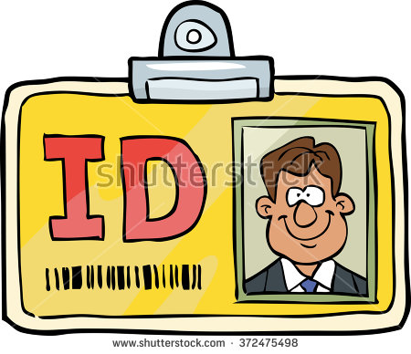

Look at your ID. Answer these questions:

What is your name? __________________________
What is your birth date? ________________________

What state do you live in? ________________________

What is your address? _______________________

What is your gender? Check one:
- Male
- Female
- Non Gender-Binary

What is your height? ______________________

