Information for your ID:

First Name: ____________________________

Last Name: ____________________________

Middle Name(s): ____________________________

Gender and Age

Gender (circle):

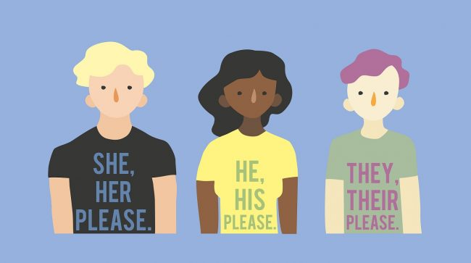

How old are you? ________ years old

What is your birthdate? Example: August 23, 1994

Month: ____________ Day: ______ Year: __________

Appearance

What is your height? ________ feet and _______ inches

What color are your eyes (circle one)?
Blue Green Brown

What color is your hair? ________________

Address

Street Number and Name:
example: 50 Whitman Street
_________________________________

Town:
example: Somerville
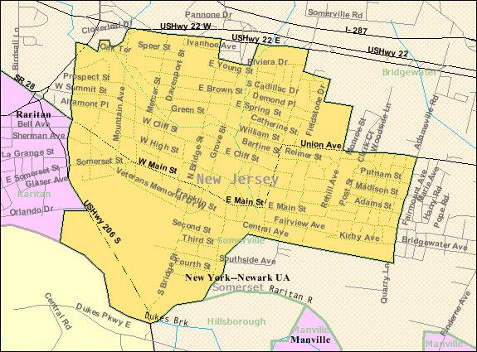 __________________________________

State:
example: Massachusetts
_________________________________

Zip Code (we will look this up together):
example: 02144

_________________________________

Signature

Sign your name on the line:

Signature:
Name:
Gender: _____________
Birthdate: ___/___/____
Height: _____’_____”
Hair Color: ____________

Add Picture Here

