“The Girl Who Started it All”

adapted from: http://kathrineswitzer.com/about-kathrine/1967-boston-marathon-the-real-story/

On a dark six-mile run in a wild snowstorm in mid-December 1966, I had a terrible argument with my otherwise kindly old coach, Arnie Briggs. It was in Syracuse, New York. I was a 19-year-old journalism student at Syracuse University, and since there was no women’s running team there or anywhere else for that matter, I began training unofficially with the men’s cross-country team.
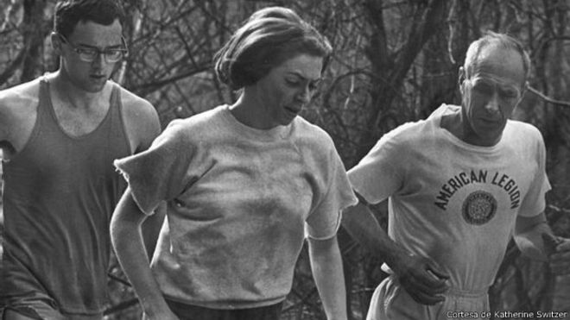
That’s where I met 50-year-old Arnie, who had trained for years with the team. Arnie was actually the university mailman and a veteran of 15 Boston Marathons. He was excited to see a woman—the first—come out to run, and took slowpoke me under his training wing. To cajole me through tough evening sessions like this, Arnie told and retold stories of famous Bostons. I loved listening to them—until this night when I snapped and said, “Oh, let’s quit talking about the Boston Marathon and run the damn thing!”

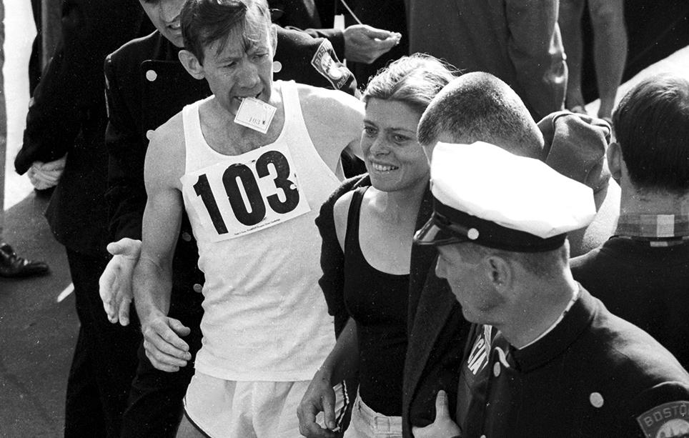
“No woman can run the Boston Marathon,” Arnie fired back. “Why not? I’m running 10 miles a night!” Switzer said. Arnie insisted the distance was too long for fragile women to run and exploded when I said that Roberta Gibb had jumped into the race and finished it the previous April.
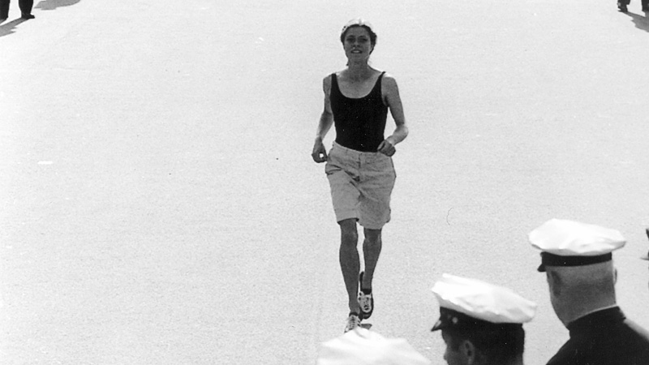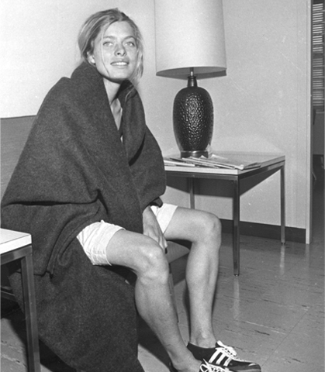
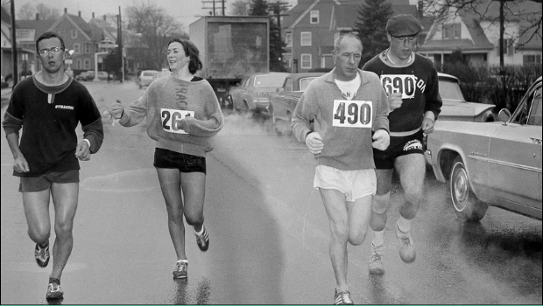
“No dame ever ran the Boston Marathon!” he shouted, “If any woman could do it, you could, but you would have to prove it to me. If you ran the distance in practice, I’d be the first to take you to Boston.” I grinned through the gloom and flakes. I thought, I have a coach, a training partner, a plan, and a goal: the biggest race in the world—Boston.

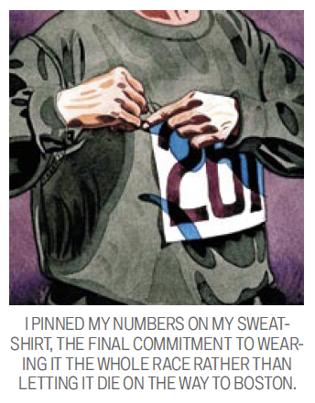
Three weeks before the marathon, Arnie and I ran our 26-mile trial. As we came down our home stretch, it felt too easy, so I suggested that we run another five-mile loop just to feel extra confident about Boston. Arnie agreed, reluctantly. Toward the end of our 31-mile run, he began turning grey. When we finished, I hugged him ecstatically—and he passed out cold. The next day Arnie came to my dorm and insisted that I sign up for the race. He said it was wrong to run without registering and, besides, I could get in serious trouble with the Amateur Athletic Union, our sport’s strict governing body.
We checked the rule book and entry form; there was nothing about gender in the marathon. I filled in my AAU number, plunked down $3 cash as entry fee, signed as I always sign my name, “K.V. Switzer,” and went to the university infirmary to get a fitness certificate. (Unlike today, the marathon did not require qualifying times then.)
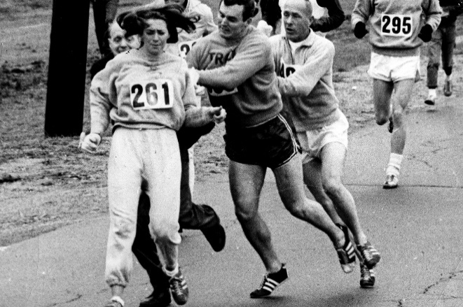
Arnie got the travel permits and mailed our entries. Two weeks later, my boyfriend, a 235-pound ex–All American football player and nationally ranked hammer thrower known as Big Tom Miller, announced that he was going to run Boston, too, and didn’t need to train because “if a girl can run a marathon, I can run a marathon.” Tom was an authority on all things athletic and would not be dissuaded. Then John Leonard, from the university cross-country team, decided to come, too. In all, we had a pretty formidable crew ready to take on the marathon.

PHOTOGRAPHS OF THEN AND NOW

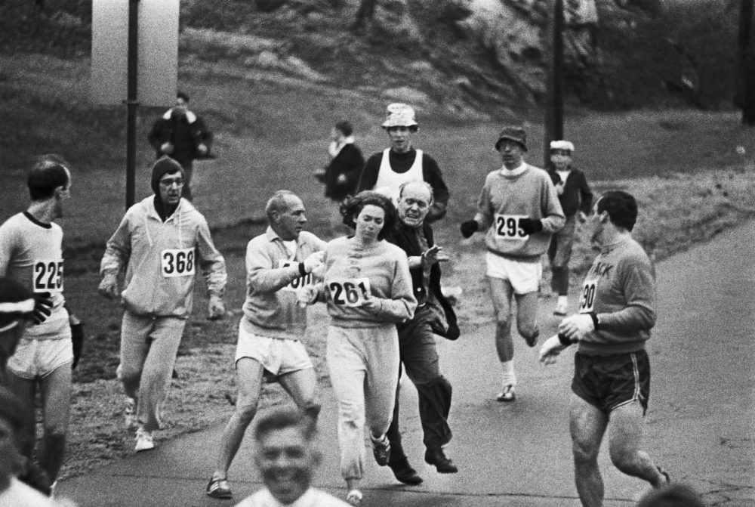

This picture shows Jock Semple trying to throw Kathrine Switzer off the race course in 1967

Kathrine Switzer today, 50 years later, ready to run the 121st Boston Marathon
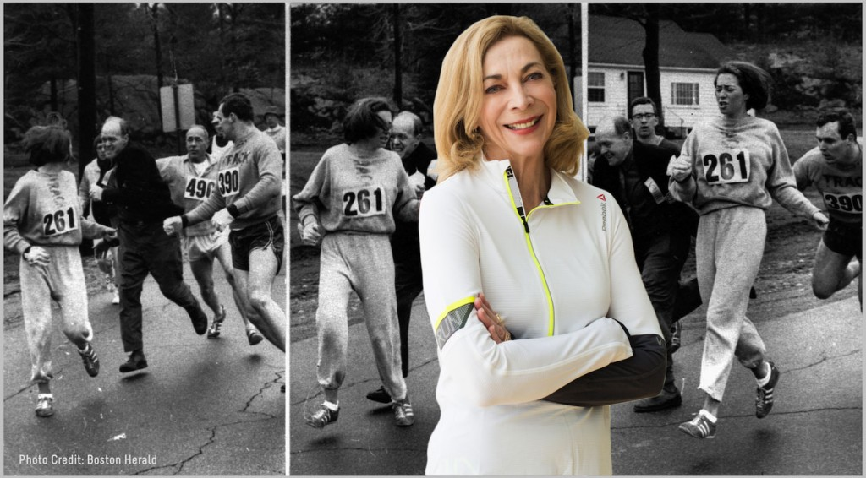

Letter Writing

- Choose:

- Write a letter to Kathrine Switzer

- Write a letter to a strong woman in your life—that you know or don’t know

- Answer all of the below:

- What makes this person strong?

- What do you admire about them?

- What have they done or said that inspires you?

- Are they considered a role model and why?

- Sign your letter!

Date: _________________

Dear ____________________:

Sincerely,

____________________

Date: _________________

Dear ____________________:

Sincerely,

____________________

